

**NEW ERA UNIVERSITY COLLEGE**

**DEPARTMENT OF COMPUTER SCIENCE & INFORMATION TECHNOLOGY**

**BACHELOR OF SOFTWARE ENGINEERING**

**BIBWB2214 - Web Application Development**

**TANG JIA HUEY 1930036 - BSE**

**LECTURER: James Woo Jong Jiann**

**DATE OF SUBMISSION: 24th August 2021**

Table of Contents

1. UAT Scope (In Scope – Out of Scope) 3

2. UAT Assumptions and Constraints 3

3. UAT Risks 3

4. UAT Team Roles & Responsibilities 4

5. UAT Entry Criteria 4

6. UAT Test Results 5

1.0 Login – Let user login to their account. 5

2.0 Home Page (Dashboard) – Display summary of the online shop 8

3.0 Create Product – Let user create a new product 11

4.0 Product List Page – List out all the product in the online shop. 18

5.0 Product’s Detail Page – Show the detail of selected product. 21

6.0 Update Product Detail Page – Let user update the selected product’s detail 22

7.0 Create Customer Page – For create a new customer 28

8.0 Customer List Page – List out all the customer in the online shop 37

9.0 Customer’s Detail Page – Show the detail of the selected customer. 40

10.0 Update Customer Detail Page – Let user to update the selected customer’s detail 41

11.0 Create Order – let user create a new order 49

12.0 Order List Page – Display all order which have been made before 53

13.0 Order’s Detail Page – Show the detail of the selected customer. 55

14.0 Update Order Details – Let user update the order’s detail. 56

7. Document Signatures 60

8. Addendums & Appendices 61

|  |  |
| --- | --- |
| 1. UAT Scope (In Scope – Out of Scope) | |
| **UAT - In Scope** | **UAT - Out of Scope** |
| 1. Login page 2. Home page (dashboard after login) 3. Create product page 4. Product list page 5. Product detail page 6. Update product page 7. Create customer page 8. Customer list page 9. Customer detail page 10. Update customer page 11. Create order page 12. Order list page 13. Order detail page 14. Update order page |  |

## 

|  |
| --- |
| 2. UAT Assumptions and Constraints |
| **UAT Assumptions** |
| 1. Test environment - The test cases are conducted by the client in their own environment by using their own devices. 2. Tester knowledge – Tester must have knowledge on how to report bugs. 3. Tester’s device (desktop / laptop) – Tester device must be at least Window 8 (for Windows) or OS X 10.9 (for MacBook), able to access the internet and have 4GB ram. 4. Tester’s device (mobile) – If tester is testing by using a mobile, make sure the mobile has internet access and has at least Android 8 (for android mobile) and iOS 10 (for iPhone). 5. Test documentation – All UAT test cases are documented and send to the client for testing. |

|  |
| --- |
| **UAT Constraints** |
| 1. Time frames – Test results must be provided by 24 August 2021. |

|  |  |  |  |
| --- | --- | --- | --- |
| 3. UAT Risks | | | |
| **Description** | **Probability**  **High|Med|Low** | **Impact**  **High|Med|Low** | **Mitigation** |
| Not properly trained tester | Low | High | Conduct training session for tester |
| Incomplete testing due to the time constraint | Low | Med | Make proper time management by timetable |

|  |  |  |
| --- | --- | --- |
| 4. UAT Team Roles & Responsibilities | | |
| **Name** | **Roles** | **Responsibilities** |
| Candace Lee Xiao Xuen | Project Owner | Testing on Window |
| James | Project Owner | Testing on iOS |

|  |  |
| --- | --- |
| 5. UAT Entry Criteria | |
| **ID** | **Criteria** |
| 5.1 | The development of the website is fully completed |
| 5.2 | Integration test are completed |
| 5.3 | No high or medium defects are reported |
| 5.4 | All bugs reported are solved |
| 5.5 | Tester is ready with his / her own device |
| 5.6 | Tester is briefed and ready to start |
| 5.7 | UAT document is available and sent to the tester |

|  |  |  |  |  |  |
| --- | --- | --- | --- | --- | --- |
| 6. UAT Test Results | | | |  |  |
| **ID** | **Test Cases** | **Expected Results** | **Pass/Fail** | **Tested By** | **Date Tested** |
| 1.0 Login – Let user login to their account. | | | | | |
| 1.1 | **Login without fill in any fields.**  Test Procedure:  Username: (leave blank)  Password: (leave blank) | An error will be pop up for not fill in any field:  Please enter your username!  Please enter your password!  (refer Figure 1.1) | pass | Candace Lee Xiao Xuen | 22 / 08 / 2021 |
| 1.2 | **Login by only filled up the username.**  Test Procedure:  Username: amanda11  Password: (leave blank) | An error will be pop up for only filled up the username:  Please enter your password!  (refer Figure 1.2) | pass | Candace Lee Xiao Xuen | 22 / 08 / 2021 |
| 1.3 | **Login by only filled up the password.**  Test Procedure:  Username: (leave blank)  Password: Amanda_11 | An error will be pop up for only filled up the password:  Please enter your username!  (refer Figure 1.3) | pass | Candace Lee Xiao Xuen | 22 / 08 / 2021 |
| 1.4 | **Login with a not exist account.**  Test Procedure:  Username: abc  Password:  abc | An error will be displayed for fill in wrong username:  Username does not exist!  (refer Figure 1.4) | pass | Candace Lee Xiao Xuen | 22 / 08 / 2021 |
| 1.5 | **Login with an existing account but with wrong password**  Test Procedure:  Username: ahyuan11  Password:  yuan123 | An error will be displayed for fill in wrong password:  Password incorrect!  (refer Figure 1.5) | pass | Candace Lee Xiao Xuen | 22 / 08 / 2021 |
| 1.6 | **Login with an account not active**  Test Procedure:  Username: Apple123  Password: Abc_123456 | An error will be displayed for the inactive account:  Sorry, your account is inactive!  (refer Figure 1.6) | pass | Candace Lee Xiao Xuen | 22 / 08 / 2021 |
| 1.7 | **Try to access another page without login**  Test Procedure:  Try to redirect to home page / dashboard ( <http://claire-online-store.rf.gd/home.php> ) without login | An error will be displayed for without login:  Please login for further proceed!  (refer Figure 1.7) | pass | Candace Lee Xiao Xuen | 22 / 08 / 2021 |
| 1.8 | **Login with an existing account with correct username and password**  Test Procedure:  Username: amanda11  Password:  Amanda_11 | Direct user to the home page  <http://claire-online-store.rf.gd/home.php>  (refer Figure 1.8) | pass | Candace Lee Xiao Xuen | 22 / 08 / 2021 |

|  |  |  |  |  |  |
| --- | --- | --- | --- | --- | --- |
| **ID** | **Test Cases** | **Expected Results** | **Pass/Fail** | **Tested By** | **Date Tested** |
| 2.0 Home Page (Dashboard) – Display summary of the online shop | | | | | |
| 2.1 | **Direct to Home Page (Dashboard)**  Test Procedure:  After user successfully login he / she will be directed to the home page. To go to the home page manually, he / she can click the “Home” from the navigation menu. | Redirect to the home page (dashboard).  All summary of the online shop will be displayed.  (refer Figure 1.8) | pass | Candace Lee Xiao Xuen | 22 / 08 / 2021 |
| 2.2 | **Greeting name change according to the login person**  Test Procedure:  Login with different account  **Account 1**  Username: amanda11  Password: Amanda_11  **Account 2**  Username: ahyuan11  Password: Yuan_759130 | The word after “Hi” will be changed according to the login username.  (refer Figure 2.2) | pass | Candace Lee Xiao Xuen | 22 / 08 / 2021 |
| 2.3 | **Direct user to customer list page from home page**  Test Procedure:  Click the icon or the words “13 customers” below at the home page to go to the customer list page  A picture containing text, vector graphics, screenshot, businesscard  Description automatically generated | Redirect to the customer list page  Customer list page is displayed  (refer Figure 2.3) | pass | Candace Lee Xiao Xuen | 22 / 08 / 2021 |
| 2.4 | **Direct user to product list page from home page**  Test Procedure:  Click the icon or the words “15 products” below at the home page to go to the product list page | Redirect to the product list page  Product list page is displayed  (refer Figure 2.4) | pass | Candace Lee Xiao Xuen | 22 / 08 / 2021 |
| 2.5 | **Direct user to product list page from home page**  Test Procedure:  Click the icon or the words “12 orders” below at the home page to go to the order list | Redirect to the order list page  Order list page is displayed  (refer Figure 2.5) | pass | Candace Lee Xiao Xuen | 22 / 08 / 2021 |
| 2.6 | **Latest order summary**  Test Procedure:  It will change when a new order has been made. | Latest order summary will be shown (it will change when a new order has been made).  (refer Figure 2.6) | pass | Candace Lee Xiao Xuen | 22 / 08 / 2021 |
| 2.7 | **Highest Purchase Amount Order Summary**  Test Procedure:  It will be changed when another order with the purchase total amount is higher than the current order purchase total amount | Order with highest purchase total amount will be shown (will be changed when another highest total amount order is appeared).  (refer Figure 2.7) | pass | Candace Lee Xiao Xuen | 22 / 08 / 2021 |
| 2.8 | **5 top selling products**  Test Procedure:  5 top product that sell the most will be shown. It can be change when another product selling quantity is higher than the current product. | 5 top selling products will be shown (it can be change when another product selling amount is higher than the current product).  (refer Figure 2.8) | pass | Candace Lee Xiao Xuen | 22 / 08 / 2021 |

|  |  |  |  |  |  |
| --- | --- | --- | --- | --- | --- |
| **ID** | **Test Cases** | **Expected Results** | **Pass/Fail** | **Tested By** | **Date Tested** |
| 3.0 Create Product – Let user create a new product | | | | | |
| 3.1 | **Direct user to create product page**  Test Procedure:  At the navigation bar click the product dropdown menu then click the “Create Product” then you will be directed to the create product page. | Direct user to the create product page  Create new product form will be displayed.  (refer Figure 3.1) | pass | Candace Lee Xiao Xuen | 22 / 08 / 2021 |
| 3.2 | **Create Product Page without fill in any fields**  Test Procedure:  Product picture: (Leave Blank)  Name: (Leave Blank)  Malay Name: (Leave Blank)  Description: (Leave Blank)  Price: (Leave Blank)  Promotion Price: (Leave Blank)  Manufacture Date: (Leave Blank)  Expired Date: (Leave Blank) | An error will be pop up for not fill in any field:  Please make sure all fields are not empty! (product picture is optional)  (refer Figure 3.2) | pass | Candace Lee Xiao Xuen | 22 / 08 / 2021 |
| 3.3 | **Create Product Page without fill in all the mandatory fields**  Test Procedure:  Name: (Leave Blank)  Malay Name:  Minyak wangi  Description: used to give the human body, animals, food, objects, and living - spaces an agreeable [scent](https://en.wikipedia.org/wiki/Scent).  Price: 120  Promotion Price: 60  Manufacture Date: 12-12-2020  Expired Date: 12-12-2023 | An error message will be pop up when all mandatory field is not fill in:  Please make sure all fields are not empty! (product picture is optional)  (refer Figure 3.3) | pass | Candace Lee Xiao Xuen | 22 / 08 / 2021 |
| 3.4 | **Insert a non-number character into price and promotion price field**  Test Procedure:  Price: abc  Promotion Price: abc | An error message will be pop up when price and product price is not a number:  Please make sure the price is a number!  Please make sure the promotion price is a number!  (refer Figure 3.4) | pass | Candace Lee Xiao Xuen | 22 / 08 / 2021 |
| 3.5 | **Insert a number which is equals to 0 or smaller than 0 in price or promotion price field.**  Test Procedure:  Price: 0  Promotion Price: -1 | An error message will be pop up when price and promotion price is 0 or negative:  Please make sure the price and promotion price must not be a negative value or zero!  (refer Figure 3.5) | pass | Candace Lee Xiao Xuen | 22 / 08 / 2021 |
| 3.6 | **Create product with price and promotion price larger than 1000.**  Test Procedure:  Price: 1500  Promotion Price: 1200 | An error message will be pop up for price and promotion price large than 1000:  Please make sure the price and promotion price is not bigger than RM 1000!  (refer Figure 3.6) | pass | Candace Lee Xiao Xuen | 22 / 08 / 2021 |
| 3.7 | **When price smaller than promotion price**  Test Procedure:  Price: 120  Promotion Price: 150 | An error message will be pop up for price smaller than promotion price:    Promotion price cannot bigger than normal price!  (refer Figure 3.7) | pass | Candace Lee Xiao Xuen | 22 / 08 / 2021 |
| 3.8 | **Insert expired date earlier than manufacture date**  Test Procedure:  Manufacture Date: 12-12-2020  Expired Date: 12-12-2019 | An error message will be pop up when expired date earlier than manufacture date:  Please make sure expired date is late than the manufacture date!  (refer Figure 3.8) | pass | Candace Lee Xiao Xuen | 22 / 08 / 2021 |
| 3.9 | **Upload a non-image file into product picture**  Test Procedure:  Insert an image with file type like document or pdf | An error message will be displayed when file uploaded is not an image file:  Please upload image ONLY! (JPG, JPEG, PNG & GIF)  (refer Figure 3.9) | pass | Candace Lee Xiao Xuen | 22 / 08 / 2021 |
| 3.10 | **Upload an image in product picture which is not in square size or 1:1 ratio**  Test Procedure:  Upload an image which is not in square size or 1:1 ratio | An error will be displayed when the uploaded picture is not a square picture:  Please make sure the ratio of the photo is 1:1!  (refer Figure 3.10) | pass | Candace Lee Xiao Xuen | 22 / 08 / 2021 |
| 3.11 | **Upload an image which the size is larger than 512KB**  Test Procedure:  Upload an image which the size is larger than 512KB | An error message will be displayed when the image uploaded is larger than 512KB:  Sorry, your photo is too large. Only 512KB is allowed!  (refer Figure 3.11) | pass | Candace Lee Xiao Xuen | 22 / 08 / 2021 |
| 3.12 | **Upload an image in product picture which is not in JPG, JPEG, PNG & GIF files.**  Test Procedure:  Upload an image which is not in JPG, JPEG, PNG & GIF files. | An error will be displayed when the file type is not JPG, JPEG, PNG or GIF:  Sorry, only JPG, JPEG, PNG & GIF files are allowed!  (refer Figure 3.12) | pass | Candace Lee Xiao Xuen | 22 / 08 / 2021 |
| 3.13 | **Create Product Page with all valid input without uploading an image**  Test Procedure:  Product Picture: (No image uploaded)  Name: Perfume  Malay Name:  Minyak wangi  Description: used to give the human body, animals, food, objects, and living - spaces an agreeable [scent](https://en.wikipedia.org/wiki/Scent).  Price: 120  Promotion Price: 60  Manufacture Date: 12-12-2020  Expired Date: 12-12-2023 | An notify message will be displayed:  Product was created.  (refer Figure 3.13) | pass | Candace Lee Xiao Xuen | 22 / 08 / 2021 |
| 3.14 | **Create Product Page with all valid input and uploading an image**  Test Procedure:  Product Picture: (exp: image.jpg)  *product picture should be in ration 1:1, not lagger than 512KB, and in JPG, JPEG, PNG & GIF files.  Name: Perfume  Malay Name:  Minyak wangi  Description: used to give the human body, animals, food, objects, and living - spaces an agreeable [scent](https://en.wikipedia.org/wiki/Scent).  Price: 120  Promotion Price: 60  Manufacture Date: 12-12-2020  Expired Date: 12-12-2023 | An notify message will be displayed:  Product was created.  (refer Figure 3.13) | pass | Candace Lee Xiao Xuen | 22 / 08 / 2021 |
| 3.15 | **Direct to the product list page**  Test Procedure:  At the bottom of the create product page click the “View Products” to go to the product list page | Direct user to the product list page  Product list page is displayed  (refer Figure 2.4) | pass | Candace Lee Xiao Xuen | 22 / 08 / 2021 |

|  |  |  |  |  |  |
| --- | --- | --- | --- | --- | --- |
| **ID** | **Test Cases** | **Expected Results** | **Pass/Fail** | **Tested By** | **Date Tested** |
| 4.0 Product List Page – List out all the product in the online shop. | | | | | |
| 4.1 | **Direct to Product List Page**  Test Procedure:  At the navigation bar click the dropdown menu of Product then choose ‘Product List’. | Redirect to the product list pages  All products should be listed.  (refer Figure 2.4) | pass | Candace Lee Xiao Xuen | 22 / 08 / 2021 |
| 4.2 | **Redirect to create product page**  Test Procedure:  Click the “Create New Product” which located right on top of the search field to go to the create new product page. | Direct user to the create product page  Create new product form will be displayed.  (refer Figure 3.1) | pass | Candace Lee Xiao Xuen | 22 / 08 / 2021 |
| 4.3 | **Search product by using the product name that exist**  Test Procedure:  Insert ‘ball’ at the search field which is located at the top right of the product list then click “Search”. | All of the product name that consist of ‘ball’ will be displayed.  (refer Figure 4.3) | pass | Candace Lee Xiao Xuen | 22 / 08 / 2021 |
| 4.4 | **Search product by using the product name that is not exist**  Test Procedure:  Insert ‘laptop’ at the search field which is located at the top right of the product list then click “Search”. | An error message will be displayed:  No product found.  (refer Figure 4.4) | pass | Candace Lee Xiao Xuen | 22 / 08 / 2021 |
| 4.5 | **Direct to Product Details Page**  Test Procedure:  Click the ‘Detail’ button of any product in the product list page. | Direct to the product details pages of the selected product (might be different due to the selected product ID)  (refer Figure 4.5) | pass | Candace Lee Xiao Xuen | 22 / 08 / 2021 |
| 4.6 | **Direct to Update Product Page**  Test Procedure:  Click the button of ‘Update’ in Product List Page of the product with product ID 1   | Redirect to the update product ID 1 page  (refer Figure 4.6) | pass | Candace Lee Xiao Xuen | 22 / 08 / 2021 |
| 4.7 | **Delete certain product in Product List Page which is not in any order.**  Test Procedure:  Click the ‘delete’ button of the product with ID 16 (product is not in any order) and click ‘OK’ when a confirmation message pops up. | An notify message will be displayed:  Product was deleted.  (refer Figure 4.7) | pass | Candace Lee Xiao Xuen | 22 / 08 / 2021 |
| 4.8 | **Delete certain product in Product List Page which is in any order.**  Test Procedure:  Click the ‘delete’ button of the product with ID 2 (product involved in order) and click ‘OK’ when a confirmation message pops up. | An error message will be displayed:  Product could not be deleted as it involved in order.  (refer Figure 4.8) | pass | Candace Lee Xiao Xuen | 22 / 08 / 2021 |

|  |  |  |  |  |  |
| --- | --- | --- | --- | --- | --- |
| **ID** | **Test Cases** | **Expected Results** | **Pass/Fail** | **Tested By** | **Date Tested** |
| 5.0 Product’s Detail Page – Show the detail of selected product. | | | | | |
| 5.1 | **Direct to update the product detail**  Test Procedure:  Click the ‘Update product’ button at the bottom of the product detail page.   | Direct to the update product detail page (might be different due to the selected product ID)  (refer Figure 4.5) | pass | Candace Lee Xiao Xuen | 22 / 08 / 2021 |
| 5.2 | **Redirect back to the product list page**  Test Procedure:  Click the ‘Back to product list’ button at the bottom of the product detail page.   | Redirect back to the product list pages  (refer Figure 2.4) | pass | Candace Lee Xiao Xuen | 22 / 08 / 2021 |

|  |  |  |  |  |  |
| --- | --- | --- | --- | --- | --- |
| **ID** | **Test Cases** | **Expected Results** | **Pass/Fail** | **Tested By** | **Date Tested** |
| 6.0 Update Product Detail Page – Let user update the selected product’s detail | | | | | |
| 6.1 | **Upload a non-image photo into the product picture field**  Test Procedure:  Upload an file with file type like document or pdf. | An error message will be displayed when file uploaded is not an image file:  Please upload image ONLY! (JPG, JPEG, PNG & GIF)  (refer Figure 6.1) | pass | Candace Lee Xiao Xuen | 22 / 08 / 2021 |
| 6.2 | **Upload an image in product picture which is not in a square size or not in 1:1 ratio.**  Test Procedure:  Upload an image which is not in a square size or not in 1:1 ratio. | An error will be displayed when the uploaded picture is not a square picture:  Please make sure the ratio of the photo is 1:1!  (refer Figure 6.2) | pass | Candace Lee Xiao Xuen | 22 / 08 / 2021 |
| 6.3 | **Upload an image in product picture which the size larger than 512KB**  Test Procedure:  Upload an image which the size larger than 512KB | An error message will be displayed when the image uploaded is larger than 512KB:  Sorry, your photo is too large. Only 512KB is allowed!  (refer Figure 6.3) | pass | Candace Lee Xiao Xuen | 22 / 08 / 2021 |
| 6.4 | **Upload an image into profile picture field which is not in JPG, JPEG, PNG & GIF files.**  Test Procedure:  Insert an image which is not in JPG, JPEG, PNG & GIF files. | An error message will be displayed when uploaded image is not in JPG, JPEG, PNG & GIF files:  Sorry, only JPG, JPEG, PNG & GIF files are allowed!  (refer Figure 6.4) | pass | Candace Lee Xiao Xuen | 22 / 08 / 2021 |
| 6.5 | **Upload an image if no image uploaded before**  Test Procedure:  Click the “Add Picture” to upload a valid picture  *product picture should be in ration 1:1, not lagger than 512KB, and in JPG, JPEG, PNG & GIF files. | The picture will be uploaded and a notify message will be displayed:  Product 1 (will change due to the selected product’s ID) was updated.  (refer Figure 6.5) | pass | Candace Lee Xiao Xuen | 22 / 08 / 2021 |
| 6.6 | **Change an image when there is an existing image uploaded before**  Test Procedure:  Click “Change Picture” then just upload a valid picture you want to upload.  *product picture should be in ration 1:1, not lagger than 512KB, and in JPG, JPEG, PNG & GIF files. | The picture will be uploaded and a notify message will be displayed:  Product 1 (will change due to the selected product’s ID) was updated.  (refer Figure 6.6) | pass | Candace Lee Xiao Xuen | 22 / 08 / 2021 |
| 6.7 | **Delete existing product picture at update product page**  Test Procedure:  Delete the exist images by clicking the ‘x’ which is located at the right of the picture | The photo will be deleted and be replaced by the default image of product and a notify message will display:  Product 1 (will change due to the selected product’s ID) was updated.  (refer Figure 6.7) | pass | Candace Lee Xiao Xuen | 22 / 08 / 2021 |
| 6.8 | **Leave any one of the mandatory field blank.**  Test Procedure:  Name: (Leave Blank)  Malay Name: Bola Keranjang  Description: A ball used in the NBA.  Price: 60  Promotion Price: 35  Manufacture Date: 06/03/2019  Expired Date:  02/06/2023 | An error message will be pop up when one of the mandatory fields is not filled:  Please make sure all fields are not empty! (product picture is optional)  (refer Figure 6.8) | pass | Candace Lee Xiao Xuen | 22 / 08 / 2021 |
| 6.9 | **Change the price and promotion price to a non-numeric character**  Test Procedure:  Price: abc  Promotion Price: abc | An error message will be pop up when the price or promotion price is not numeric:  Please make sure the price is a number!  Please make sure the promotion price is a number!  (refer Figure 6.9) | pass | Candace Lee Xiao Xuen | 22 / 08 / 2021 |
| 6.10 | **Change the price and promotion price to 0 or smaller than 0**  Test Procedure:  Price: 0  Promotion Price: -1 | An error message will be pop up when price or promotion price is negative or 0:  Please make sure the price and promotion price must not be a negative value or zero!  (refer Figure 6.10) | pass | Candace Lee Xiao Xuen | 22 / 08 / 2021 |
| 6.11 | **Change the price and promotion price to a number bigger than 1000**  Test Procedure:  Price: 1500  Promotion Price: 1200 | An error message will be pop up when price or promotion price is bigger than 1000:  Please make sure the price and promotion price is not bigger than RM 1000!  (refer Figure 6.11) | pass | Candace Lee Xiao Xuen | 22 / 08 / 2021 |
| 6.12 | **Change the price become smaller than promotion price**  Test Procedure:  Price: 60  Promotion Price: 70 | An error message will be pop up when the promotion price is bigger than the normal price:    Promotion price cannot bigger than normal price!  (refer Figure 6.12) | pass | Candace Lee Xiao Xuen | 22 / 08 / 2021 |
| 6.13 | **Change the expired date become earlier than manufacture date**  Test Procedure:  Manufacture Date: 06/03/2019  Expired Date:  02/06/2018 | An error message will be pop up when the expired date is earlier than manufacture date:    Please make sure expired date is late than the manufacture date!  (refer Figure 6.13) | pass | Candace Lee Xiao Xuen | 22 / 08 / 2021 |
| 6.14 | **Save product detail without changing any information.**  Test Procedure:  Click the “Save Changes” which is located right on the top of the footer. | The product detail will be saved and a notify message will displayed:  Product 1 (will change due to the selected product’s ID) was updated.  (refer Figure 6.5) | pass | Candace Lee Xiao Xuen | 22 / 08 / 2021 |
|  | **Redirect back to the product list page**  Test Procedure:  Click the “Back to Product List” which is located right on the top of the footer to view the products list. | Redirect back to the products list page.  All product in the online store is displayed.  (refer Figure 2.4) | pass | Candace Lee Xiao Xuen | 22 / 08 / 2021 |

|  |  |  |  |  |  |
| --- | --- | --- | --- | --- | --- |
| **ID** | **Test Cases** | **Expected Results** | **Pass/Fail** | **Tested By** | **Date Tested** |
| 7.0 Create Customer Page – For create a new customer | | | | | |
| 7.1 | **Direct user to create customer page**  Test Procedure:  At the navigation bar click the product dropdown menu then click the “Create Customer” then you will be directed to the create customer page. | Direct user to the create customer page  Create new customer form will be displayed.  (refer Figure 7.1) | pass | Candace Lee Xiao Xuen | 22 / 08 / 2021 |
| 7.2 | **Create a customer without fill in any fields**  Test Procedure:  Profile Picture: (Leave Blank)  Username: (Leave Blank)  Password: (Leave Blank)  Confirm Password: (Leave Blank)  First Name: (Leave Blank)  Last Name: (Leave Blank)  Gender: (Leave Blank)  Date of Birth: (Leave Blank)  Account Status: (Leave Blank) | An error message will be pop up when no one field is filled:  Please make sure all fields are not empty! (profile picture is optional)  Username must be 6 - 15 characters and no space included!  Password should be 8 - 15 character!  Password should contain at least a number, a special character, a SMALL letter and a CAPITAL letter!  (refer Figure 7.2) | pass | Candace Lee Xiao Xuen | 22 / 08 / 2021 |
| 7.3 | **Create a customer without fill in all mandatory fields**  Test Procedure:  Username: (NULL)  Password: Abc_12345  Confirm Password: Abc_12345  First Name: Amber  Last Name: Chong  Gender: female  Date of Birth: 11/12/1988  Account Status: active | An error message will be pop up when some of the mandatory field is blank:  Please make sure all fields are not empty! (profile picture is optional)  Username must be 6 - 15 characters and no space included!  (refer Figure 7.3) | pass | Candace Lee Xiao Xuen | 22 / 08 / 2021 |
| 7.4 | **Create a customer with a username less than 6 characters**  Test Procedure:  Username: Imabc | An error message will be pop up when username has less than 6 characters:  Username must be 6 - 15 characters and no space included!  (refer Figure 7.4) | pass | Candace Lee Xiao Xuen | 22 / 08 / 2021 |
| 7.5 | **Create a customer with a username that has a space in it.**  Test Procedure:  Username: Im abc | An error message will be pop up when a username contain space:  Username must be 6 - 15 characters and no space included!  (refer Figure 7.4) | pass | Candace Lee Xiao Xuen | 22 / 08 / 2021 |
| 7.6 | **Create a customer with a username more than 15 characters**  Test Procedure:  Username: Im_abc1234567890 | An error message will be pop up when username has more than 15 characters:  Username must be 6 - 15 characters and no space included!  (refer Figure 7.4) | pass | Candace Lee Xiao Xuen | 22 / 08 / 2021 |
| 7.7 | **Create customer by using existing customer username.**  Test Procedure:  Image: (Leave Blank)  Username: ahhuey19  Password: Abc_123456  Confirm Password: Abc_12345  First Name: Amber  Last Name: Chong  Gender: female  Date of Birth: 11/12/1988  Account Status: active | An error will be displayed when the username is existing:  Username exist please try another username.  (refer Figure 7.7) | pass | Candace Lee Xiao Xuen | 22 / 08 / 2021 |
| 7.8 | **Insert password into password and confirm password field with less than 8 characters.**  Test Procedure:  Password: Abc_12  Confirm Password: Abc_12 | An error message will be pop up when password and confirm password is less than 8 characters:  Password should be 8 - 15 character!  Password should contain at least a number, a special character, a SMALL letter, a CAPITAL letter!  (refer Figure 7.8) | pass | Candace Lee Xiao Xuen | 22 / 08 / 2021 |
| 7.9 | **Insert password into password and confirm password field with more than 15 characters.**  Test Procedure:  Password: Abcde_1234567890  Confirm Password: Abcde_1234567890 | An error message will be pop up when password and confirm password is more than 15 characters:  Password should be 8 - 15 character!  Password should contain at least a number, a special character, a SMALL letter, a CAPITAL letter!  (refer Figure 7.8) | pass | Candace Lee Xiao Xuen | 22 / 08 / 2021 |
| 7.10 | **Insert a password into confirm password that is different from the password field.**  Test Procedure:  Password: Abc_123456  Confirm Password: Abc_12345 | An error message will be pop up when the password and confirm password is not the same:  Password and confirm password are not the same!  (refer Figure 7.10) | pass | Candace Lee Xiao Xuen | 22 / 08 / 2021 |
| 7.11 | **Insert a password into password and confirm password field with no uppercase letter included.**  Test Procedure:  Password: abc_12345  Confirm Password: abc_12345 | An error message will be pop up when there is no at least a uppercase in the password or confirm password field:  Password should contain at least a number, a special character, a SMALL letter and a CAPITAL letter!  (refer Figure 7.11) | pass | Candace Lee Xiao Xuen | 22 / 08 / 2021 |
| 7.12 | **Insert a password into password and confirm password field with no lowercase letter included**  Test Procedure:  Password: ABC_12345  Confirm Password: ABC_12345 | An error will be pop up when the password and confirm password has at least a lowercase included:  Password should contain at least a number, a special character, a SMALL letter and a CAPITAL letter!  (refer Figure 7.11) | pass | Candace Lee Xiao Xuen | 22 / 08 / 2021 |
| 7.13 | **Insert a password into password and confirm password field with no number included**  Test Procedure:  Password: Abcdefghijk_  Confirm Password: Abcdefghijk_ | An error will be pop up when the password or confirm password does not have at least a number:  Password should contain at least a number, a special character, a SMALL letter and a CAPITAL letter!  (refer Figure 7.11) | pass | Candace Lee Xiao Xuen | 22 / 08 / 2021 |
| 7.14 | **Insert a password into password and confirm password field with no special character included**  Test Procedure:  Password: Abc12345  Confirm Password: Abc12345 | An error will be pop up when the password or confirm password does not have at least a special character  Password should contain at least a number, a special character, a SMALL letter and a CAPITAL letter!  (refer Figure 7.11) | pass | Candace Lee Xiao Xuen | 22 / 08 / 2021 |
| 7.15 | **Insert a birth date which is not 18 years old and above**  Test Procedure:  Date of Birth: 11/12/2010 | An error will be pop up when the birth date inserted is not 18 years old and above:  User must be 18 years old and above!  (refer Figure 7.15) | pass | Candace Lee Xiao Xuen | 22 / 08 / 2021 |
| 7.16 | **Upload a non-image photo to profile picture field**  Test Procedure:  Insert an image with file type like document or pdf | An error message will be displayed when the file uploaded is not an image file:  Please upload image ONLY! (JPG, JPEG, PNG & GIF)  (refer Figure 7.16) | pass | Candace Lee Xiao Xuen | 22 / 08 / 2021 |
| 7.17 | **Upload an image which is not in a square size or not in 1:1 ratio.**  Test Procedure:  Insert an image which is not in a square size or not in 1:1 ratio. | An error will be displayed when the image uploaded is not a square photo:  Please make sure the ratio of the photo is 1:1!  (refer Figure 7.17) | pass | Candace Lee Xiao Xuen | 22 / 08 / 2021 |
| 7.18 | **Upload an image which is larger than 512KB**  Test Procedure:  Upload an image with the size is larger than 512KB | An error will be displayed when the image is larger than 512KB:  Sorry, your file is too large. Only 512KB is allowed!  (refer Figure 7.18) | pass | Candace Lee Xiao Xuen | 22 / 08 / 2021 |
| 7.19 | **Upload an image in profile picture which is not in JPG, JPEG, PNG & GIF files.**  Test Procedure:  Upload an image which is not in JPG, JPEG, PNG & GIF files. | An error will be displayed when the file type is not JPG, JPEG, PNG or GIF:  Sorry, only JPG, JPEG, PNG & GIF files are allowed!  (refer Figure 7.19) | pass | Candace Lee Xiao Xuen | 22 / 08 / 2021 |
| 7.20 | **Create customer with all valid input without uploading an image**  Test Procedure:  Profile Picture: (Leave Blank)  Username: Imabc123  Password: Abc_123456  Confirm Password: Abc_12345  First Name: Amber  Last Name: Chong  Gender: female  Date of Birth: 11/12/1988  Account Status: active | An notify message will be displayed:  Customer was created.  (refer Figure 7.20) | pass | Candace Lee Xiao Xuen | 22 / 08 / 2021 |
| 7.21 | **Create customer with all valid input and uploading an image**  Test Procedure:  Profile Picture: (exp: image.jpg)  *profile picture should be in ration 1:1, not lagger than 512KB, and in JPG, JPEG, PNG & GIF files.  Username: Imabc123  Password: Abc_123456  Confirm Password: Abc_12345  First Name: Amber  Last Name: Chong  Gender: female  Date of Birth: 11/12/1988  Account Status: active | An notify message will be displayed:  Customer was created.  (refer Figure 7.20) | pass | Candace Lee Xiao Xuen | 22 / 08 / 2021 |
| 7.22 | **Direct to the customer list page**  Test Procedure:  At the bottom of the create customer page click the “View Customers” to go to the customer list page | Direct user to the customer list page  Customer list page is displayed  (refer Figure 2.3) | pass | Candace Lee Xiao Xuen | 22 / 08 / 2021 |

|  |  |  |  |  |  |
| --- | --- | --- | --- | --- | --- |
| **ID** | **Test Cases** | **Expected Results** | **Pass/Fail** | **Tested By** | **Date Tested** |
| 8.0 Customer List Page – List out all the customer in the online shop | | | | | |
| 8.1 | **Direct to Customer List Page**  Test Procedure:  At the navigation bar click the dropdown menu of Customer then choose ‘Customer List’. | Direct user to the customer list pages  All customers should be listed.  (refer Figure 2.3) | pass | Candace Lee Xiao Xuen | 22 / 08 / 2021 |
| 8.2 | **Redirect to create customer page**  Test Procedure:  Click the “Create New Customer” which located right on top of the search field to go to the create customer page. | Redirect user to the create customer page  Create new customer form will be displayed  (refer Figure 7.1) | pass | Candace Lee Xiao Xuen | 22 / 08 / 2021 |
| 8.3 | **Search Customer by using an existing customer username**  Test Procedure:  Insert ‘abby’ at the search field which is located at the top right of the customer list then click “Search”   | All of the customer username that consist of ‘abby’ will be displayed.  (refer Figure 8.3) | pass | Candace Lee Xiao Xuen | 22 / 08 / 2021 |
| 8.4 | **Search Customer by using a not existing customer username**  Test Procedure:  Insert ‘Micheal’ at the search field which is located at the top right of the customer list then click “Search”   | An error message will be displayed:  No customer found.  (refer Figure 8.4) | pass | Candace Lee Xiao Xuen | 22 / 08 / 2021 |
| 8.5 | **Direct to Customer Details Page**  Test Procedure:  Click the ‘Detail’ button of any customer in the customer list page. | Direct to the customer details pages of the selected customer (might be different due to the selected username)  (refer Figure 8.5) | pass | Candace Lee Xiao Xuen | 22 / 08 / 2021 |
| 8.6 | **Direct to Update Customer Page**  Test Procedure:  Click the button of ‘Update’ in Customer List Page of the customer with customer username = ahhuey19   | Redirect to the update customer page with customer username = ahhuey19 (might be different due to the selected username)  (refer Figure 8.6) | pass | Candace Lee Xiao Xuen | 22 / 08 / 2021 |
| 8.7 | **Delete certain customer in Customer List Page who does not make any order.**  Test Procedure:  Click the ‘delete’ button of the customer with username = apple123 (customer does not make any order) and click ‘OK’ when a confirmation message pops up.  A picture containing logo  Description automatically generated | An notify message will be displayed when the customer is deleted:  Customer was deleted.  (refer Figure 8.7) | pass | Candace Lee Xiao Xuen | 22 / 08 / 2021 |
| 8.8 | **Delete certain customer in Customer List Page who has made at least one order before**  Test Procedure:  Click the ‘delete’ button of the customer with username = ahhuey19 (customer who has made at least one order before) and click ‘OK’ when a confirmation message pops up.  A picture containing logo  Description automatically generated | An error message will be displayed if the customer couldn’t be deleted:  Customer could not be deleted as he/she has make an order.  (refer Figure 8.8) | pass | Candace Lee Xiao Xuen | 22 / 08 / 2021 |

|  |  |  |  |  |  |
| --- | --- | --- | --- | --- | --- |
| **ID** | **Test Cases** | **Expected Results** | **Pass/Fail** | **Tested By** | **Date Tested** |
| 9.0 Customer’s Detail Page – Show the detail of the selected customer. | | | | | |
| 9.1 | **Direct to update the customer detail**  Test Procedure:  Click the ‘Update customer’ button at the bottom of the customer detail page.   | Direct to the update customer detail page (might be different due to the selected customer username)  (refer Figure 8.5) | pass | Candace Lee Xiao Xuen | 22 / 08 / 2021 |
| 9.2 | **Redirect back to the customer list page**  Test Procedure:  Click the ‘Back to customer list’ button at the bottom of the customer detail page.   | Redirect back to the customer list pages  (refer Figure 2.3) | pass | Candace Lee Xiao Xuen | 22 / 08 / 2021 |

|  |  |  |  |  |  |
| --- | --- | --- | --- | --- | --- |
| **ID** | **Test Cases** | **Expected Results** | **Pass/Fail** | **Tested By** | **Date Tested** |
| 10.0 Update Customer Detail Page – Let user to update the selected customer’s detail | | | | | |
| 10.1 | **Upload a non-image photo to profile picture field**  Test Procedure:  Upload a file with file type like document or pdf | An error message will be displayed if the file uploaded is not an image file:  Please upload image only! (JPG, JPEG, PNG & GIF)  (refer Figure 10.1) | pass | Candace Lee Xiao Xuen | 22 / 08 / 2021 |
| 10.2 | **Upload an image in profile picture which is not in a square size or not in 1:1 ratio.**  Test Procedure:  Upload an image which is not in a square size or not in 1:1 ratio. | An error message will be displayed when the image uploaded is not a square image:  Please make sure the ratio of the photo is 1:1!  (refer Figure 10.2) | pass | Candace Lee Xiao Xuen | 22 / 08 / 2021 |
| 10.3 | **Upload an image into profile picture field which the size larger than 512KB**  Test Procedure:  Insert an image which the size is larger than 512KB | An error message will be displayed when the image uploaded is larger than 512KB:  Sorry, your file is too large. Only 512KB is allowed!  (refer Figure 10.3) | pass | Candace Lee Xiao Xuen | 22 / 08 / 2021 |
| 10.4 | **Upload an image into profile picture field which is not in JPG, JPEG, PNG & GIF files.**  Test Procedure:  Insert an image which is not in JPG, JPEG, PNG & GIF files. | An error message will be displayed when uploaded image is not in JPG, JPEG, PNG & GIF files:  Sorry, only JPG, JPEG, PNG & GIF files are allowed!  (refer Figure 10.4) | pass | Candace Lee Xiao Xuen | 22 / 08 / 2021 |
| 10.5 | **Upload an image when there is no image uploaded before**  Test Procedure:  Click the “Add Picture” to upload a valid picture  *profile picture should be in ration 1:1, not lagger than 512KB, and in JPG, JPEG, PNG & GIF files. | The picture will be uploaded and a notify message will be displayed:  Ahhuey19 (will change due to the selected customer’s username) detail was updated.  (refer Figure 10.5) | pass | Candace Lee Xiao Xuen | 22 / 08 / 2021 |
| 10.6 | **Change an image when there is an existing image uploaded before**  Test Procedure:  Click “Change Picture” then just upload a valid picture you want to upload.  *profile picture should be in ration 1:1, not lagger than 512KB, and in JPG, JPEG, PNG & GIF files. | The picture will be uploaded and a notify message will be displayed:  Ahhuey19 (will change due to the selected customer’s username) detail was updated.  (refer Figure 10.6) | pass | Candace Lee Xiao Xuen | 22 / 08 / 2021 |
| 10.7 | **Delete existing product picture at update product page**  Test Procedure:  Delete the exist images by clicking the ‘x’ which is located at the right of the picture | The photo will be deleted and be replaced by the default image of product and a notify message will be displayed:  ahHuey19 (will be changed due to the selected customer’s username) detail was updated.  (refer Figure 10.7) | pass | Candace Lee Xiao Xuen | 22 / 08 / 2021 |
| 10.8 | **Leave any one of the mandatory field blank.**  Test Procedure:  Password: Tang_1234567  Confirm Password: Tang_1234567  First Name: (Leave Blank)  Last Name: Huey  Gender: female  Date of Birth: 19/03/2001  Account Status: active | An error message will be pop up when one of the fields is not filled:  Please make sure all fields are not empty! (profile picture is optional)  (refer Figure 10.8) | pass | Candace Lee Xiao Xuen | 22 / 08 / 2021 |
| 10.9 | **Change password in password and confirm password field to become less than 8 characters.**  Test Procedure:  Password: Tang_12  Confirm Password: Tang_12 | An error will be pop up when the password and confirm password is less than 8 characters:  Password should be 8 - 15 character!  Password should contain at least a number, a special character, a SMALL letter, a CAPITAL letter!  (refer Figure 10.9) | pass | Candace Lee Xiao Xuen | 22 / 08 / 2021 |
| 10.10 | **Change password in password and confirm password field to become more than 15 characters.**  Test Procedure:  Password: hiTang_1234567890  Confirm Password: hiTang_1234567890 | An error message will be pop up when the password and confirm password is more than 15 characters:  Password should be 8 - 15 character!  Password should contain at least a number, a special character, a SMALL letter, a CAPITAL letter!  (refer Figure 10.9) | pass | Candace Lee Xiao Xuen | 22 / 08 / 2021 |
| 10.11 | **Change password to make it different from the confirm password.**  Test Procedure:  Password: Tang_12345678  Confirm Password: Tang_1234567 | An error will be pop up when password and confirm password is not the same:  Password and confirm password are not the same!   (refer Figure 10.11) | pass | Candace Lee Xiao Xuen | 22 / 08 / 2021 |
| 10.12 | **Change a password and confirm password with no uppercase letter included**  Test Procedure:  Password: tang_1234567  Confirm Password: tang_1234567 | An error will be pop up when the password and confirm password do not included at least a uppercase:  Password should contain at least a number, a special character, a SMALL letter and a CAPITAL letter!  (refer Figure 10.12) | pass | Candace Lee Xiao Xuen | 22 / 08 / 2021 |
| 10.13 | **Change a password and confirm password with no lowercase letter included**  Test Procedure:  Password: TANG_1234567  Confirm Password: TANG_1234567 | An error will be pop up when the password and confirm password do not have at least a lowercase:  Password should contain at least a number, a special character, a SMALL letter and a CAPITAL letter!  (refer Figure 10.12) | pass | Candace Lee Xiao Xuen | 22 / 08 / 2021 |
| 10.14 | **Update a password into password field and confirm password field with no number included**  Test Procedure:  Password: Tang_huey  Confirm Password: Tang_huey | An error message will be pop up when the password and confirm password do not contain at least a number:  Password should contain at least a number, a special character, a SMALL letter and a CAPITAL letter!  (refer Figure 10.12) | pass | Candace Lee Xiao Xuen | 22 / 08 / 2021 |
| 10.15 | **Update a password into password field and confirm password field with no special character included**  Test Procedure:  Image: (NULL)  Password: Tang1234567  Confirm Password: Tang1234567  First Name: Ah  Last Name: Huey  Gender: female  Date of Birth: 19/03/2001  Account Status: active | An error will be pop up when the password and confirm password do not contain at least a special character:  Password should contain at least a number, a special character, a SMALL letter and a CAPITAL letter!  (refer Figure 10.12) | pass | Candace Lee Xiao Xuen | 22 / 08 / 2021 |
| 10.16 | **Update the date of birth field to a birth date which is not 18 years and above**  Test Procedure:  Date of Birth: 19/03/2010 | An error will be displayed when the updated birth date is not 18 years old and above:  User must be 18 years old and above!  (refer Figure 10.16) | pass | Candace Lee Xiao Xuen | 22 / 08 / 2021 |
| 10.17 | **Save customer detail without changing any information**  Test Procedure:  Click the “Save Changes” which is located right on the top of the footer. | The customer detail will be saved and a notify message will be displayed:  Ahhuey19 (will change due to the selected customer’s username) detail was updated.  (refer Figure 10.6) | pass | Candace Lee Xiao Xuen | 22 / 08 / 2021 |
| 10.18 | **Redirect back to the customer list page**  Test Procedure:  Click the “Back to Customer List” which is located right on the top of the footer. | Redirect back to the customer list page.  All customer in the online system is displayed.  (refer figure 2.3) | pass | Candace Lee Xiao Xuen | 22 / 08 / 2021 |

|  |  |  |  |  |  |
| --- | --- | --- | --- | --- | --- |
| **ID** | **Test Cases** | **Expected Results** | **Pass/Fail** | **Tested By** | **Date Tested** |
| 11.0 Create Order – let user create a new order | | | | | |
| 11.1 | **Direct user to create order page**  Test Procedure:  At the navigation bar click the product dropdown menu then click the “Create Order” then you will be directed to the create order page. | Direct user to the create order page  Create new order form will be displayed.  (refer Figure 11.1) | pass | Candace Lee Xiao Xuen | 22 / 08 / 2021 |
| 11.2 | **Create order without fill in anything.**  Test Procedure:  Customer Username: (Leave Blank)  Product: (Leave Blank)  Quantity: (Leave Blank) | An error message will be pop up when does not fill in anything:  Please choose the customer username!  Please select at least one product!  Please select the quantity of the product you chose!  (refer Figure 11.2) | pass | Candace Lee Xiao Xuen | 22 / 08 / 2021 |
| 11.3 | **Create order without choosing any customer username.**  Test Procedure:  Customer Username: (Leave Blank)  Product: Basketball  Quantity: 1 | An error will be pop up when the customer username is not chosen:  Please choose the customer username!  (refer Figure 11.3) | pass | Candace Lee Xiao Xuen | 22 / 08 / 2021 |
| 11.4 | **Create order without choosing a product.**  Test Procedure:  Customer Username: ahhuey19  Product: (Leave Blank)  Quantity: 1 | An error will be pop up when the product is not chosen:  Please select at least one product!  (refer Figure 11.4) | pass | Candace Lee Xiao Xuen | 22 / 08 / 2021 |
| 11.5 | **Create order without choosing the quantity.**  Test Procedure:  Customer Username: ahhuey19  Product: Basketball  Quantity: (Leave Blank) | An error will be pop up when the quantity is not chosen.  Please select the quantity of the product you chose!  (refer Figure 11.5) | pass | Candace Lee Xiao Xuen | 22 / 08 / 2021 |
| 11.6 | **Add more product when creating order.**  Test Procedure:  Just click a “Add more product” button at the bottom of the create order page | The field to choose product and quantity will be shown  (refer Figure 11.6) | pass | Candace Lee Xiao Xuen | 22 / 08 / 2021 |
| 11.7 | **Delete product when creating order**  Test Procedure:  Just click a “Delete Last product” button at the bottom of the create order page | The select product field will be deleted but will remain at least one product field because an order must has at least one product  (refer Figure 11.7) | pass | Candace Lee Xiao Xuen | 22 / 08 / 2021 |
| 11.8 | **Create order with only one product**  Test Procedure:  Customer Username: ahhuey19  Product: Basketball  Quantity: 1 | Order will be created and a notify message will be displayed:  Record was saved. Order ID is 20. (the order ID will be change)  (Refer Figure 11.8) | pass | Candace Lee Xiao Xuen | 22 / 08 / 2021 |
| 11.9 | **Create order with more than one product**  Test Procedure:  Customer Username: ahhuey19  Product: Basketball  Quantity: 1  Product: Netball  Quantity: 1 | Order will be created and a notify message will be displayed:  Record was saved. Order ID is 20. (the order ID will be change)  (Refer Figure 11.8) | pass | Candace Lee Xiao Xuen | 22 / 08 / 2021 |
| 11.10 | **Direct to the order list page**  Test Procedure:  At the bottom of the create order page click the “View Orders” to go to the order list page | Direct User to the order list page.  Order list page is displayed.  (refer Figure 2.5) | pass | Candace Lee Xiao Xuen | 22 / 08 / 2021 |

|  |  |  |  |  |  |
| --- | --- | --- | --- | --- | --- |
| **ID** | **Test Cases** | **Expected Results** | **Pass/Fail** | **Tested By** | **Date Tested** |
| 12.0 Order List Page – Display all order which have been made before | | | | | |
| 12.1 | **Direct to Order List Page**  Test Procedure:  At the navigation bar click the dropdown menu of Order then choose ‘Order List’. | Redirect to the order list page  All order should be listed  (refer Figure 2.5) | pass | Candace Lee Xiao Xuen | 22 / 08 / 2021 |
| 12.2 | **Redirect to create order page**  Test Procedure:  Click the “Create New Order” which is located right on top of the search field to go to the create order page | Redirect user to the create order page  Create new order form will be displayed  (refer Figure 12.2) | pass | Candace Lee Xiao Xuen | 22 / 08 / 2021 |
| 12.3 | **Search Order by using the existing order ID or username**  Test Procedure:  Insert ‘11’ at the search field which is located at the top right of the order list then click “Search”   | All of the order ID or customer username that consist of ‘11’ or ‘1’ will be displayed.  (refer Figure 12.3) | pass | Candace Lee Xiao Xuen | 22 / 08 / 2021 |
| 12.4 | **Search Order by using the not existing order ID or username**  Test Procedure:  Insert ‘30’ at the search field which is located at the top right of the order list then click “Search”   | An error message will be displayed:  No order found.  (refer Figure 12.4) | pass | Candace Lee Xiao Xuen | 22 / 08 / 2021 |
| 12.5 | **Direct to Order Details Page**  Test Procedure:  Click the ‘Detail’ button of any order in the order list page. | Direct to the order details pages of the selected order (might be different due to the selected order ID)  (refer Figure 12.5) | pass | Candace Lee Xiao Xuen | 22 / 08 / 2021 |
| 12.6 | **Direct to Update Order Page**  Test Procedure:  Click the button of ‘Update’ in Order List Page of the order with Order ID = 21   | Redirect to the update order page with Order ID = 21 (might be different due to the selected order ID)  (refer Figure 12.6) | pass | Candace Lee Xiao Xuen | 22 / 08 / 2021 |
|  | **Delete certain order in Order List Page**  Test Procedure:  Click the ‘delete’ button of any order and click ‘OK’ when a confirmation message pops up.   | An notify message will be displayed:  Order was deleted.  (refer Figure 12.7) | pass | Candace Lee Xiao Xuen | 22 / 08 / 2021 |

|  |  |  |  |  |  |
| --- | --- | --- | --- | --- | --- |
| **ID** | **Test Cases** | **Expected Results** | **Pass/Fail** | **Tested By** | **Date Tested** |
| 13.0 Order’s Detail Page – Show the detail of the selected customer. | | | | | |
| 13.1 | **Direct to update the order detail**  Test Procedure:  Click the ‘Update order’ button at the bottom of the order detail page.   | Direct to the update order detail page (might be different due to the selected order)  (refer Figure 12.5) | pass | Candace Lee Xiao Xuen | 22 / 08 / 2021 |
| 13.2 | **Redirect back to the order list page**  Test Procedure:  Click the ‘Back to order list’ button at the bottom of the order detail page.   | Redirect back to the order list pages  (refer Figure 2.5) | pass | Candace Lee Xiao Xuen | 22 / 08 / 2021 |

|  |  |  |  |  |  |
| --- | --- | --- | --- | --- | --- |
| **ID** | **Test Cases** | **Expected Results** | **Pass/Fail** | **Tested By** | **Date Tested** |
| 14.0 Update Order Details – Let user update the order’s detail. | | | | | |
| 14.1 | **Change the product selected before**  Test Procedure:  Change the product of the order to any other product listed in the dropdown menu | A notify message will be displayed:  Order 19(will be changed according to the order ID selected) was updated!  (refer Figure 14.1) | pass | Candace Lee Xiao Xuen | 22 / 08 / 2021 |
| 12.2 | **Change the quantity of the product selected before**  Test Procedure:  Change the quantity of the product in the order | A notify message will be displayed:  Order 19(will be changed according to the order ID selected) was updated!  (refer Figure 14.1) | pass | Candace Lee Xiao Xuen | 22 / 08 / 2021 |
| 14.3 | **Delete the product when the order only has one product in the order by selecting the quantity to 0.**  Test Procedure:  Change the quantity of the product into 0. | An error message will pop up:  Product cannot be deleted!  An order must buy at least one product  Please re-enter the quantity other than zero!  (refer Figure 14.3) | pass | Candace Lee Xiao Xuen | 22 / 08 / 2021 |
| 14.4 | **Delete the product when the order has more than one product in the order by selecting the quantity to 0.**  Test Procedure:  Change the quantity of the product into 0. | A notify message will be displayed:  Order 19(will be changed according to the order ID selected) was updated!  (refer Figure 14.1) | pass | Candace Lee Xiao Xuen | 22 / 08 / 2021 |
| 14.5 | **Update the order by adding products into the order.**  Test Procedure:  At the “Add on product field” simply choose any product and quantity from the dropdown menu. | A notify message will be displayed:  Order 19(will be changed according to the order ID selected) was updated!  (refer Figure 14.1) | pass | Candace Lee Xiao Xuen | 22 / 08 / 2021 |
| 14.6 | **Add product by only choose the product**  Test Procedure:  At the add on product field choose only the product from the dropdown list. | An error message will be displayed:  Please make sure the quantity is selected!  (refer Figure 14.6) | pass | Candace Lee Xiao Xuen | 22 / 08 / 2021 |
| 14.7 | **Add product by only choose the quantity**  Test Procedure:  At the add on product field choose only the quantity from the dropdown list. | An error message will be displayed:  Please make sure the product is selected!  (refer Figure 14.7) | pass | Candace Lee Xiao Xuen | 22 / 08 / 2021 |
| 14.8 | **Cancel add new product into the order**  Test Procedure:  Click “Cancel” button which is located at the end of the add more product field. | The new product and the quantity will be cancelled and set back into default.  (refer Figure 14.8) | pass | Candace Lee Xiao Xuen | 22 / 08 / 2021 |
| 14.9 | **Delete the product by using ‘Delete’ button at the end of the row of the product (order only have one product)**  Test Procedure:  Click the ‘delete’ button at the end of the row of the product and click ‘OK’ when the confirmation message pops up. | An error message will be displayed:  Product could not be deleted.  (refer Figure 14.9) | pass | Candace Lee Xiao Xuen | 22 / 08 / 2021 |
| 14.10 | **Delete the product by using ‘Delete’ button at the end of the row of the product (order has more than one product)**  Test Procedure:  Click the ‘delete’ button at the end of the row of the product and click ‘OK’ when the confirmation message pops up. | A notify message will be displayed:  Product was deleted.  (refer Figure 14.10) | pass | Candace Lee Xiao Xuen | 22 / 08 / 2021 |
| 14.11 | **The changes of the total price of a single product**  Test Procedure:  Change the quantity (either increase the quantity or reduce the quantity) of a product and click “Save Changes” to view the changes. | The total price of a single product will be changed. | pass | Candace Lee Xiao Xuen | 22 / 08 / 2021 |
| 14.12 | **The changes of the total amount for an order**  Test Procedure:  At the add on Product field insert a new product and the quantity of the product to view the changes of the total amount of the order | The total amount of the order will be changed | pass | Candace Lee Xiao Xuen | 22 / 08 / 2021 |

|  |  |  |  |
| --- | --- | --- | --- |
| 7. Document Signatures | | | |
| **Role** | **Name** | **Signature** | **Date** |
| Project Manager | Tang Jia Huey | Claire | 22/08/2021 |
| Project Owner | Candace Lee Xiao Xuen | Candace | 22/08/2021 |
| Project Owner | James |  |  |

# 8. Addendums & Appendices

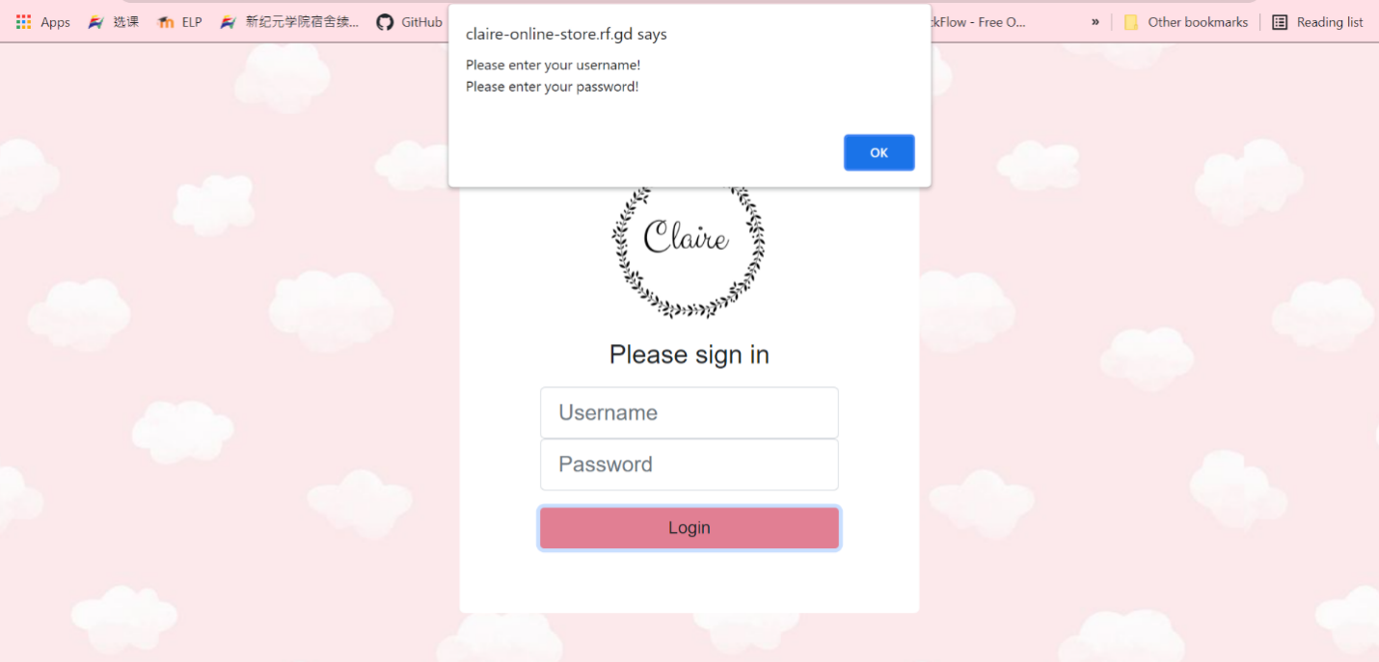

Figure 1.1: Login without fill in any fields

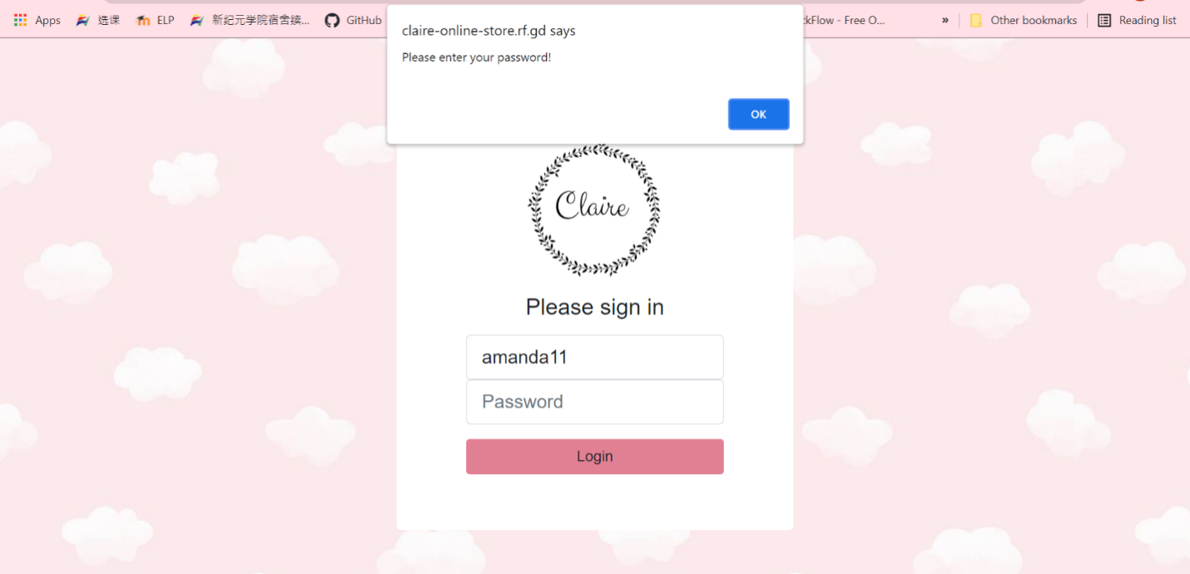

Figure 1.2: Login without password

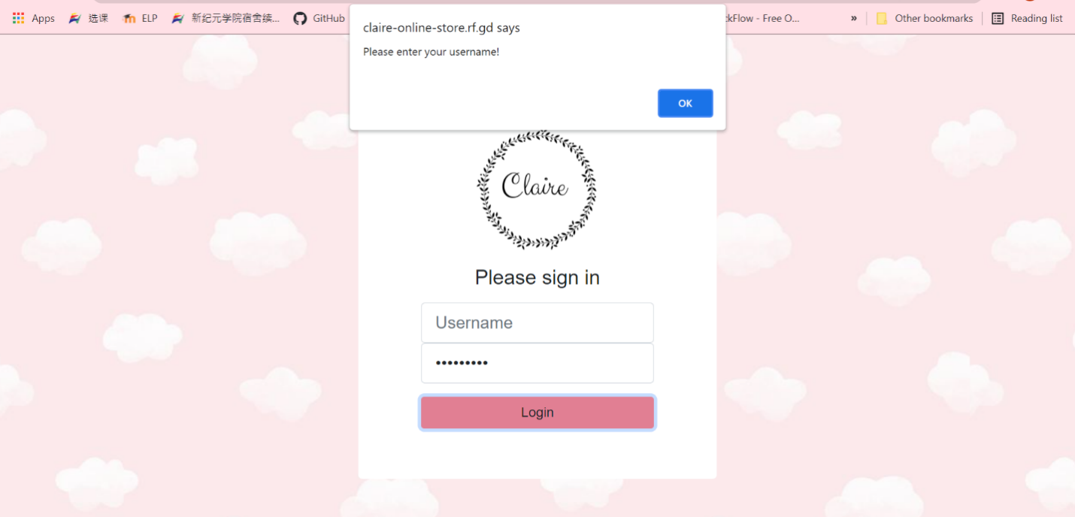

Figure 1.3: Login without username

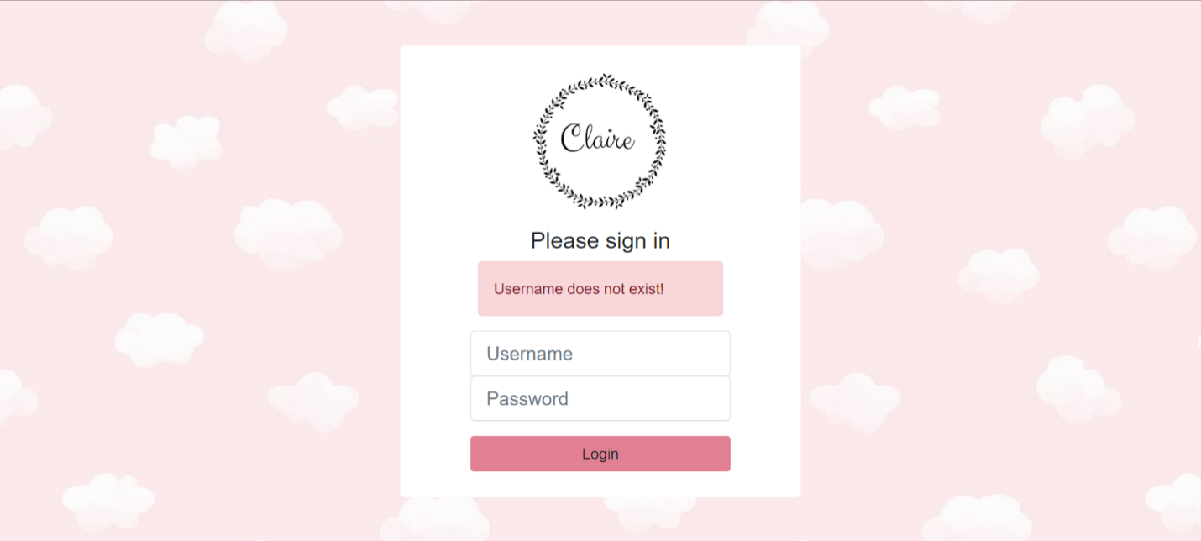

Figure 1.4: Login with a not existing account

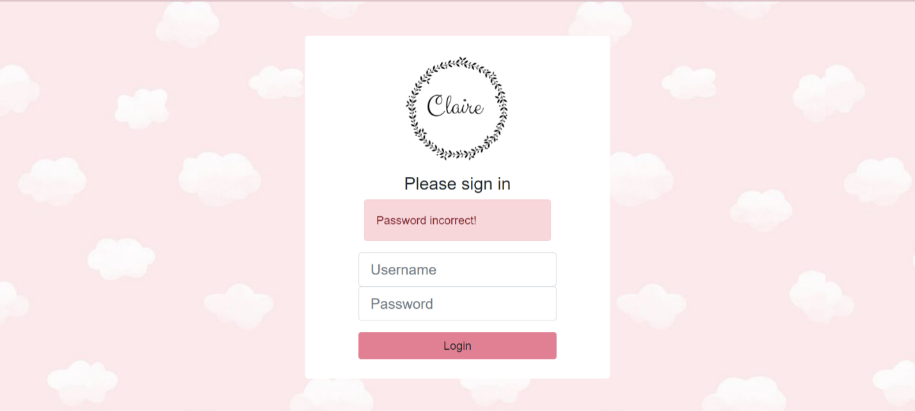

Figure 1.5: Login with an exist account but wrong password

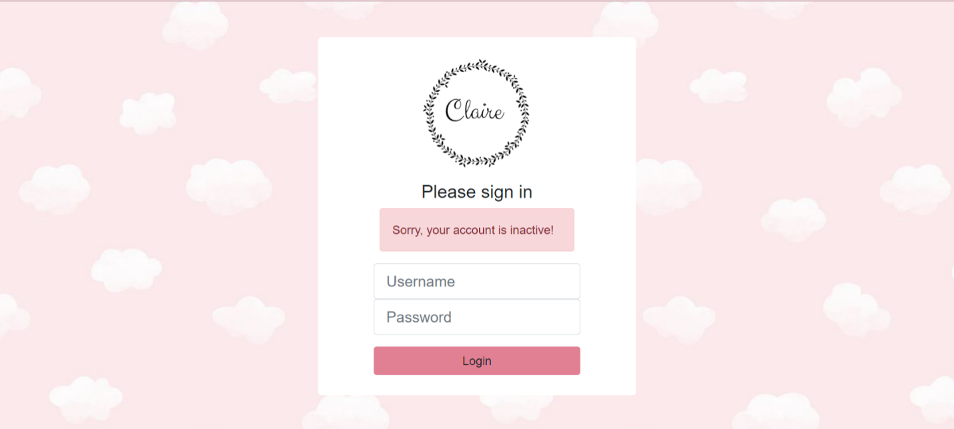

Figure 1.6: Login with a not active account

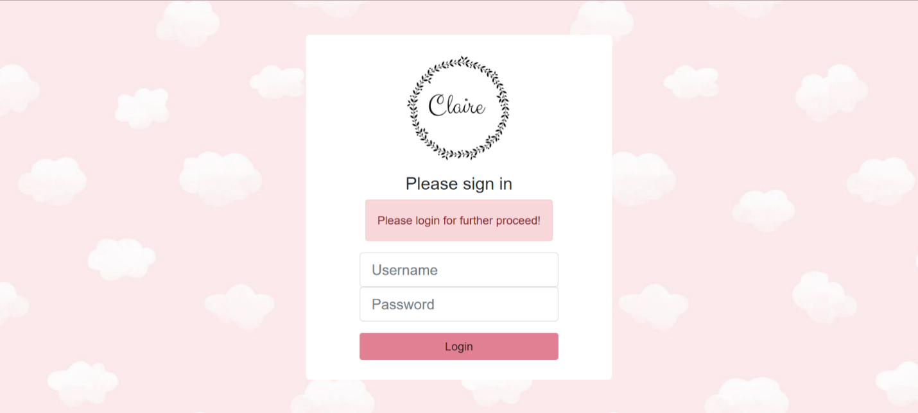

Figure 1.7: Try to access another page without login

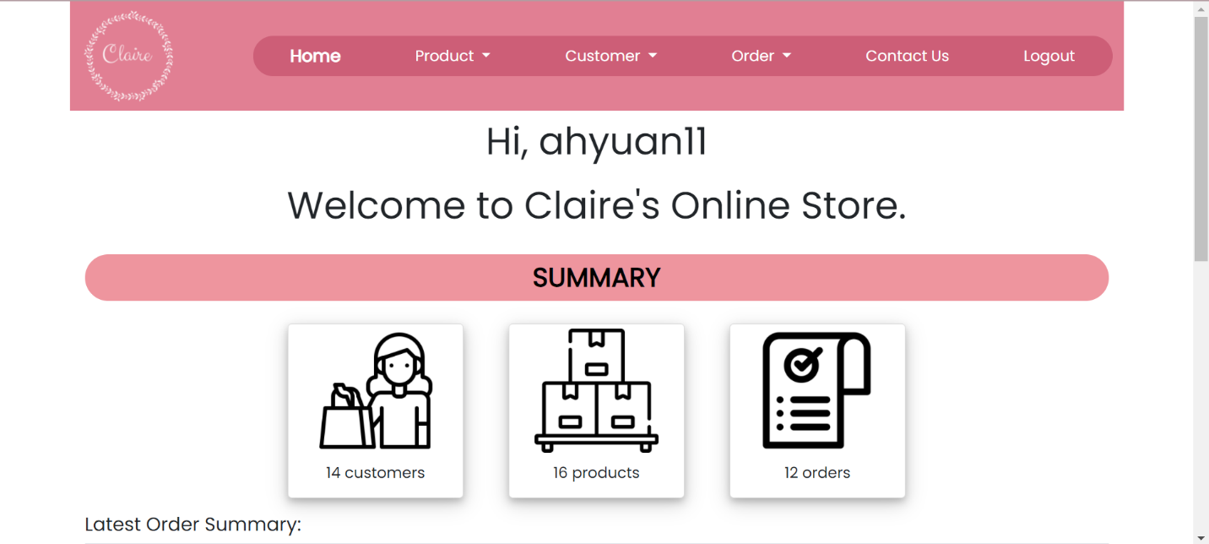

Figure 1.8: Home Page (Dashboard)

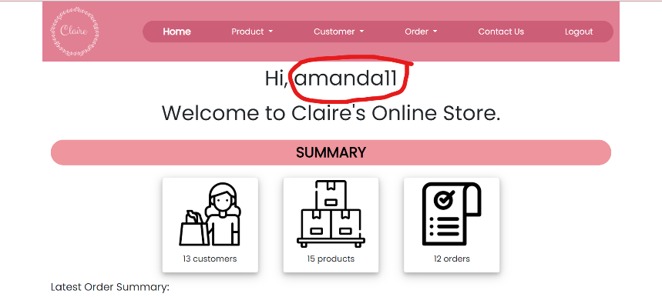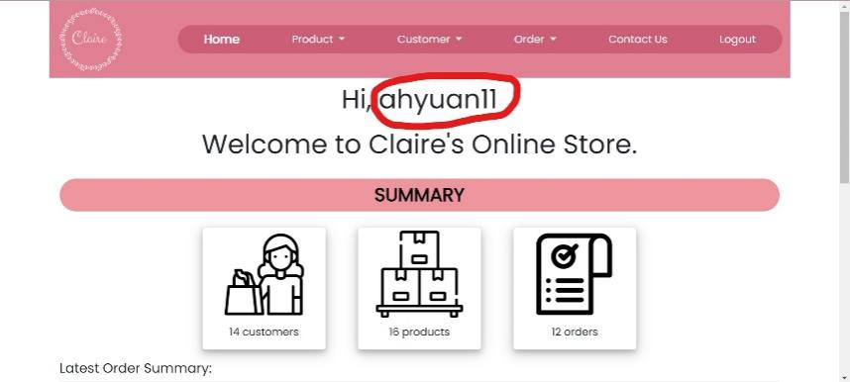

Figure 2.2: Username changed from **amanda11** to **ahyuan11**

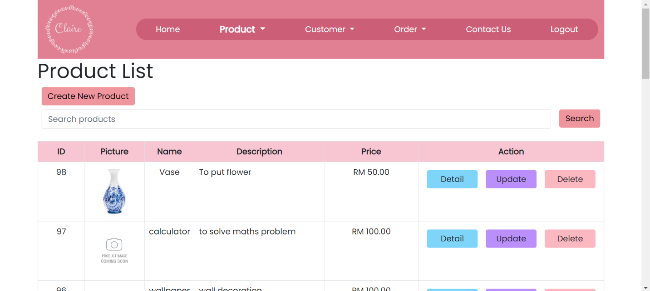

Figure 2.3: Product list page

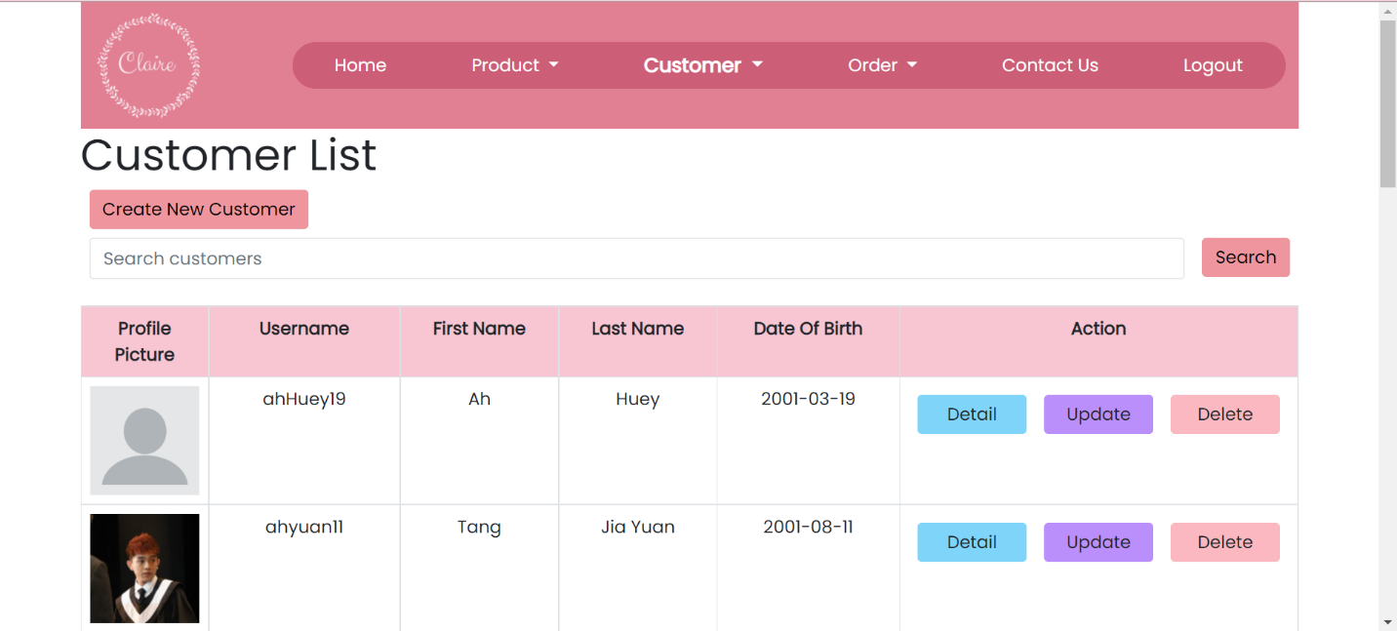

Figure 2.4: Customer list page

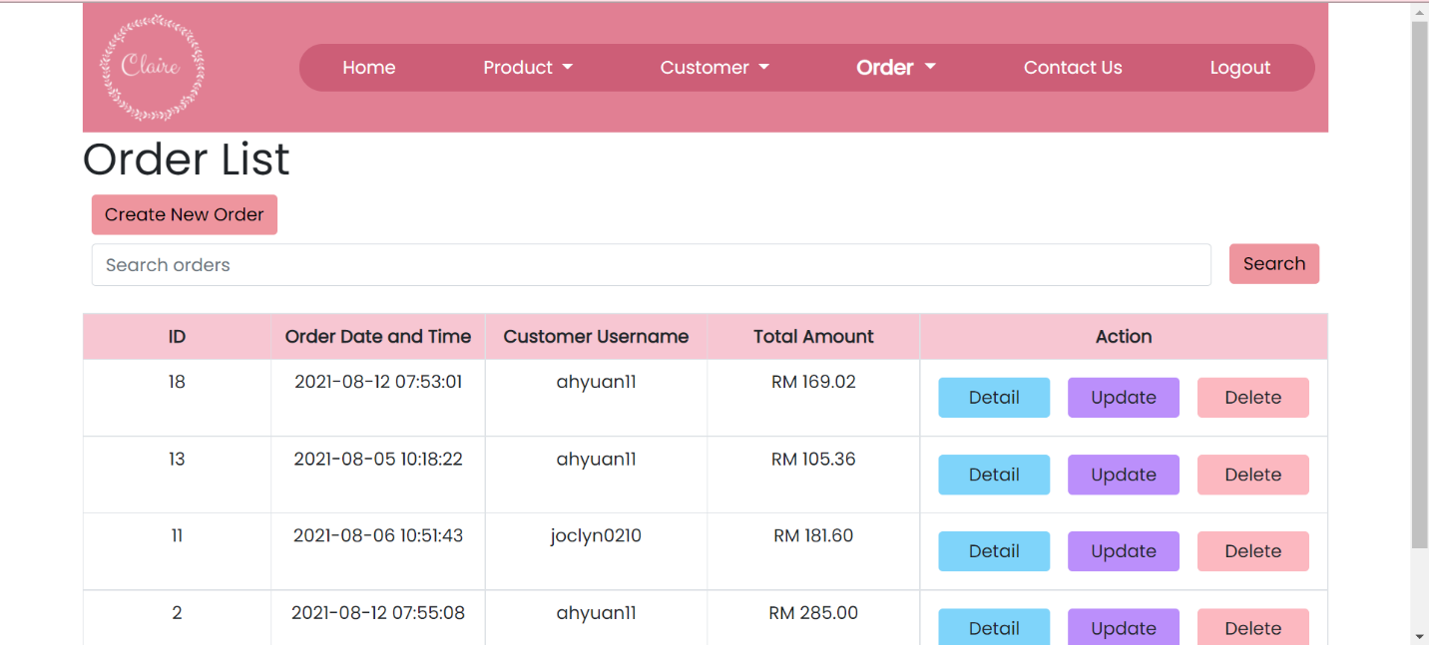

Figure 2.5: Order list page

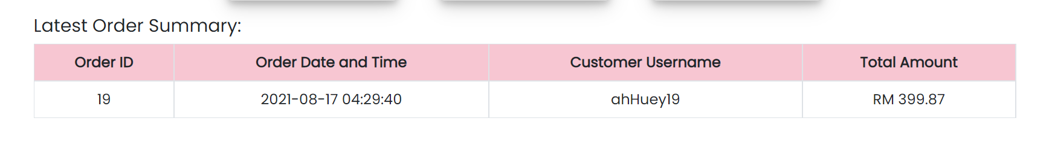

Figure 2.6: Latest order summary

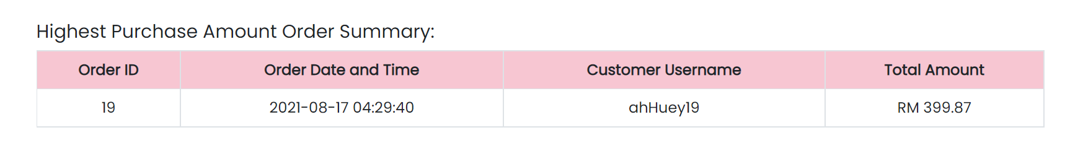

Figure 2.7: Highest purchase amount order summary

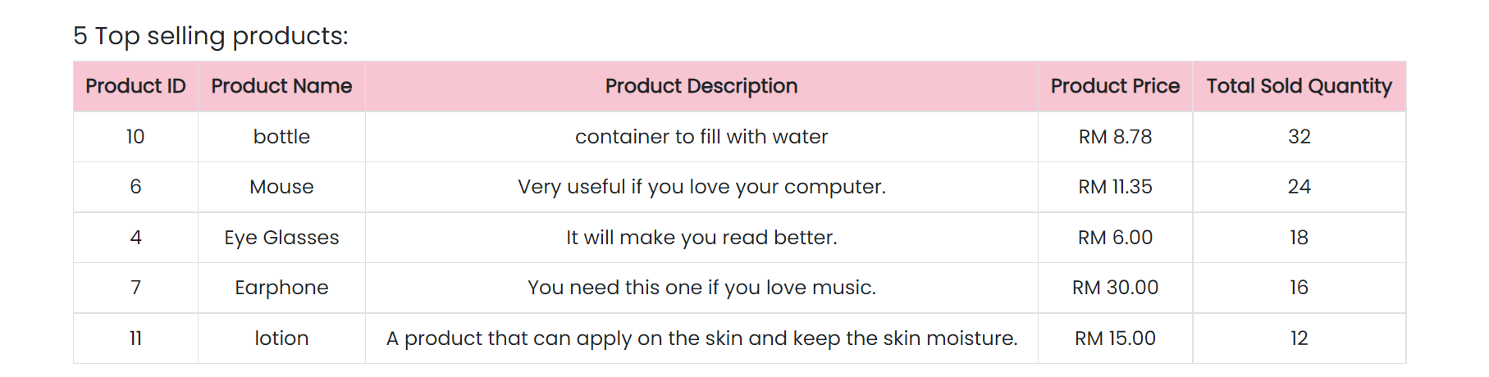

Figure 2.8: 5 top selling products

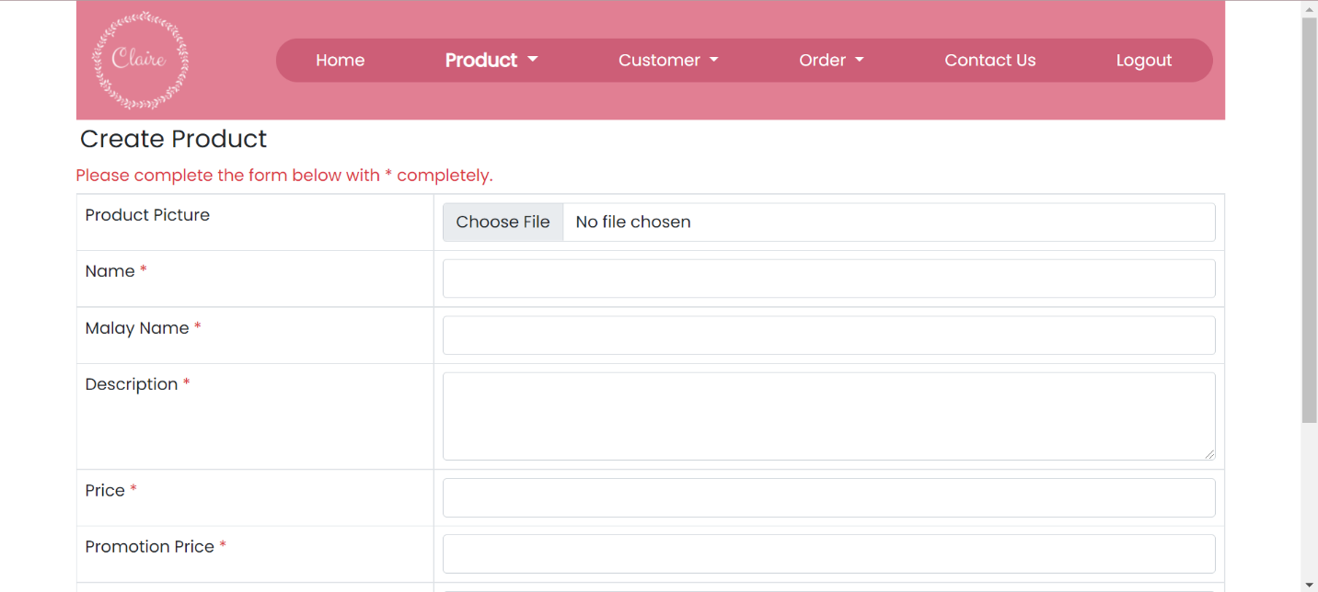

Figure 3.1: Create product page

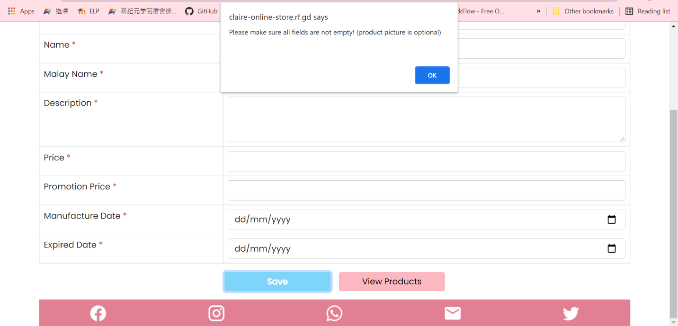

Figure 3.2: Create Product Page without fill in any fields

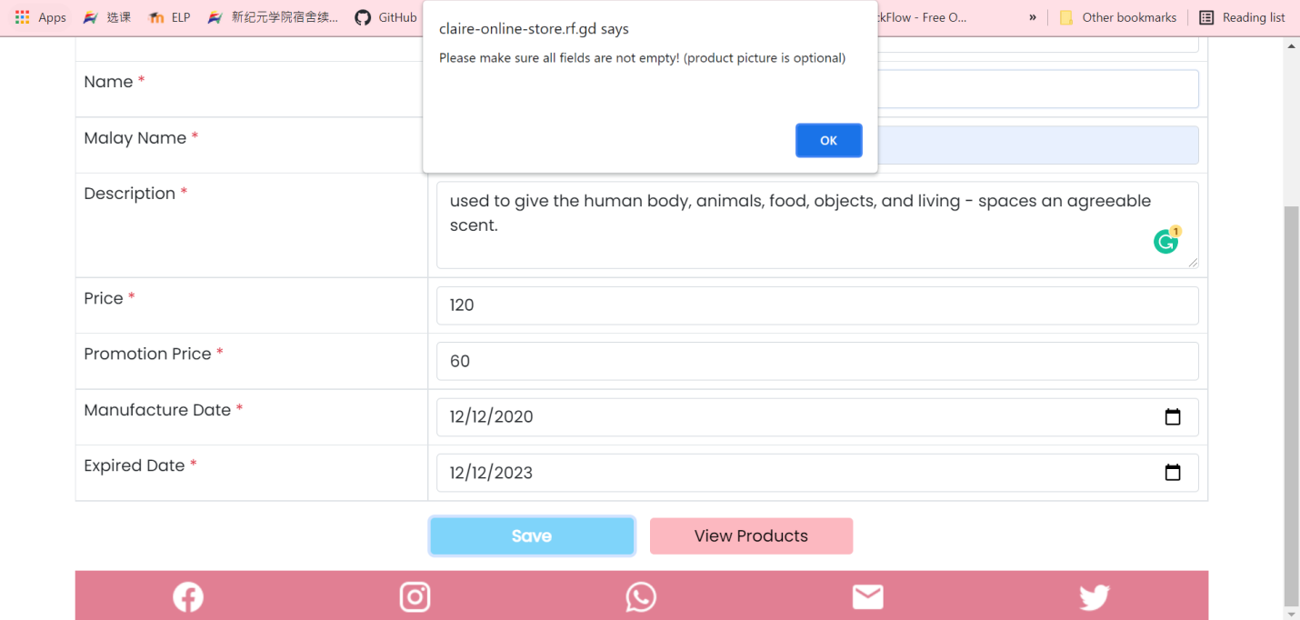

Figure 3.3: Create Product Page without fill in all fields

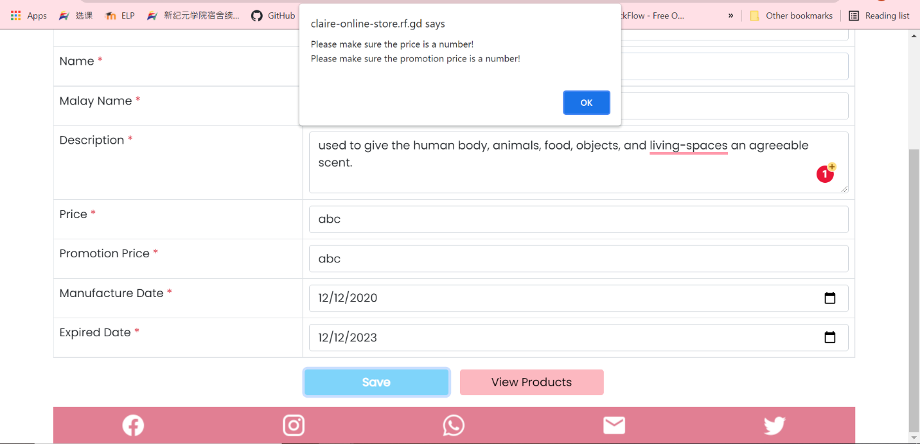

Figure 3.4: Insert a non-number character into price or promotion price field

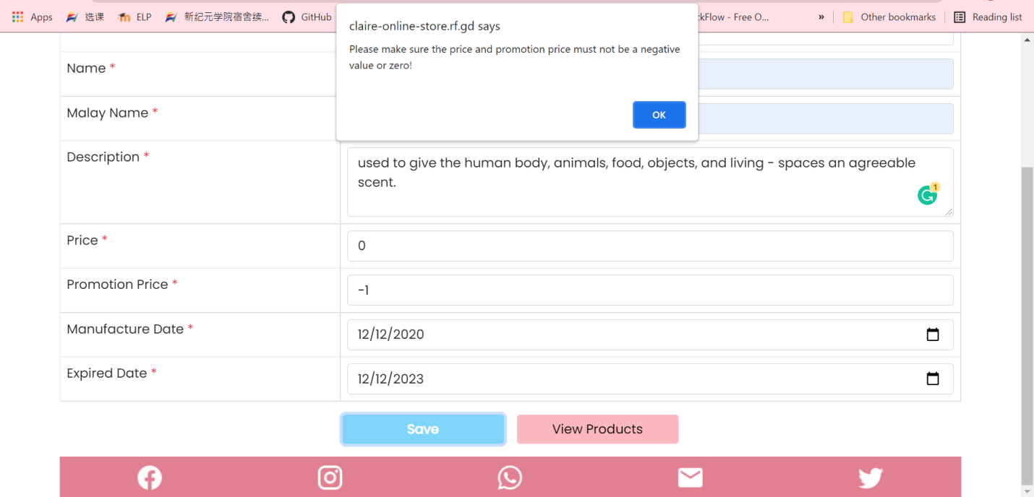

Figure 3.5: Insert a number which is equals to 0 or smaller than 0 in price or promotion price field.

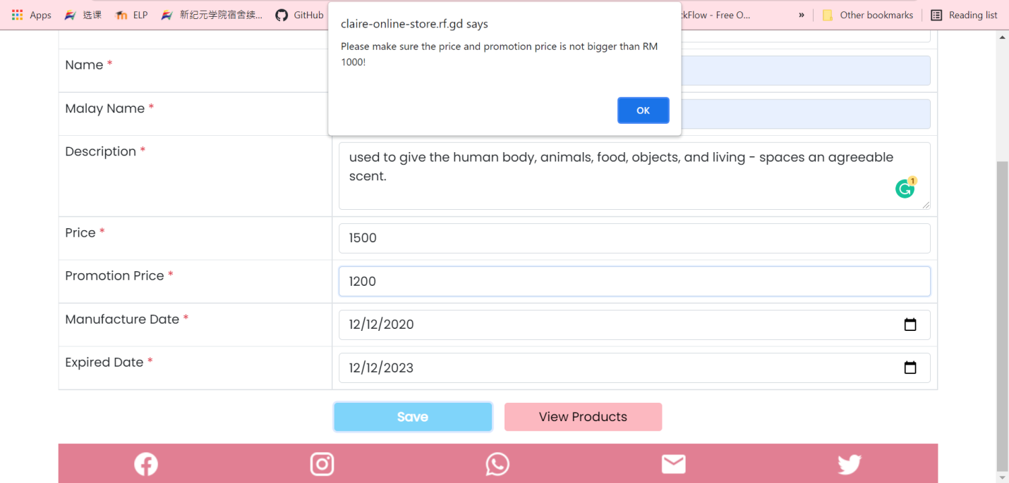

Figure 3.6: Create product with price and promotion price larger than 1000.

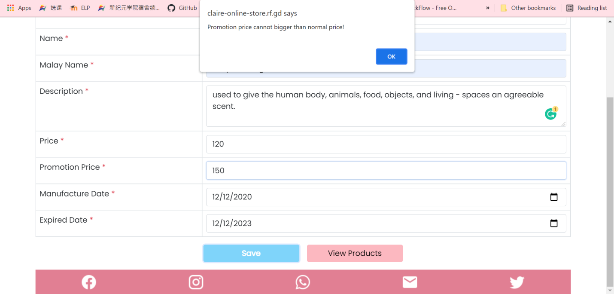

Figure 3.7: When price smaller than promotion price

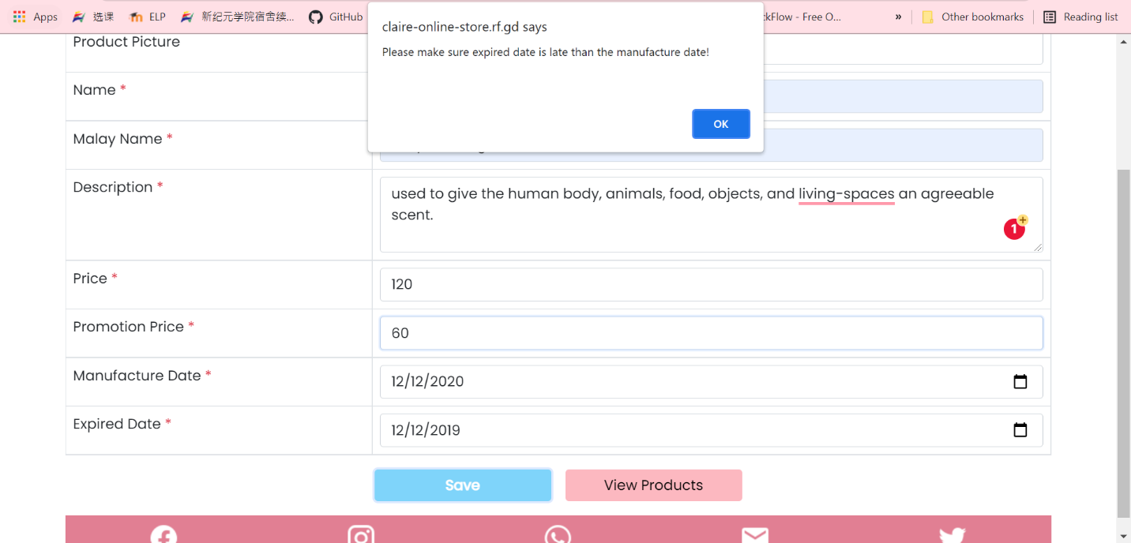

Figure 3.8: Insert expired date earlier than manufacture date

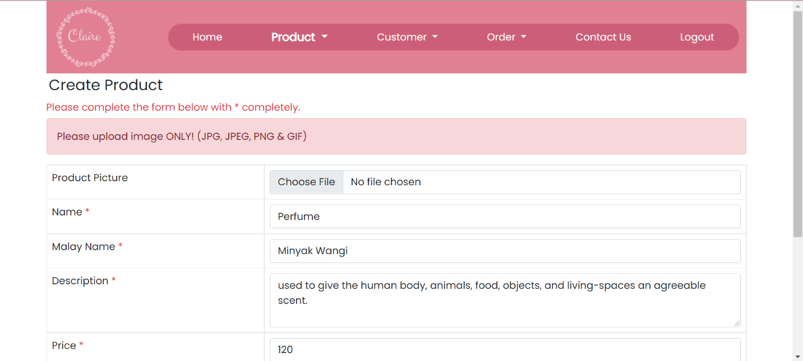

Figure 3.9: Upload a non-image file into product image

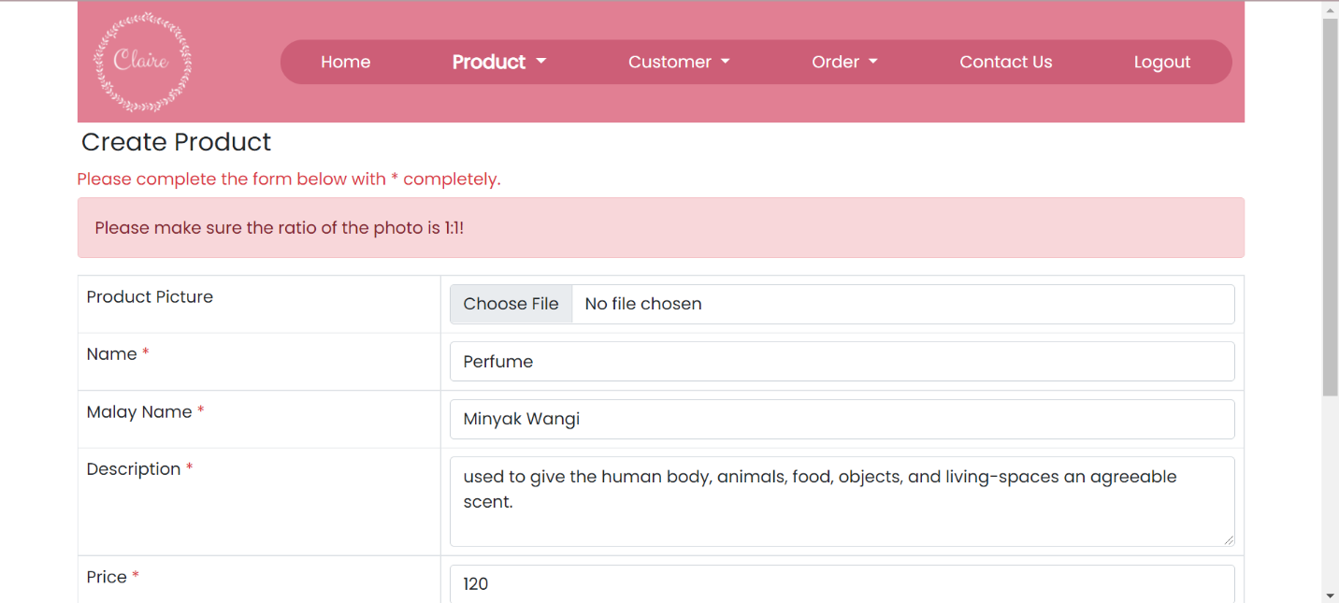

Figure 3.10: Upload an image in product image which is not in square size or 1:1 ratio

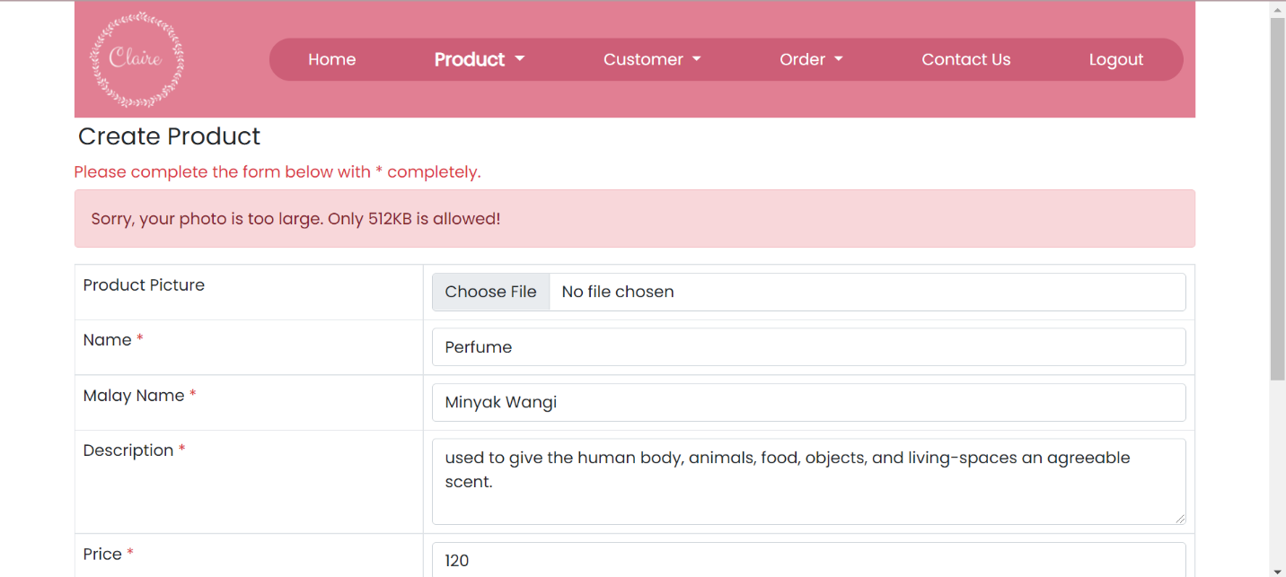

Figure 3.11: Upload an image which the size larger than 512KB

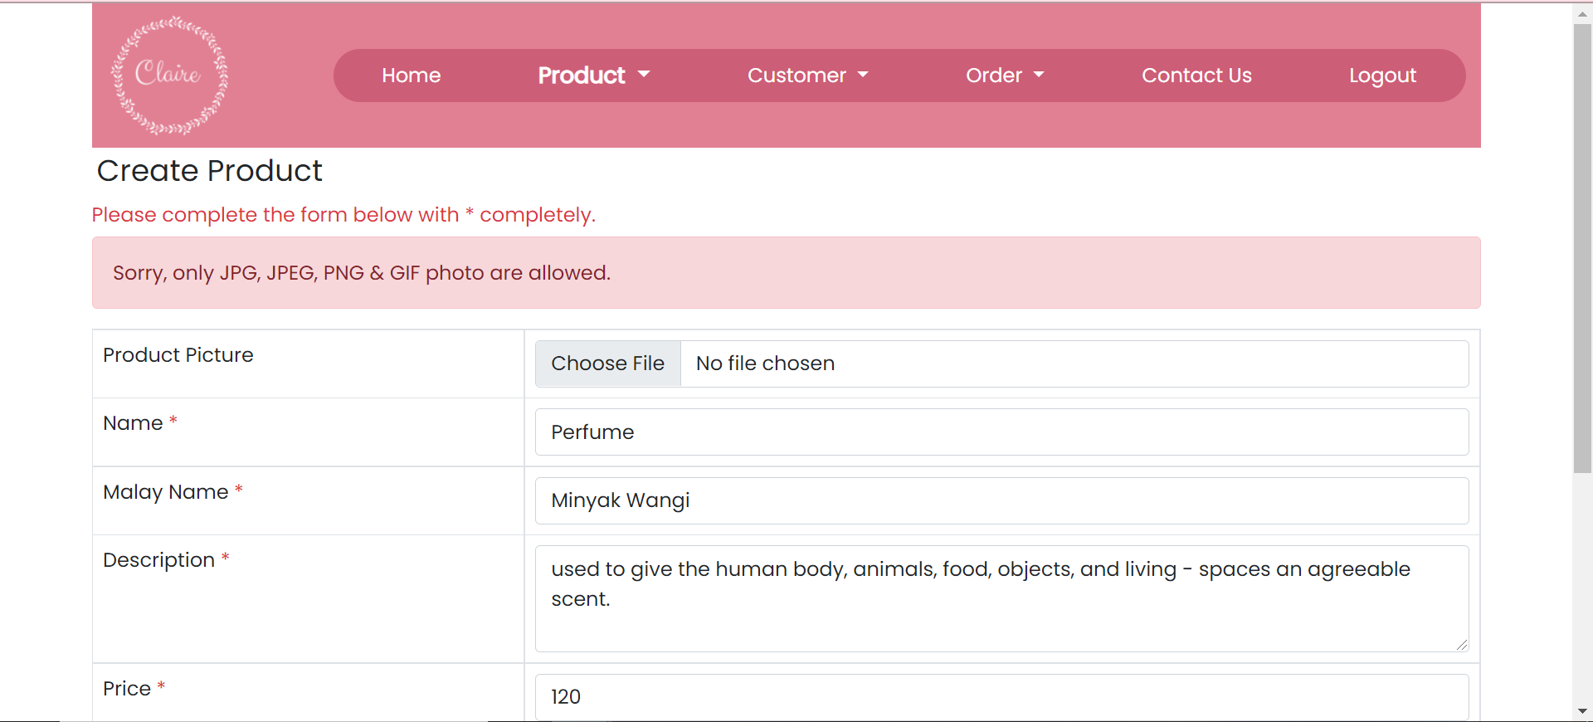

Figure 3.12: Upload an image in product image which is not in JPG, JPEG, PNG & GIF files.

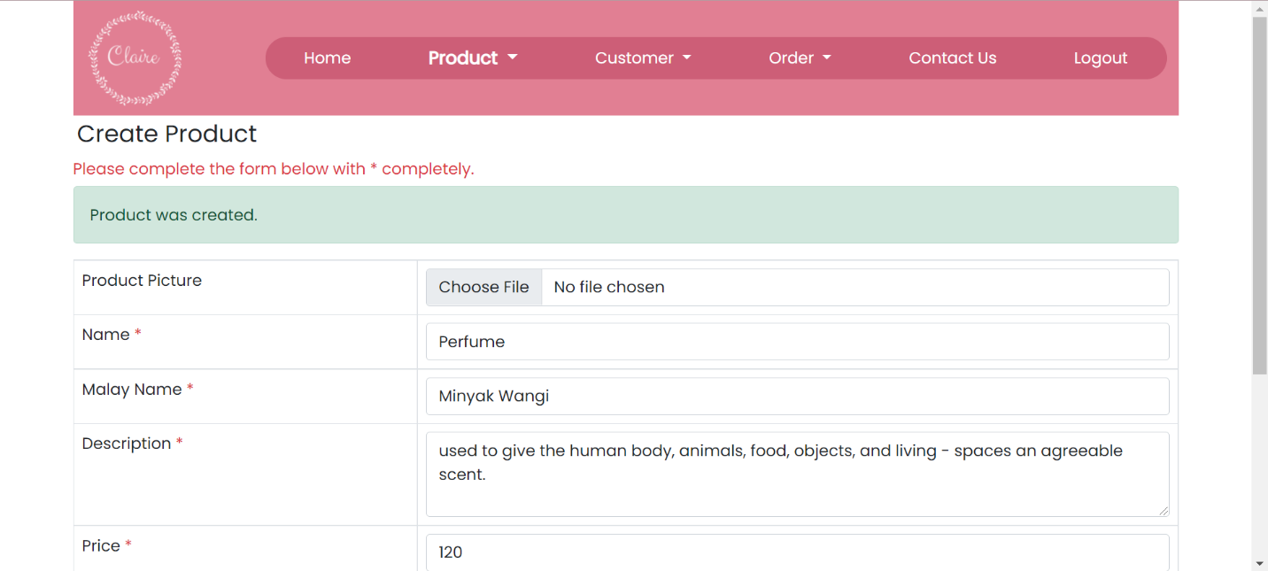

Figure 3.13: New product is created

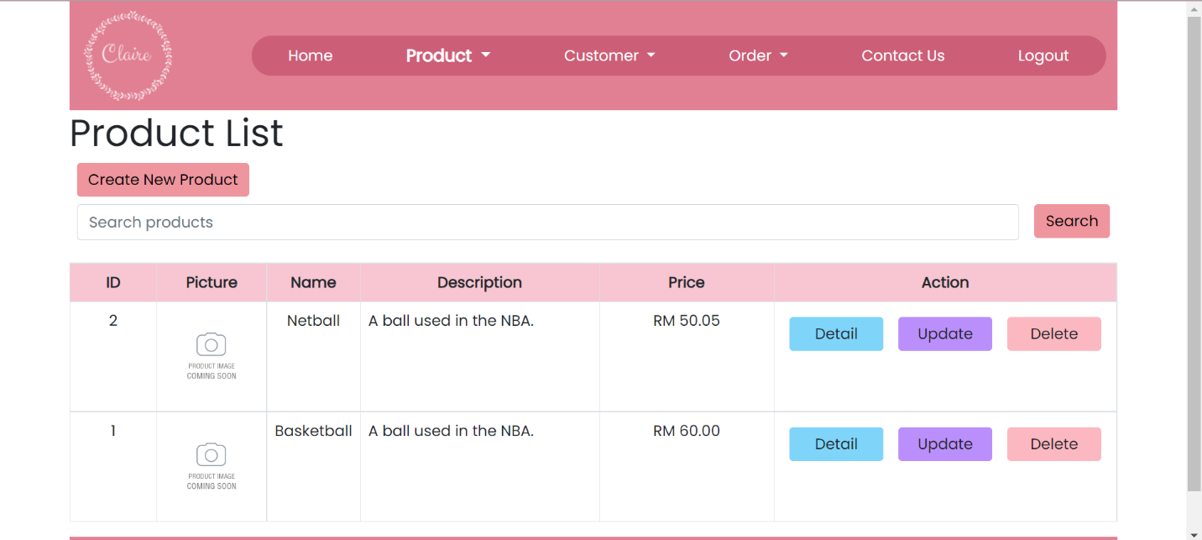

Figure 4.3: Search product by using the existing product name

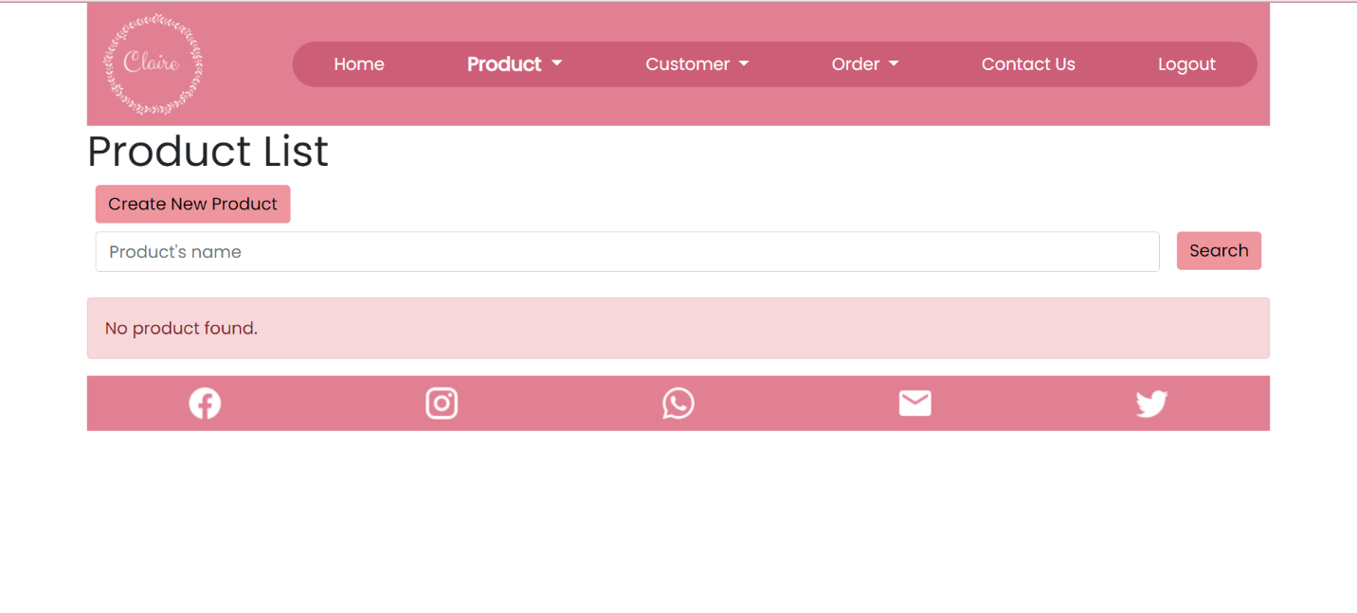

Figure 4.4: Search product by using the not existing product name

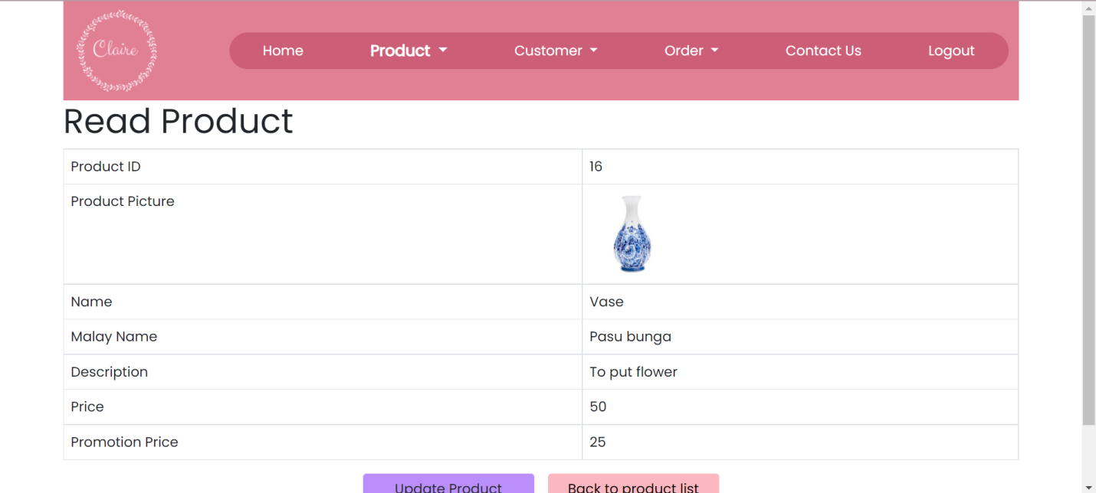

Figure 4.5: Product’s detail page (Product ID 16)

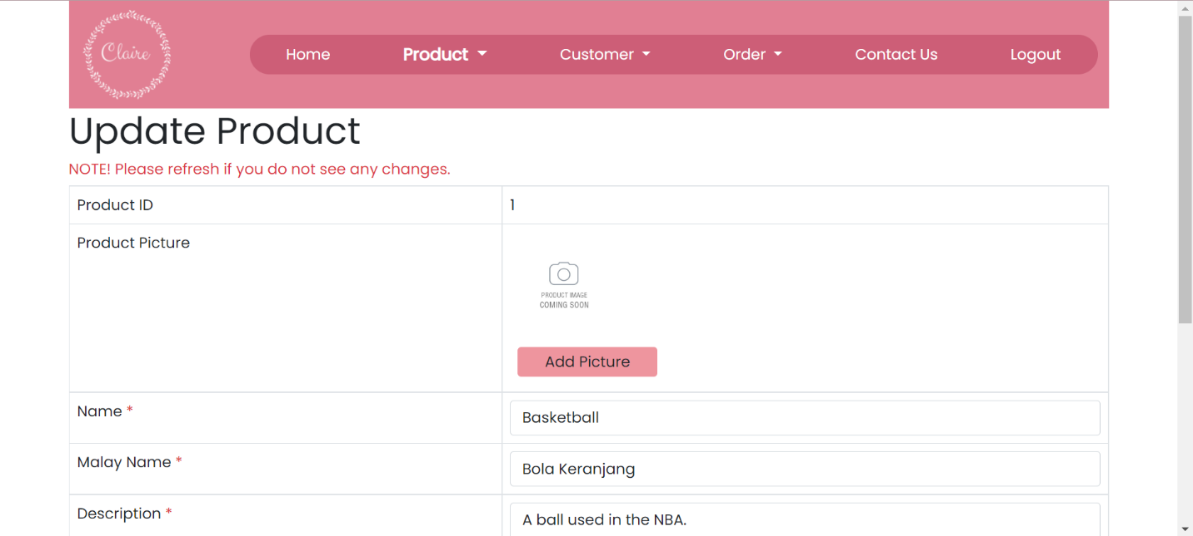

Figure 4.6: Direct to Update Product Page (Product ID 1)

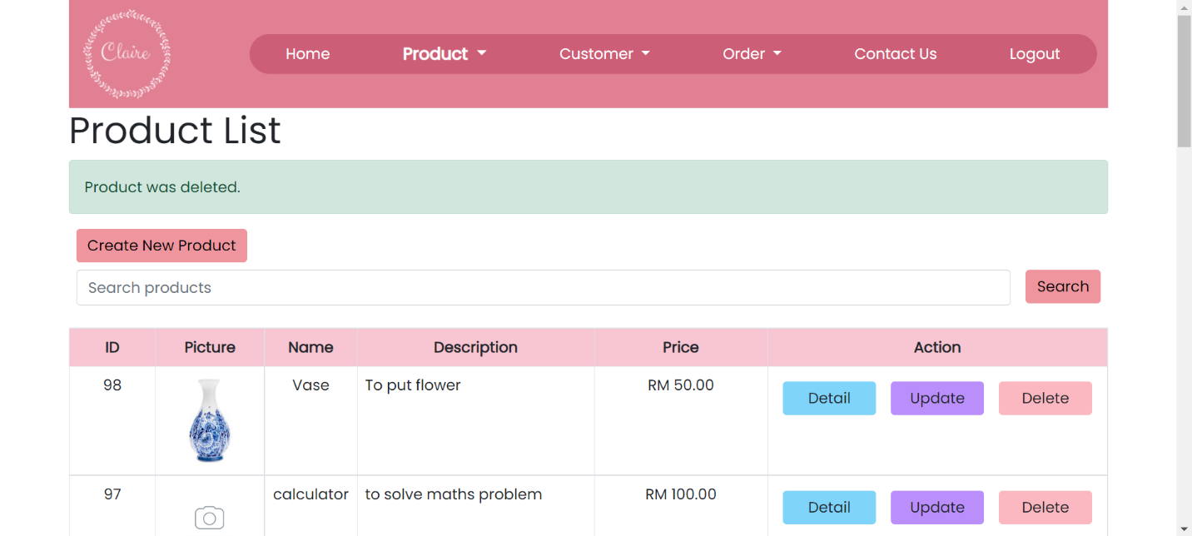

Figure 4.7: Delete certain product in Product List Page (product not in any order)

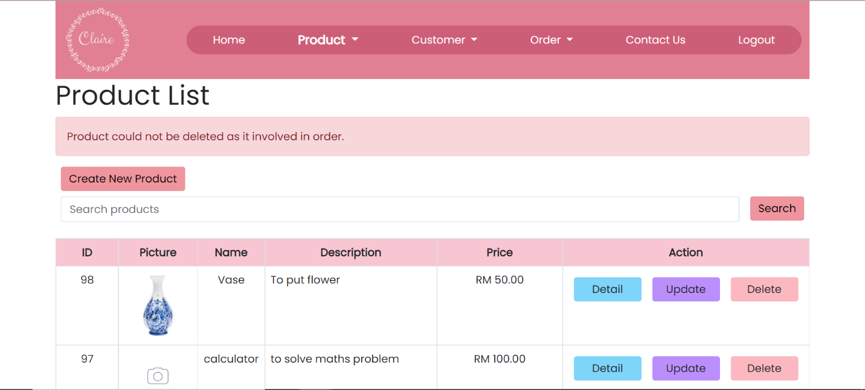

Figure 4.8: Delete certain product in Product List Page (product in at least one order)

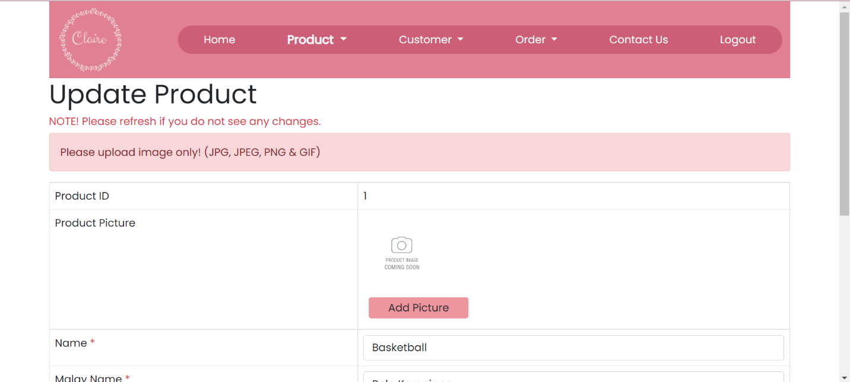

Figure 6.1: Upload a non-image photo into the product picture field

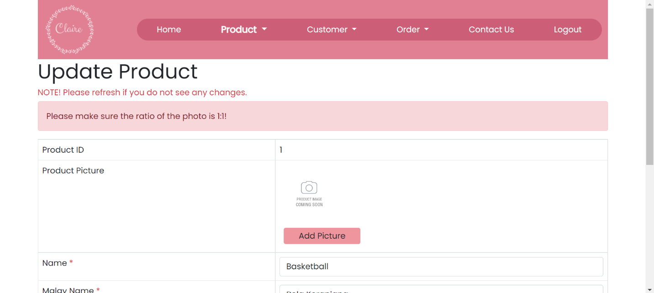

Figure 6.2: Upload an image in product image which is not in a square size or not in 1:1 ratio.

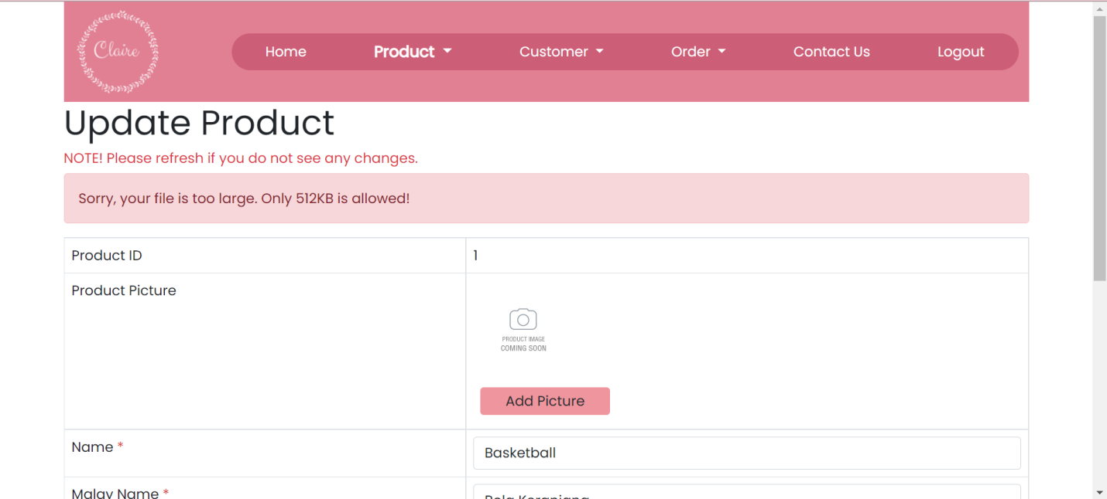

Figure 6.3: Upload an image in product image which the size larger than 512KB

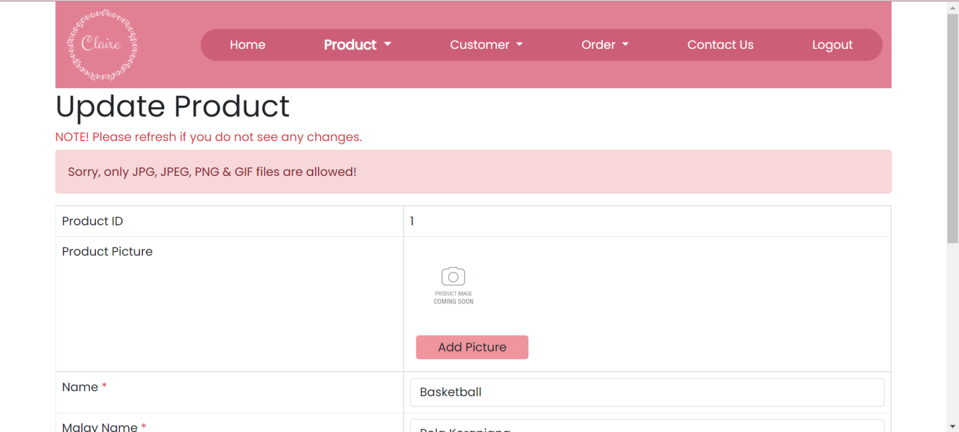

Figure 6.4: image uploaded is not in JPG, JPEG, PNG and GIF file

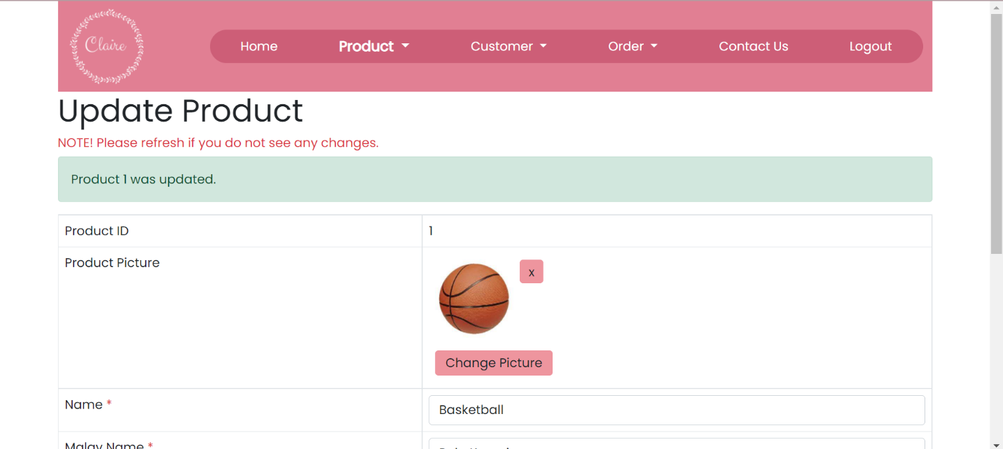

Figure 6.5: Product detail updated

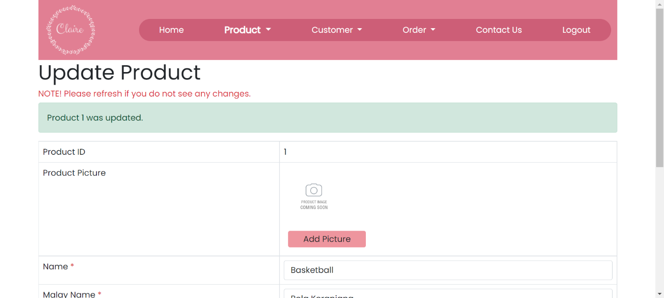

Figure 6.7: Delete existing image in Update Product Page

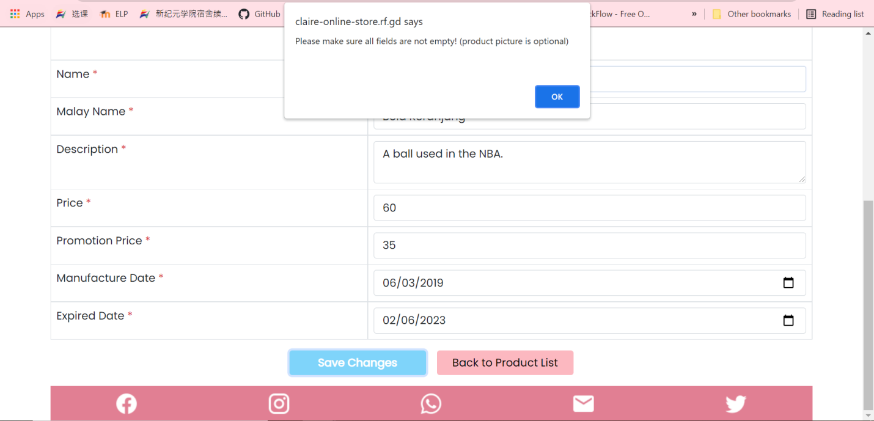

Figure 6.8: Save the Update Product Page without fill in all fields

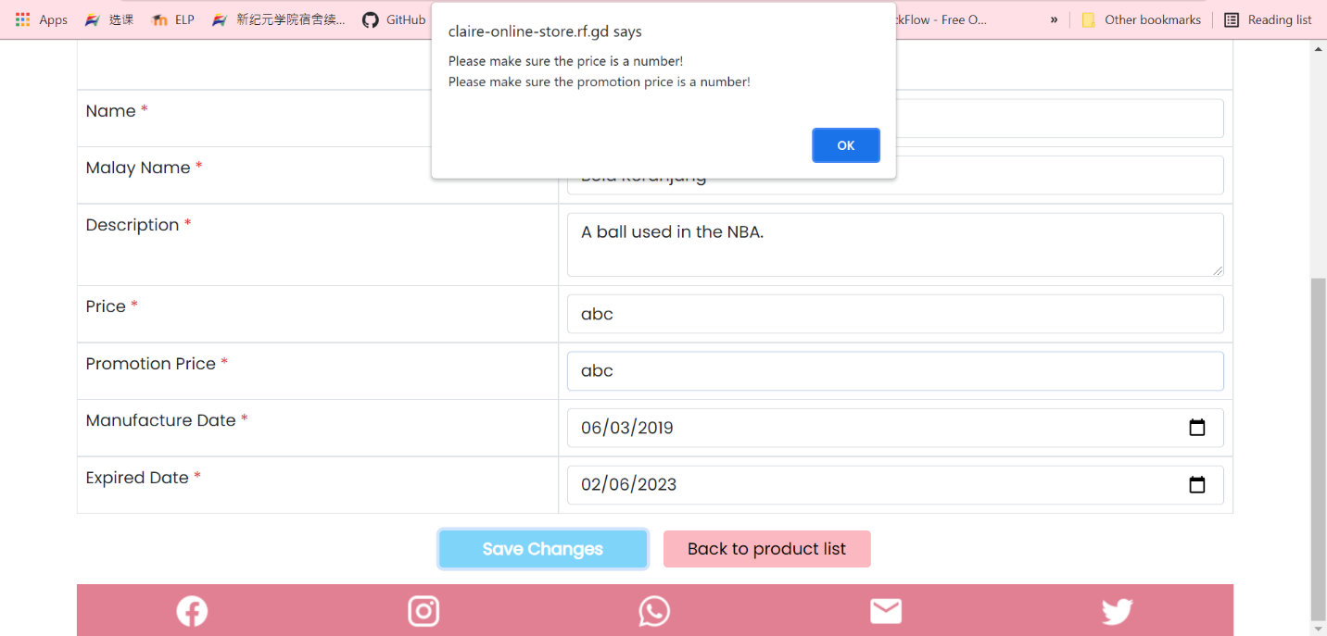

Figure 6.9: Change the price or promotion price to a non-numeric character

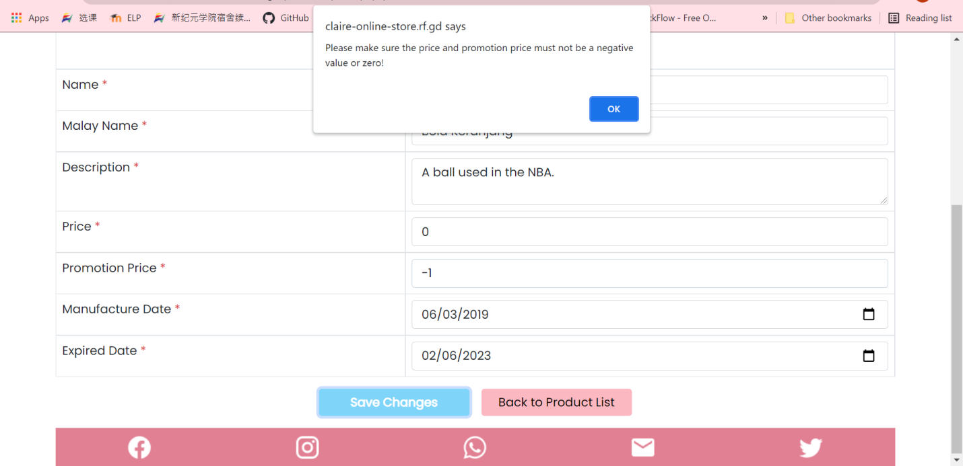

Figure 6.10: Change the price or promotion price to 0 or smaller than 0

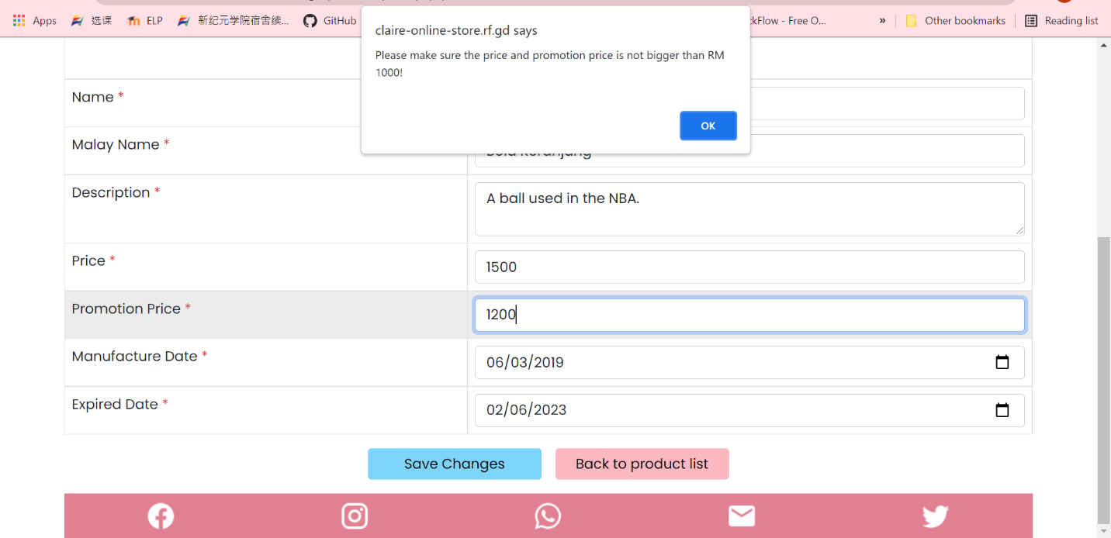

Figure 6.11: Change the price or promotion price to a number bigger than 1000

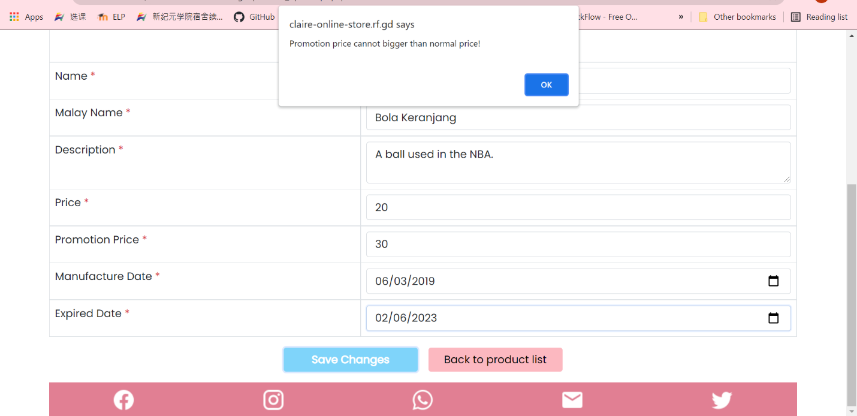

Figure 6.12: Change the price become smaller than promotion price

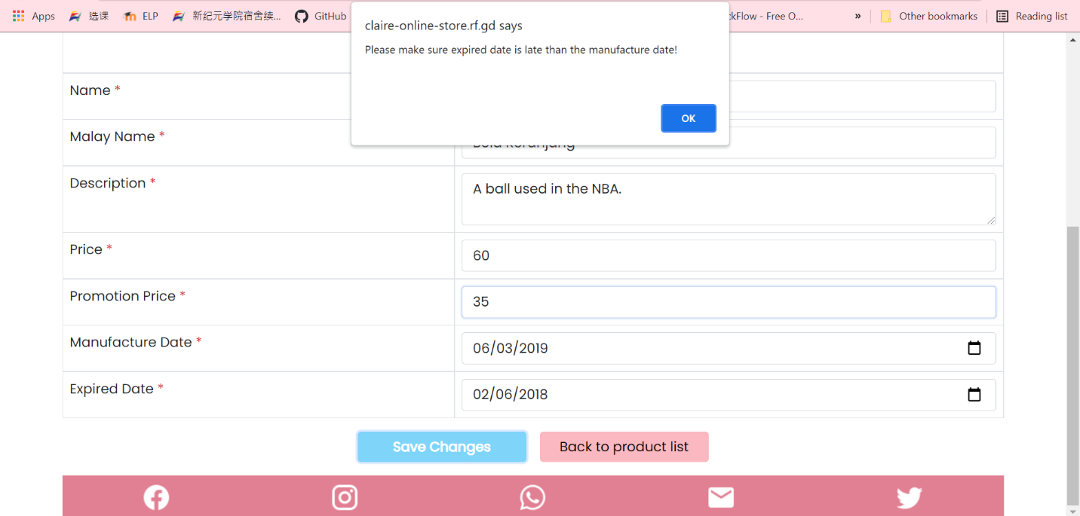

Figure 6.13: Change the expired date become earlier than manufacture date

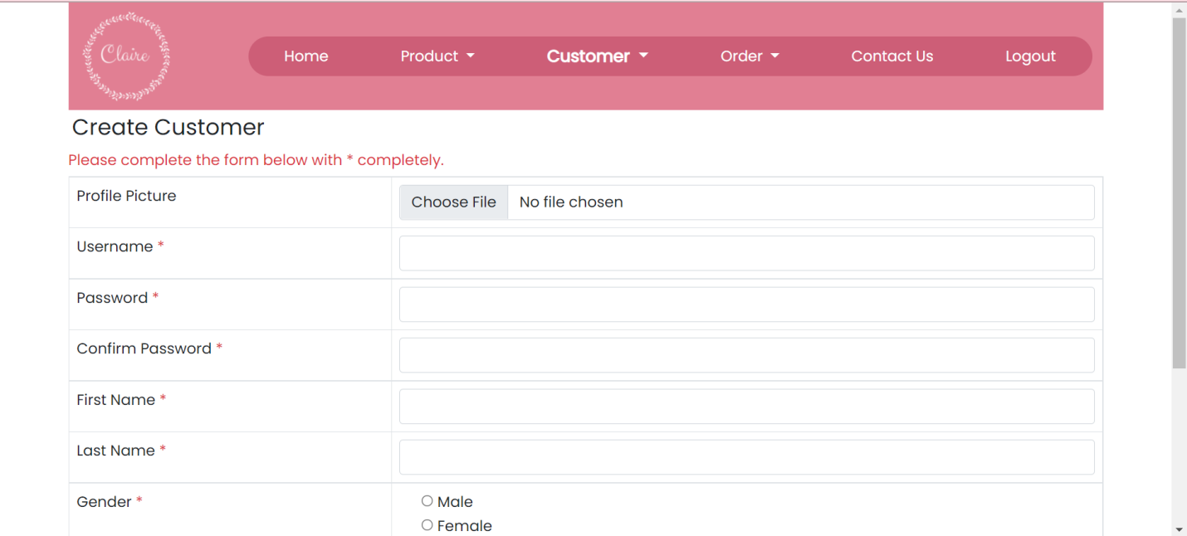

Figure 7.1: Create customer page

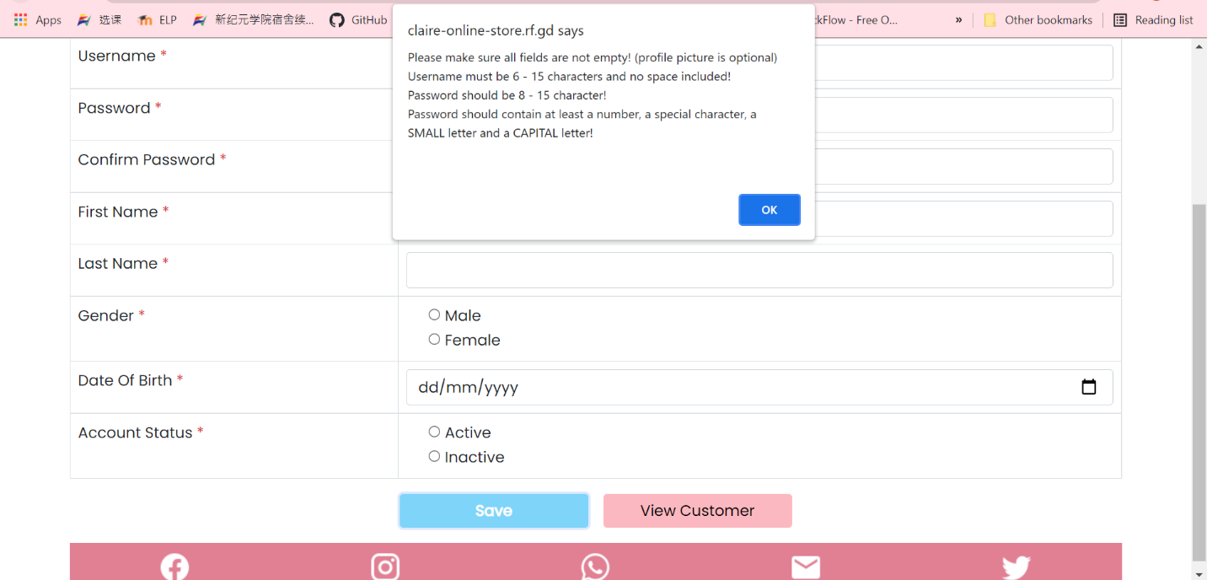

Figure 7.2: Create a customer without fill in any fields

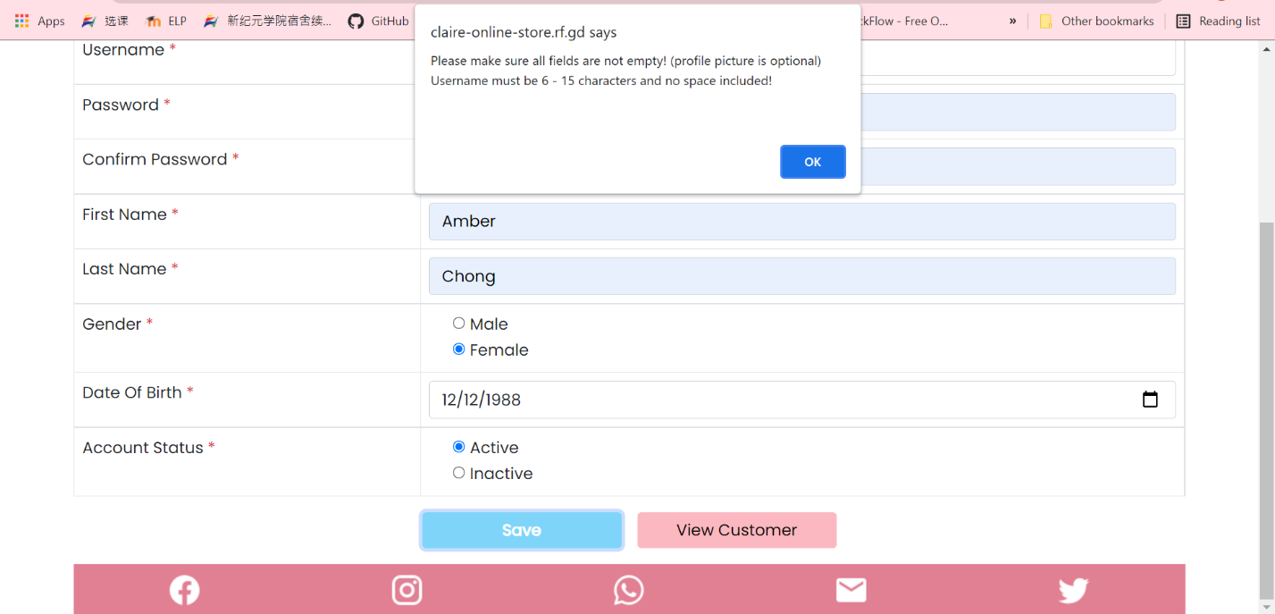

Figure 7.3: Create a customer without fill in all fields

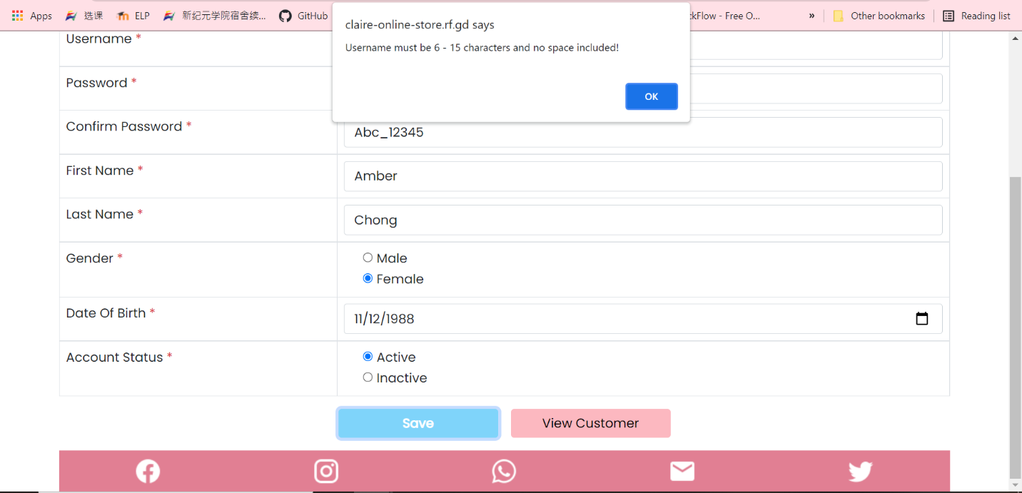

Figure 7.4: Create a customer with a username less than 6 character, has space or more than 15 characters

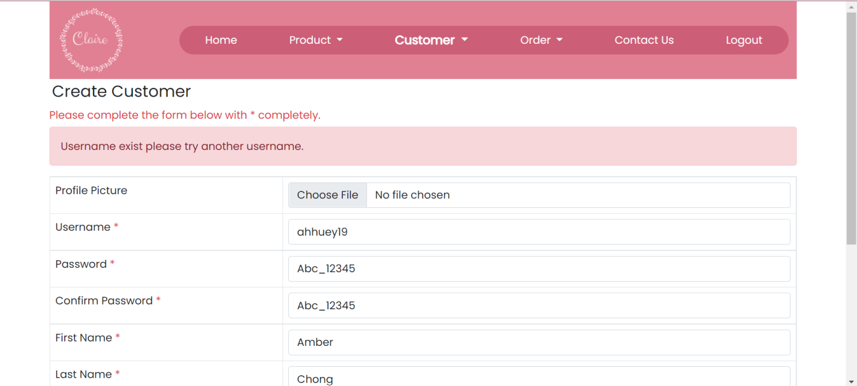

Figure 7.7: Create new customer with existing username

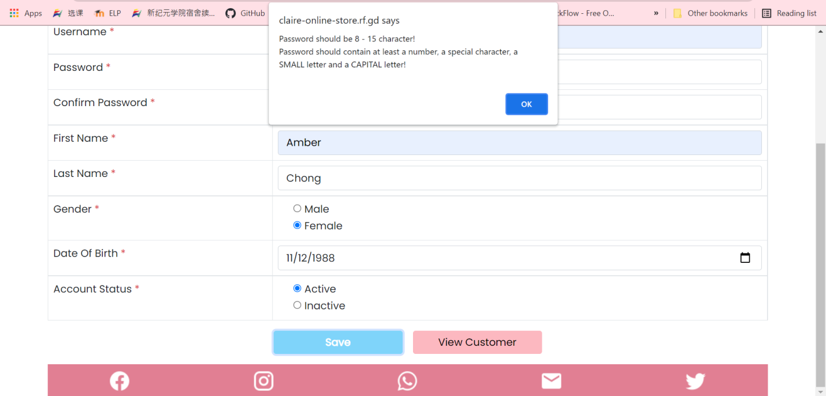

Figure 7.8: Insert password into password and confirm password field with less than 8 characters or more than 15 characters

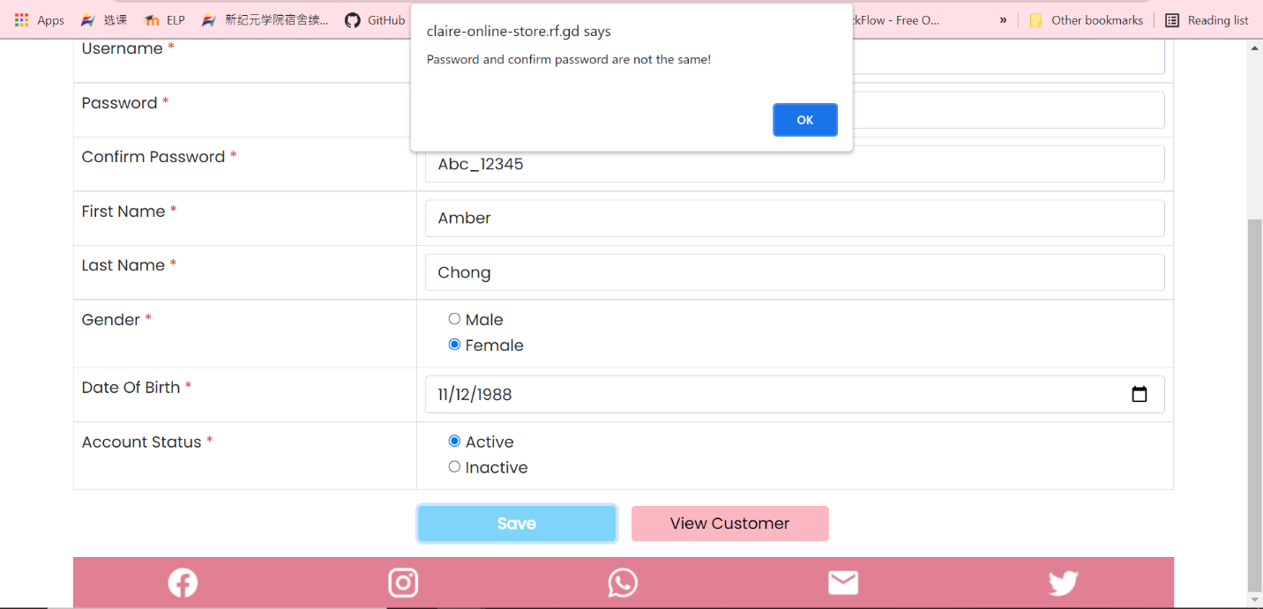

Figure 7.10: Insert a password into confirm password that is different from the password field.

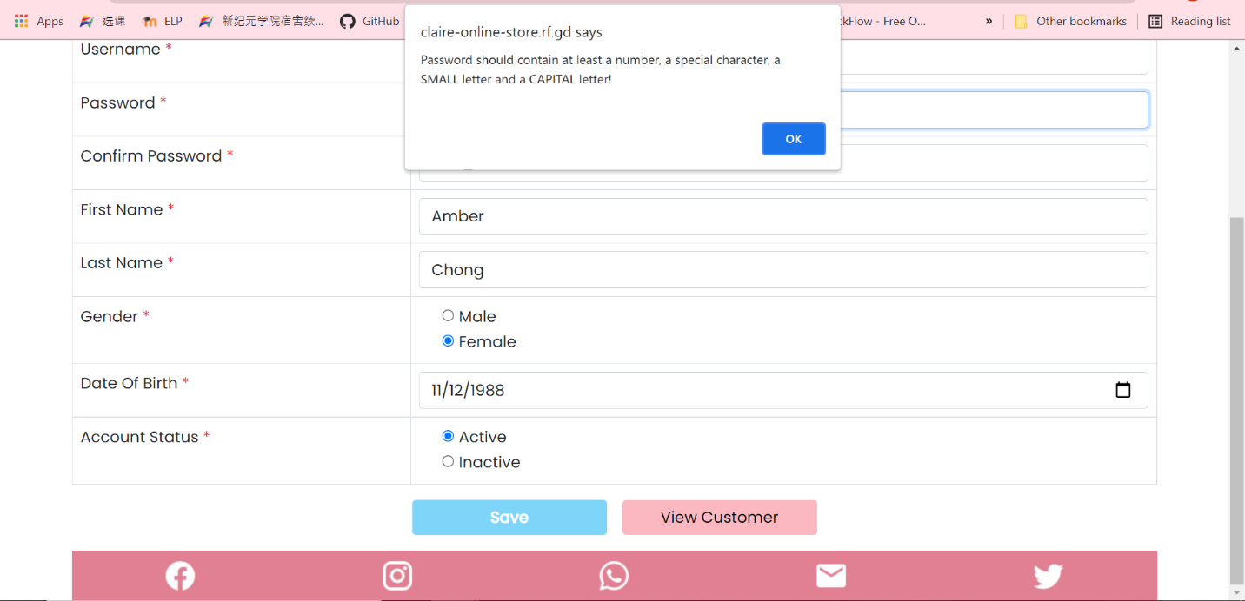

Figure 7.11: Insert a password into password and confirm password field with no uppercase letter or no lowercase letter or no number or no special character included

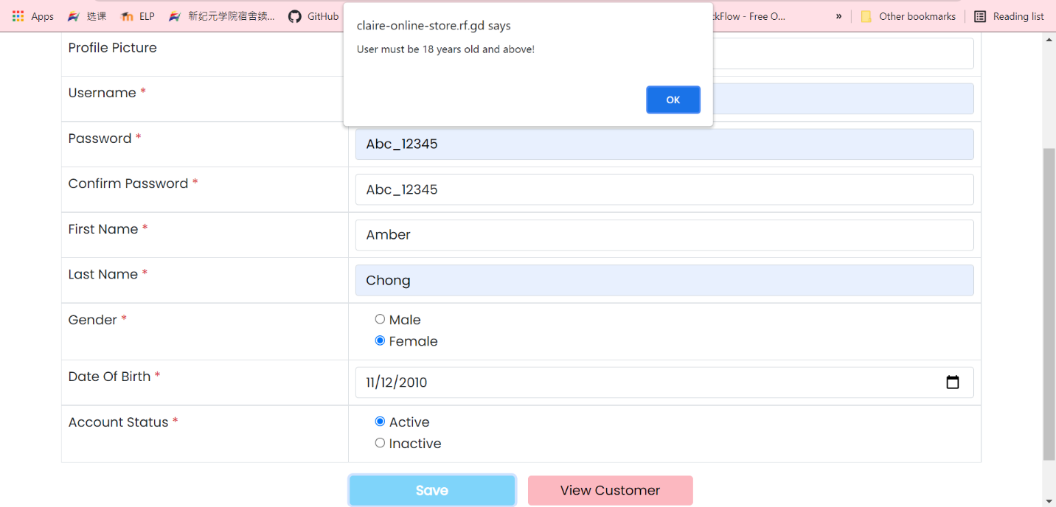

Figure 7.15: Insert a birth date which is not 18 years old and above

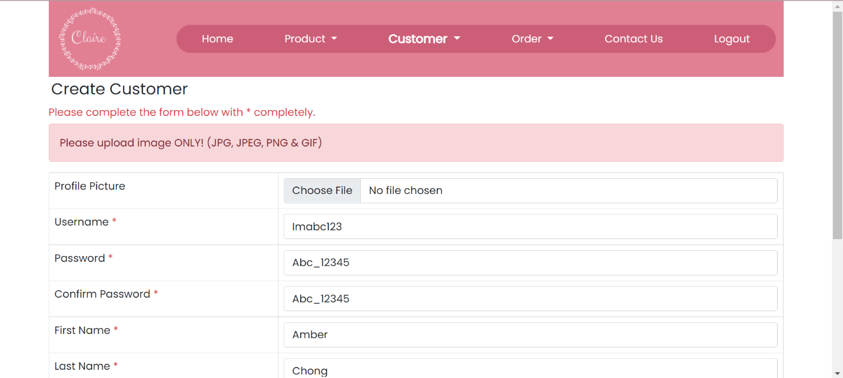

Figure 7.16: Upload a non-image photo to profile picture field

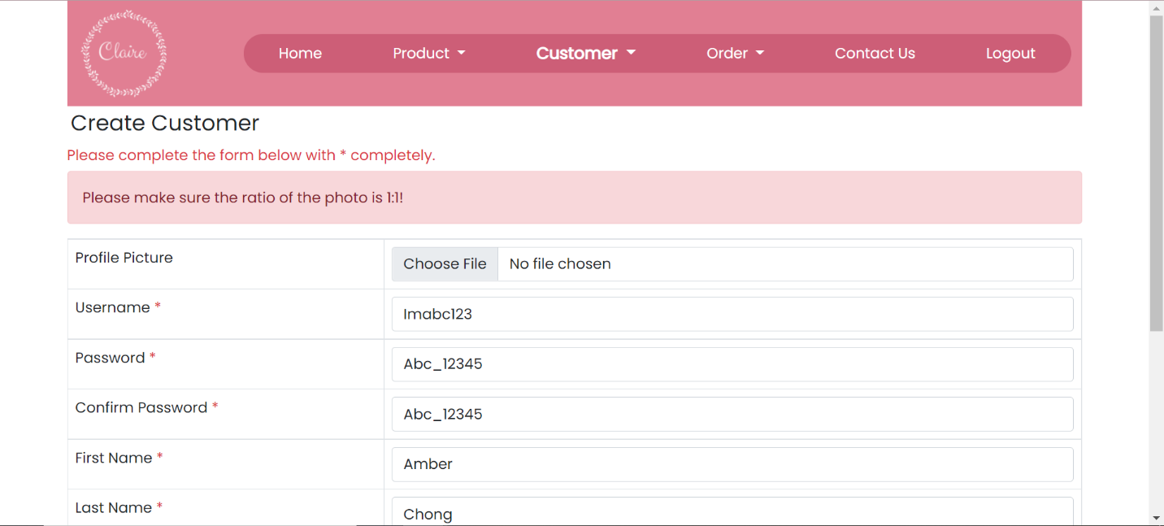

Figure 7.17: Upload an image which is not in a square size or not in 1:1 ratio.

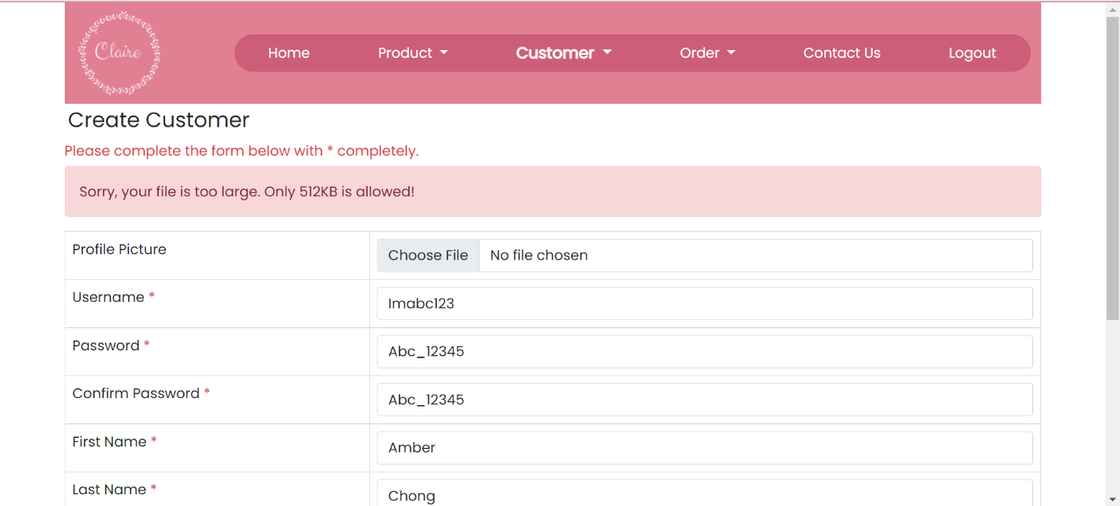

Figure 7.18: Upload an image which is larger than 512KB

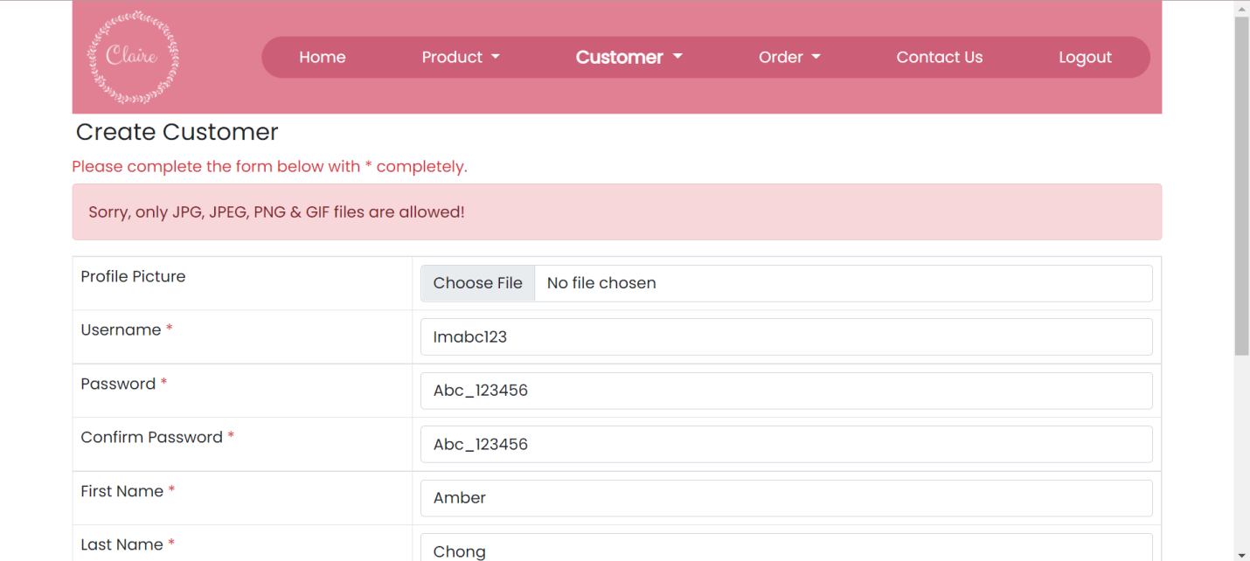

Figure 7.19: Upload an image in customer image which is not in JPG, JPEG, PNG & GIF files.

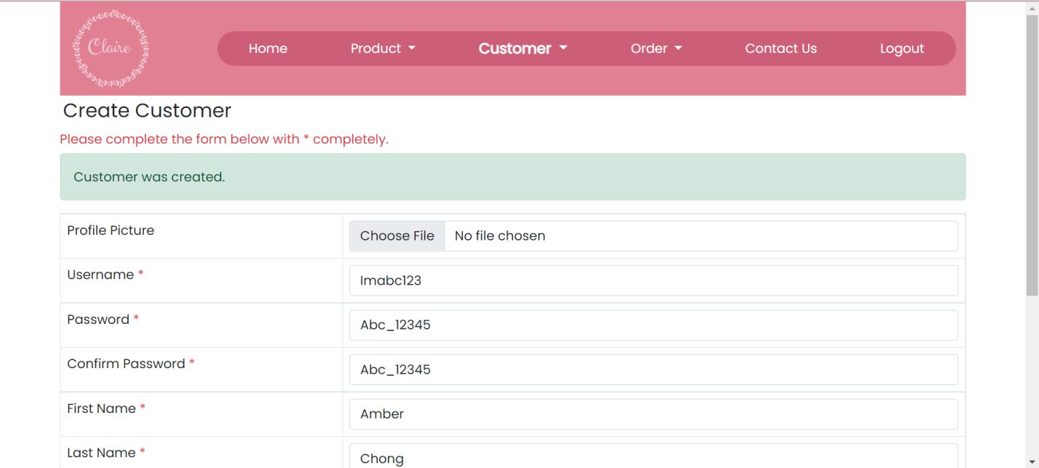

Figure 7.20: Customer was created.

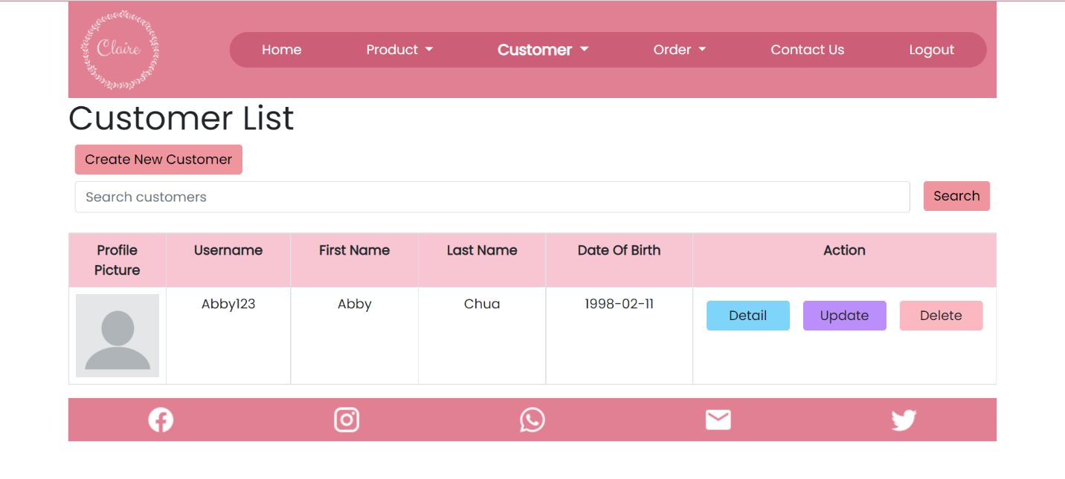

Figure 8.3: Search Customer by using the existing customer username

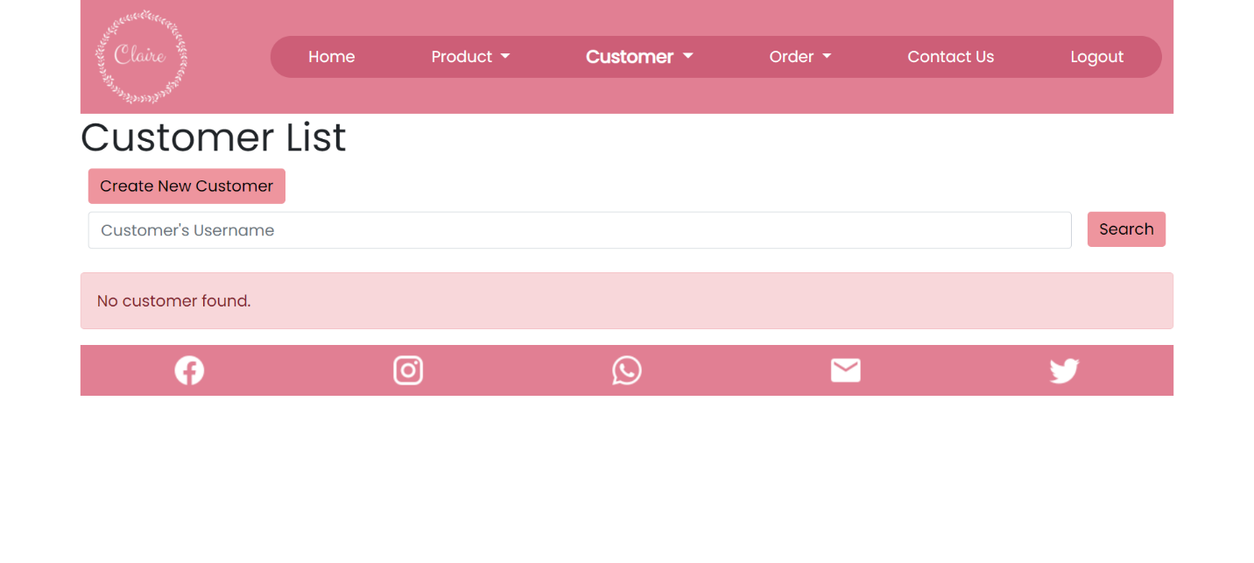

Figure 8.4: Search Customer by using the not existing customer username

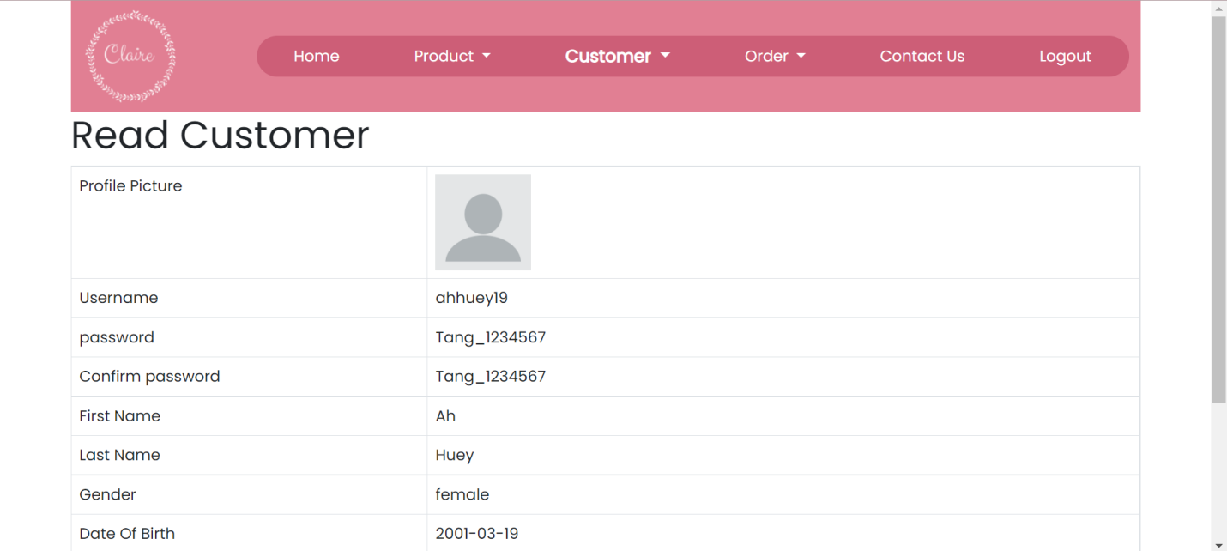

Figure 8.5: Direct to Customer Details Page

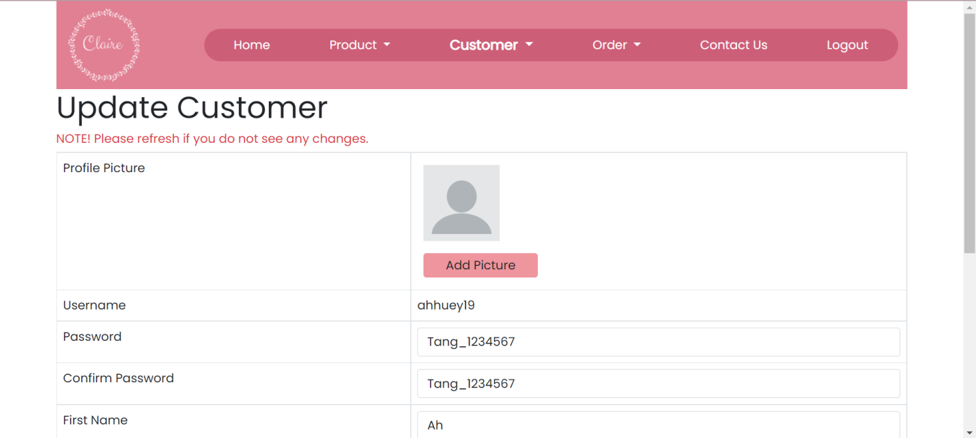

Figure 8.6: Direct to update customer details page

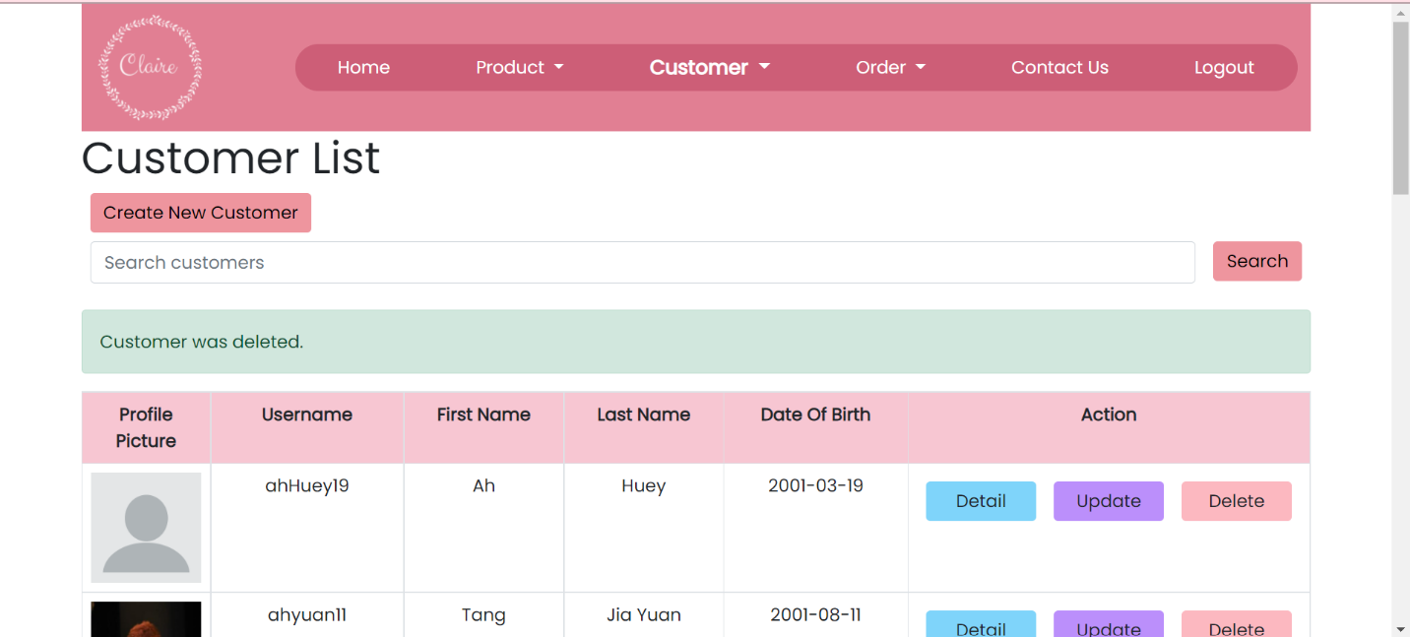

Figure 8.7: Delete customer who does not make at least one order

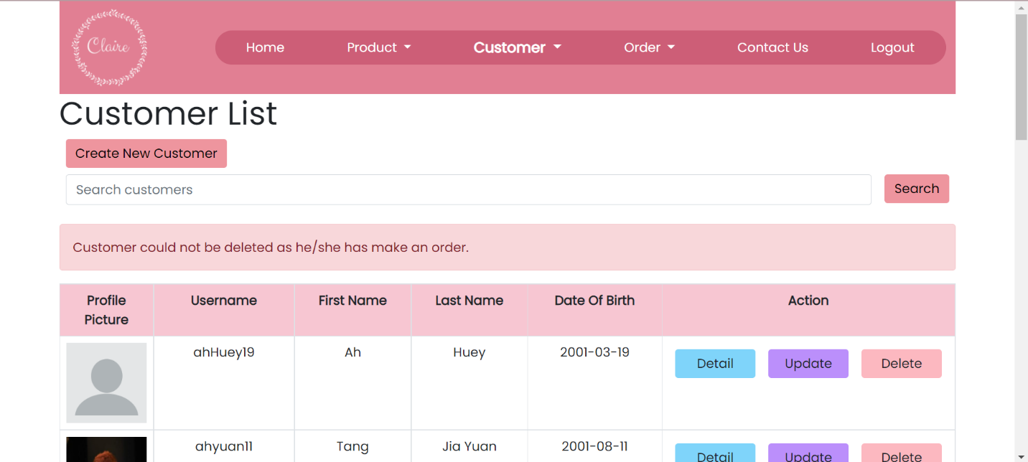

Figure 8.8: Delete customer who make at least one order before

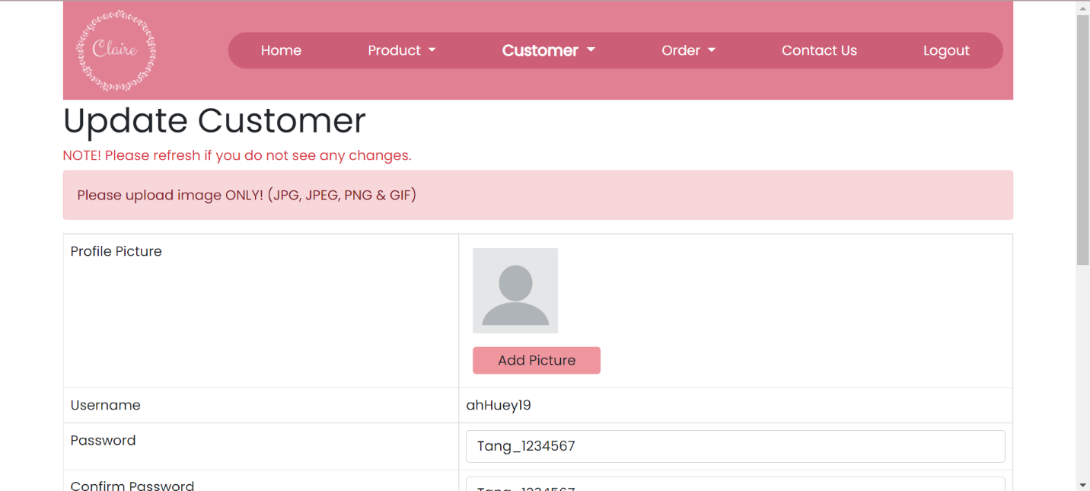

Figure 10.1: Upload a non-image photo to product image

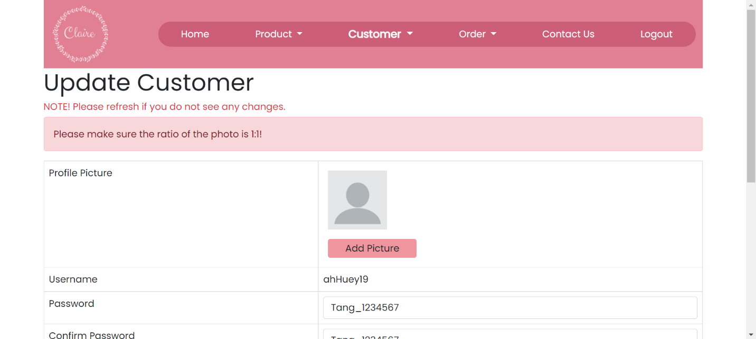

Figure 10.3: Upload an image in customer image which is not in a square size or not in 1:1 ratio.

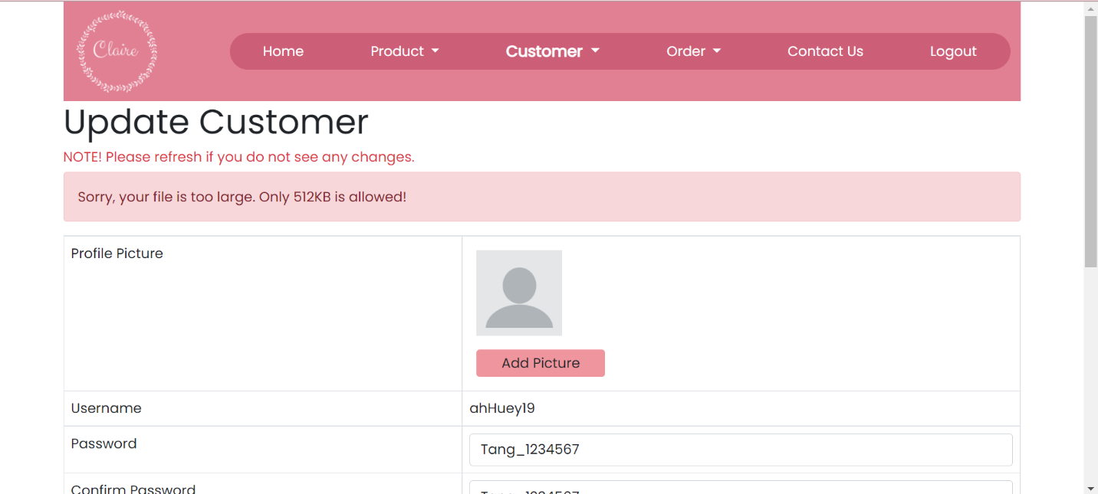

Figure 10.3: Upload an image in customer image which the size larger than 512KB

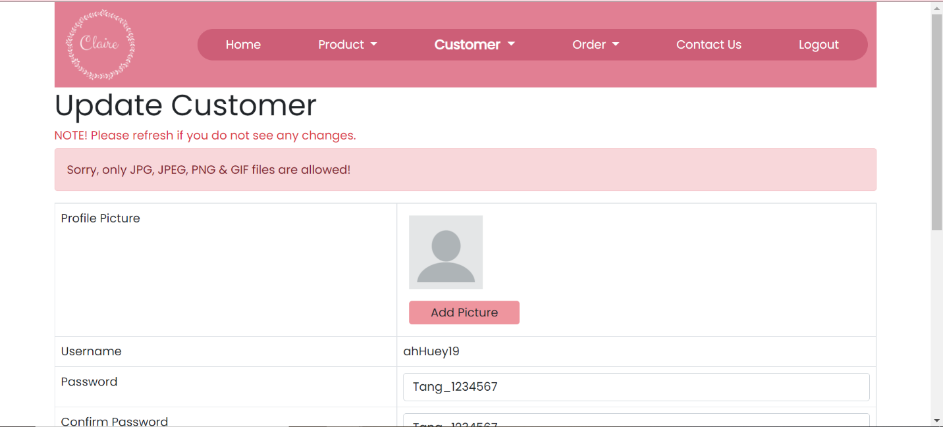

Figure 10.4: Upload an image in customer image which is not in JPG, JPEG, PNG & GIF files.

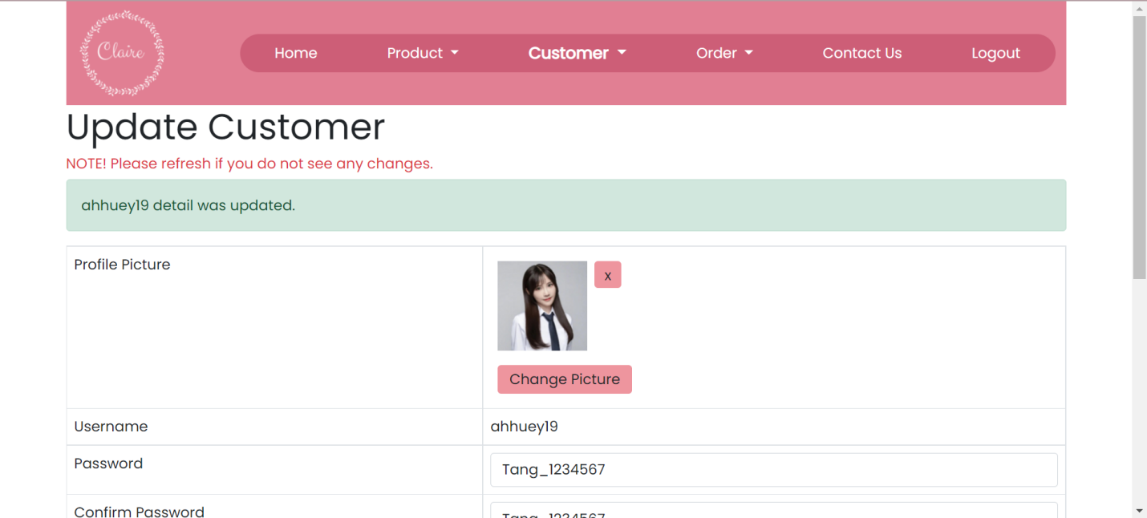

Figure 10.5: Add picture / change the existing picture

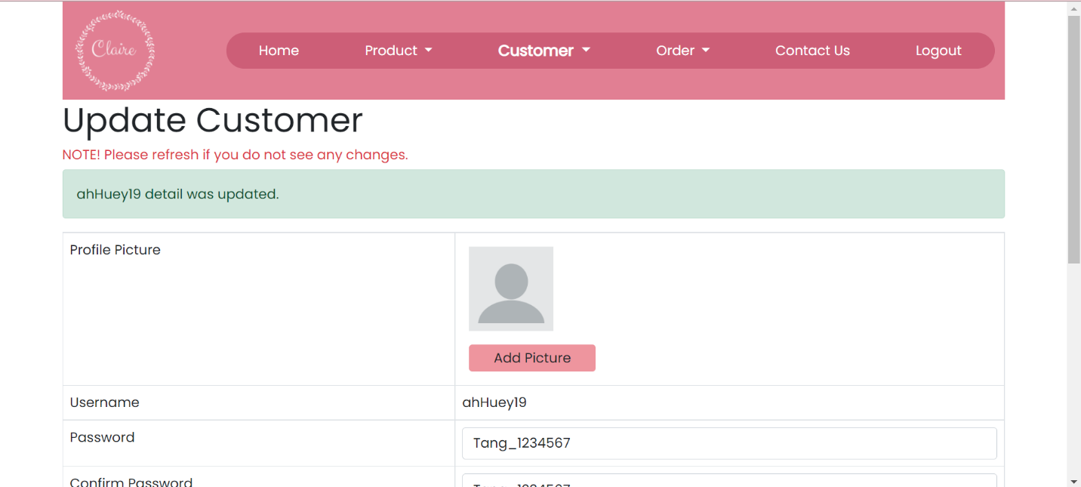

Figure 10.7: Delete customer from the Edit Customer Page

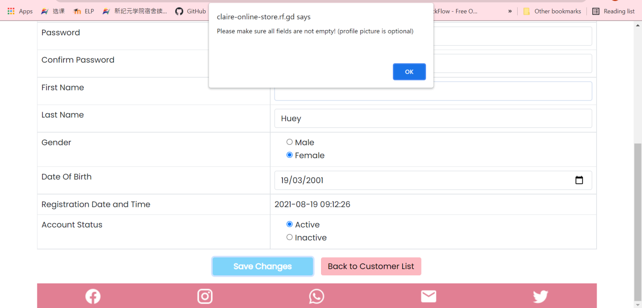

Figure 10.8: Update Customer Page without fill in all mandatory fields

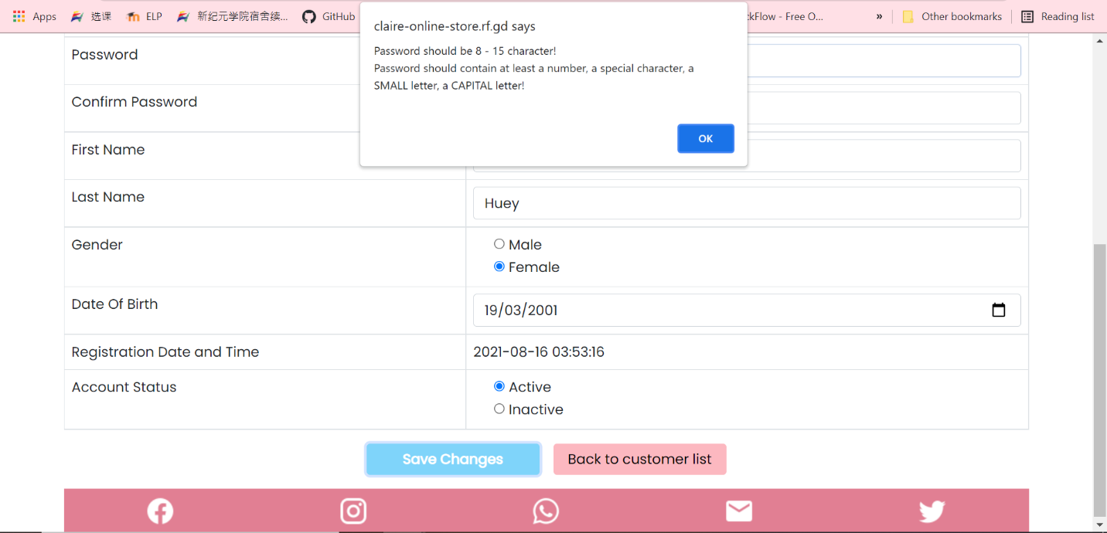

Figure 10.9: Change password in the password and confirm password field to become less than 8 characters or more than 15 characters

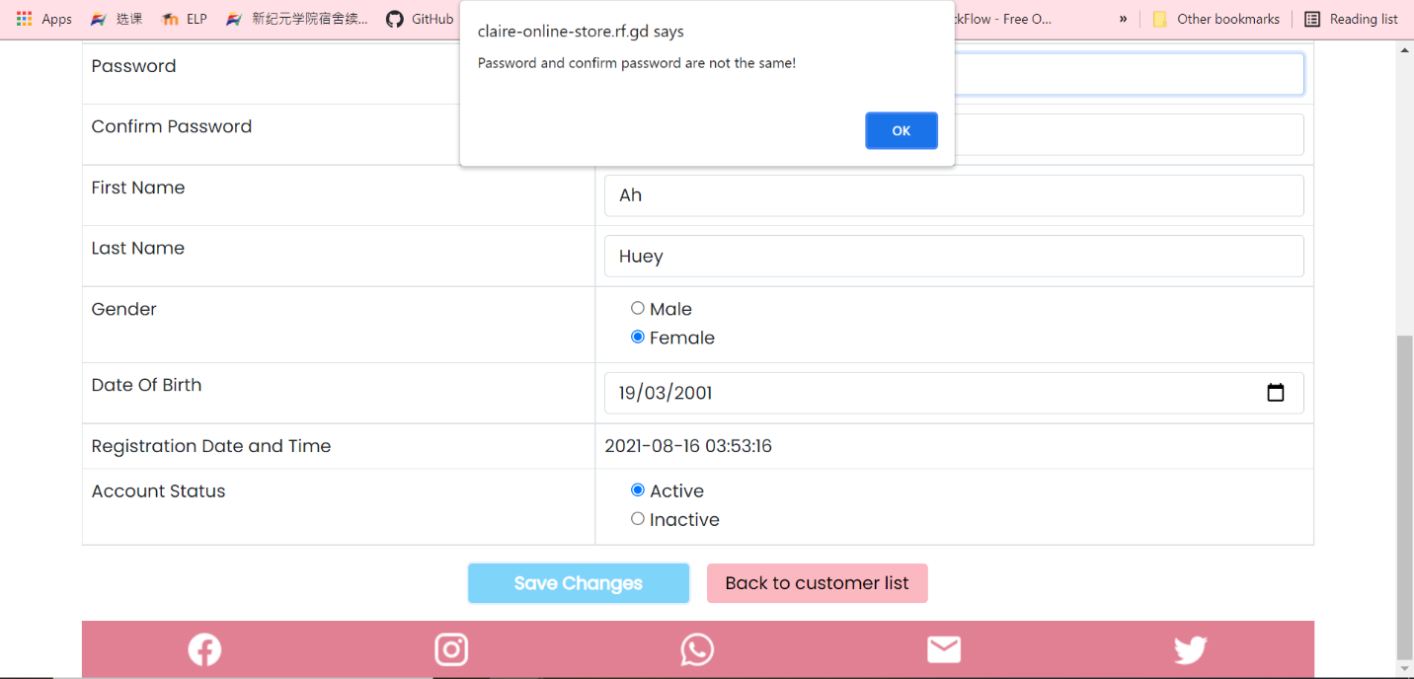

Figure 10.11: Change password to make it different from the confirm password.

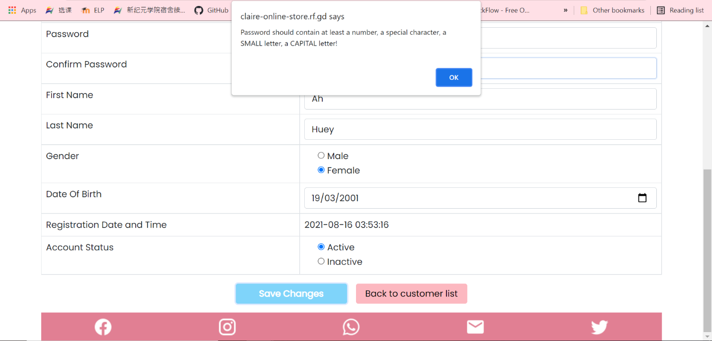

Figure 10.12: Change a password and confirm password with no uppercase letter or no lowercase or no number or no special character included

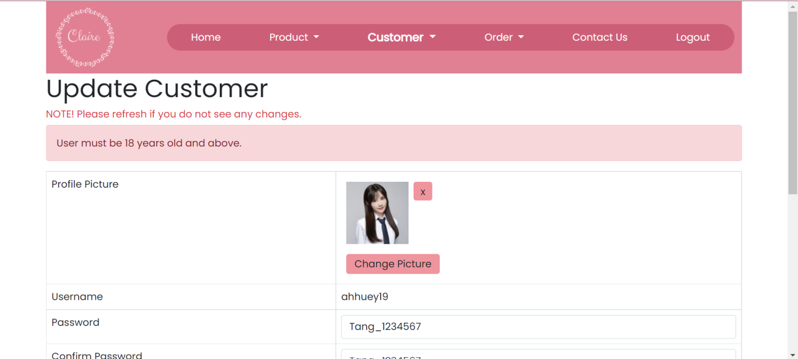

Figure 10.16: Update the date of birth which is not 18 years old and above

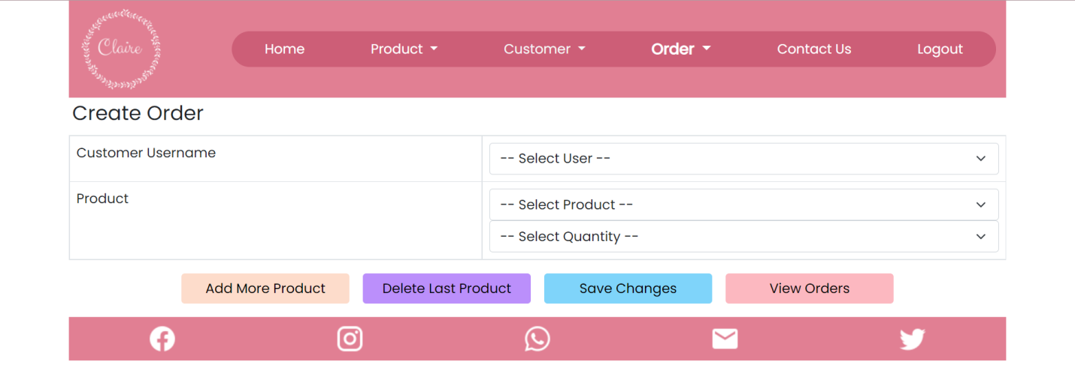

Figure 11.1: Create Order Page

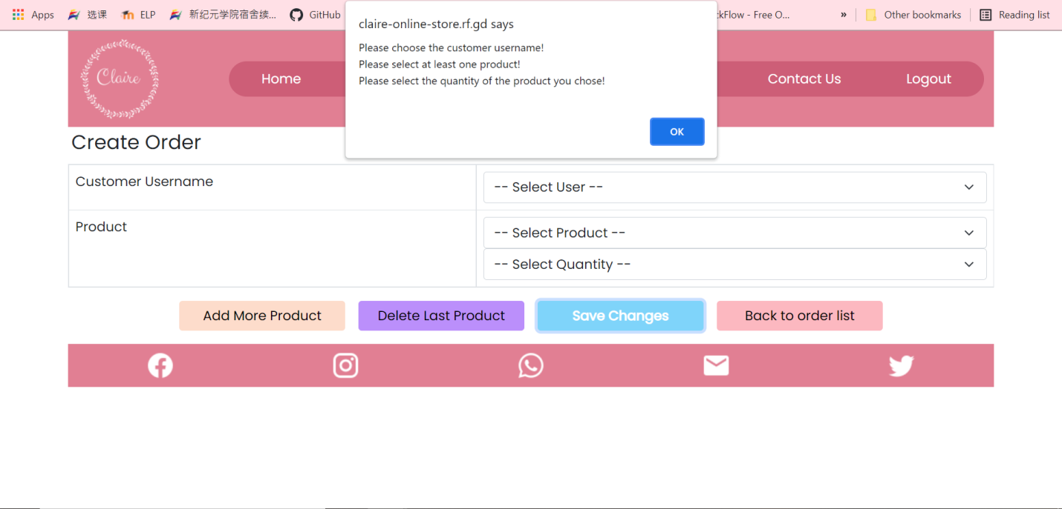

Figure 11.2: Create order without fill in anything.

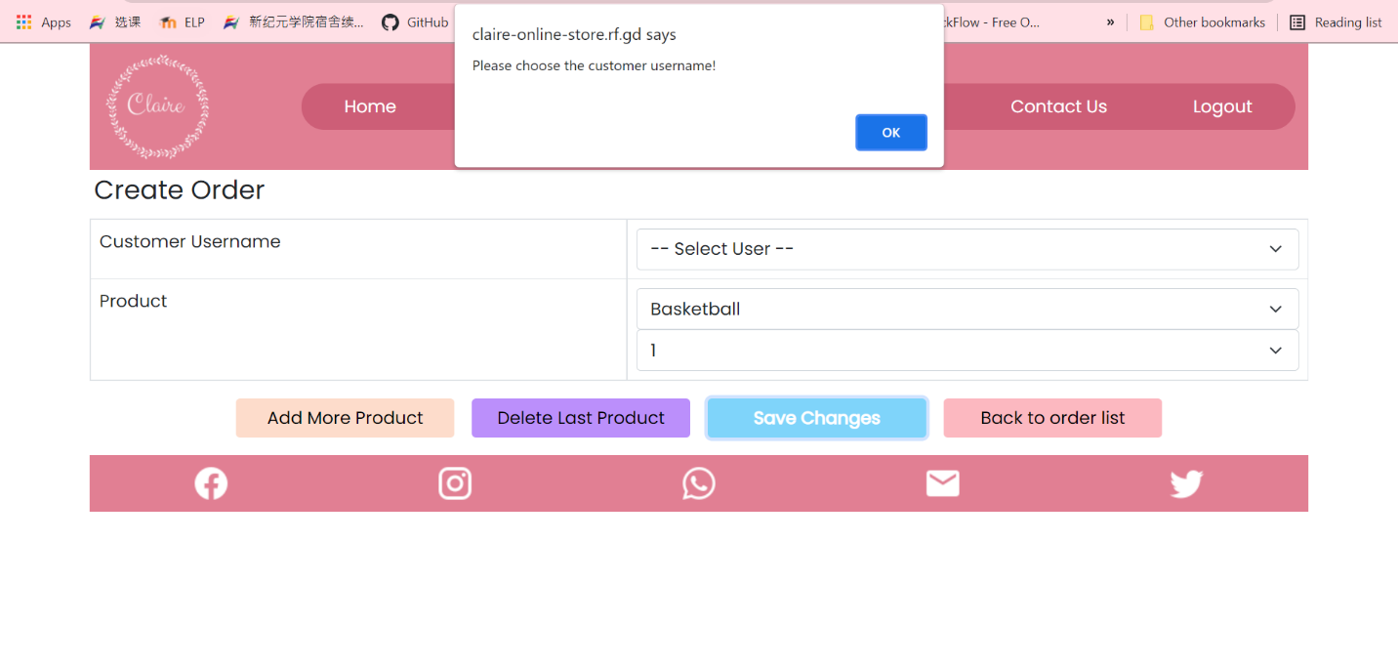

Figure 11.3: Create order without choosing any customer username.

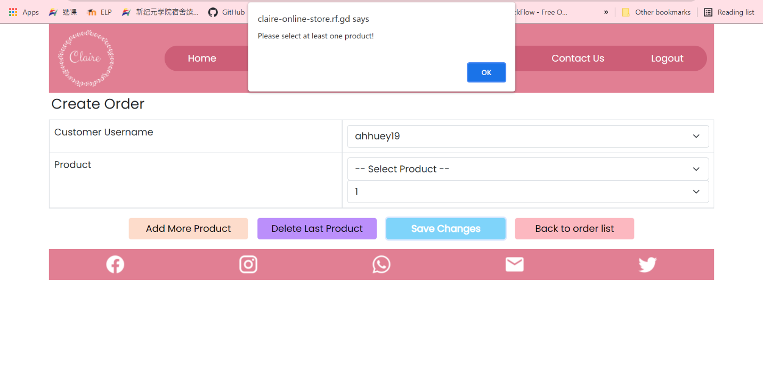

Figure 11.4: Create order without choosing a product.

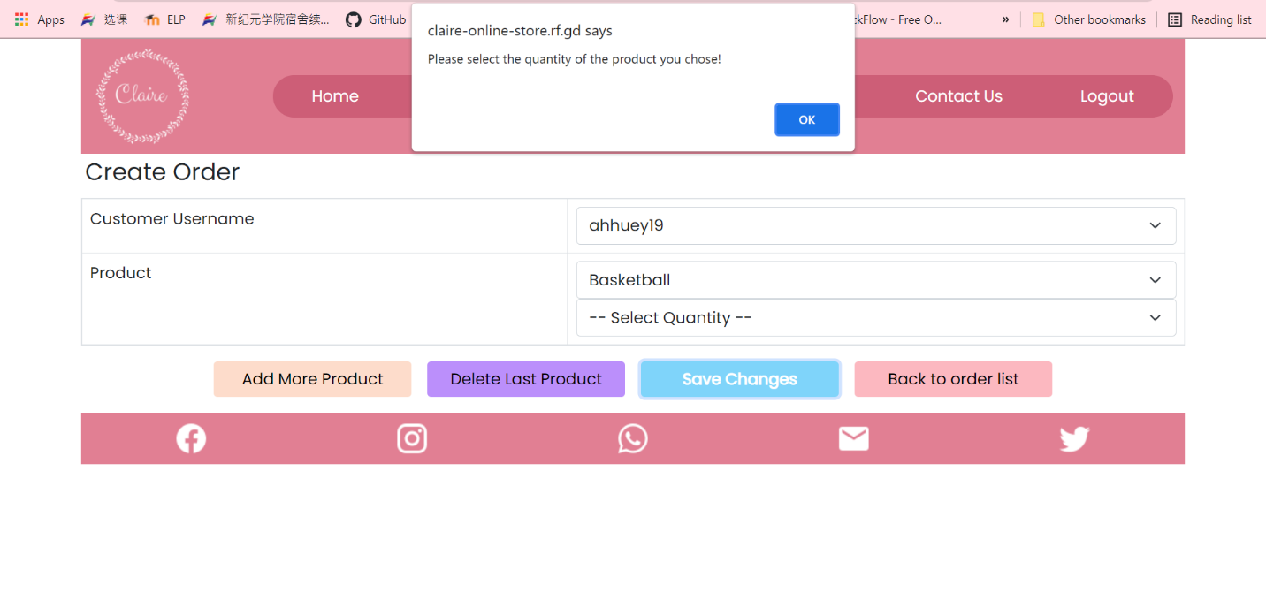

Figure 11.5: Create order without choosing the quantity.

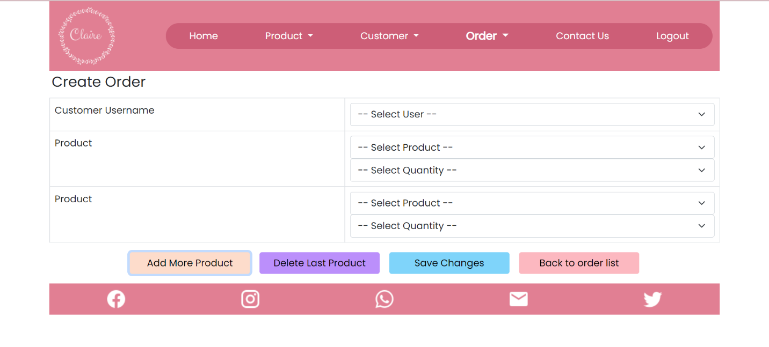

Figure 11.6: Add more product when creating order.

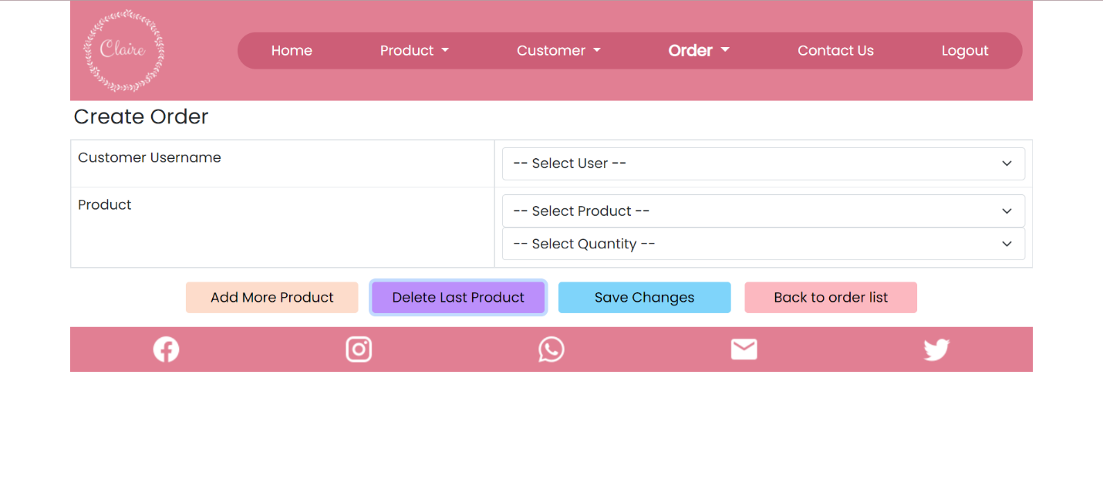

Figure 11.7: Delete product when creating order

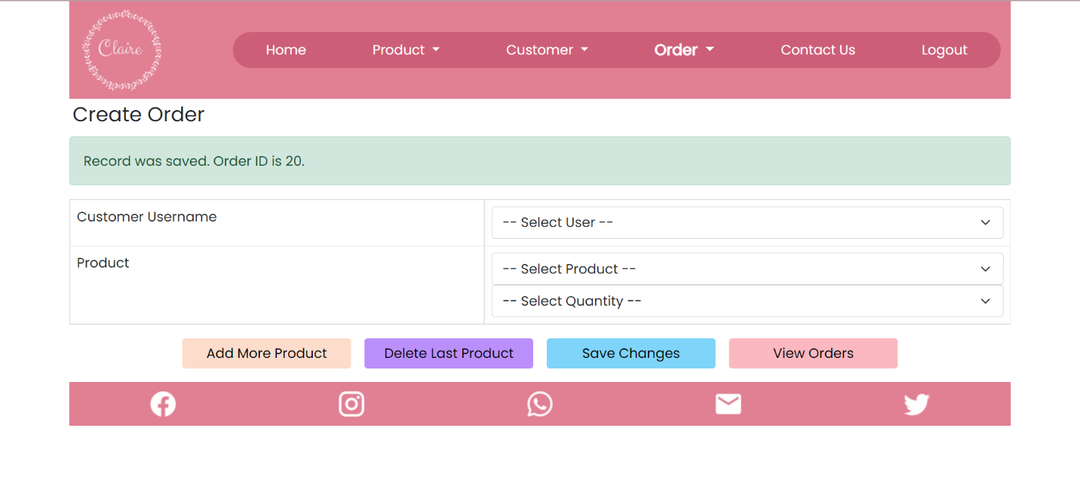

Figure 11.8: Order created successfully



Figure 12.3: Search Order by using the existing order ID or username

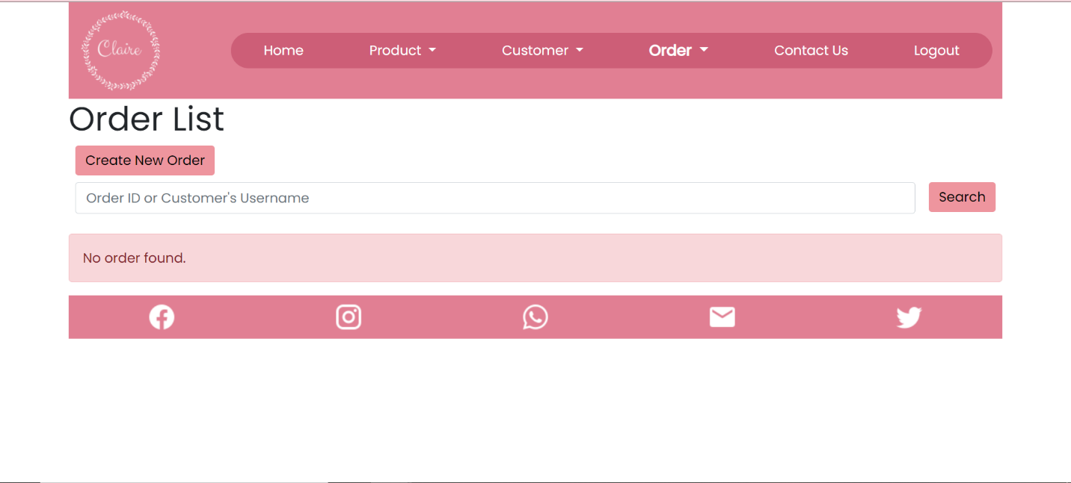

Figure 12.4: Search Order by using the not existing order ID or username

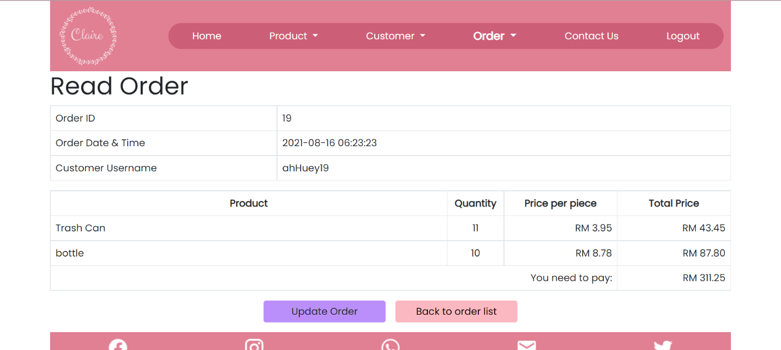

Figure 12.5: Direct to Order Details Page (Order ID 19)

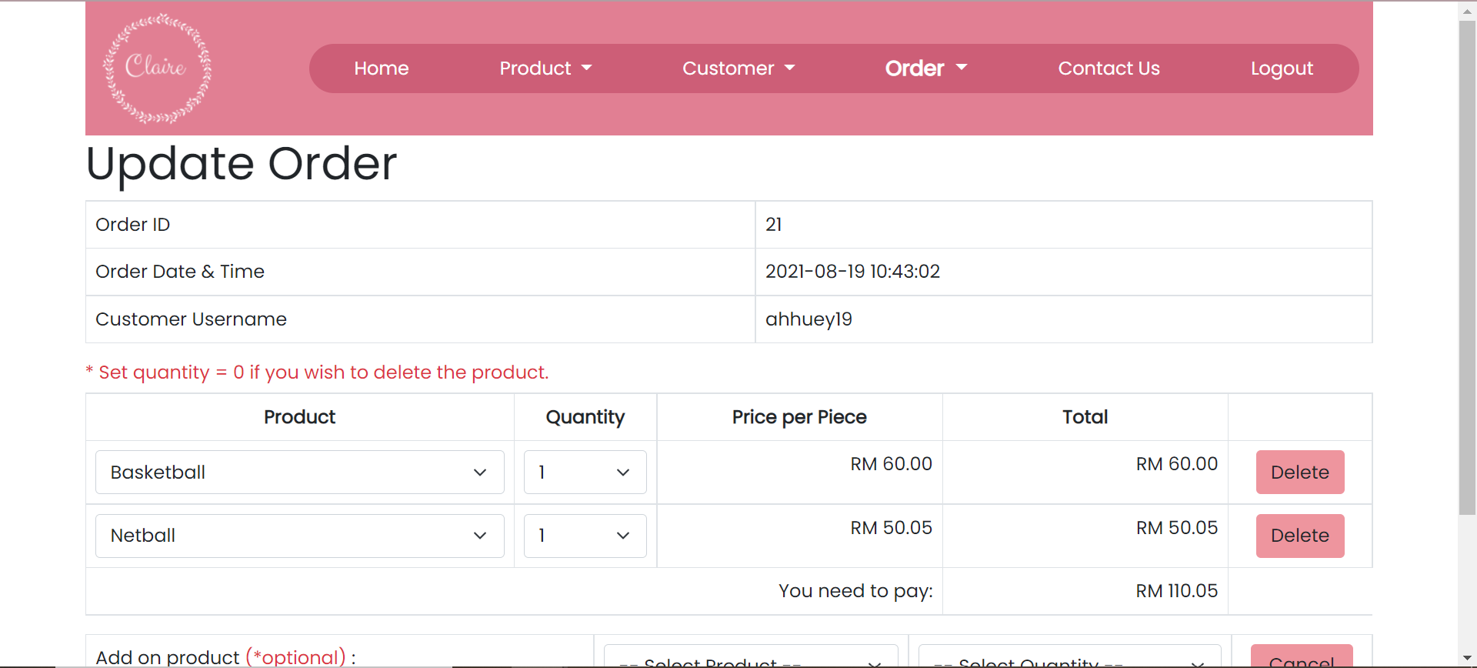

Figure 12.6: Update order page (Order ID 21)

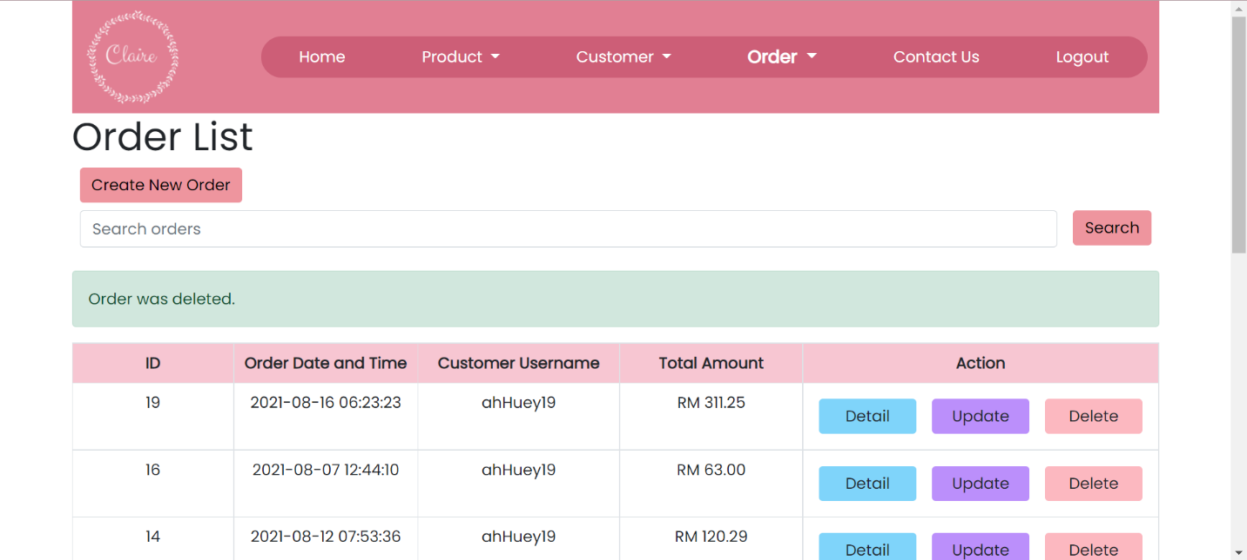

Figure 12.7: Delete certain order in Order List Page

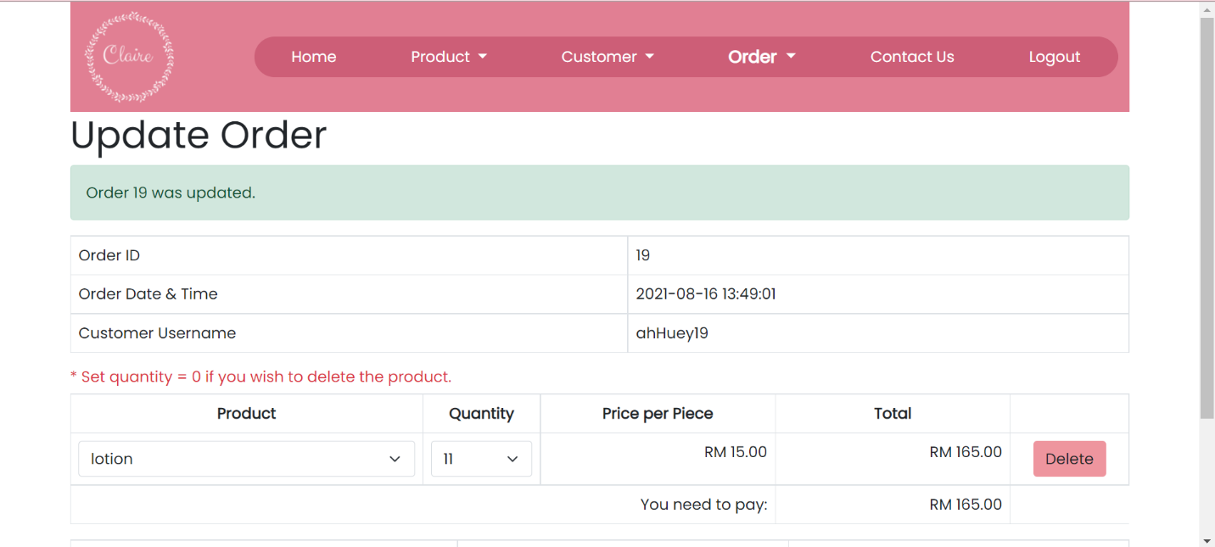

Figure 14.1: Change the product of the order

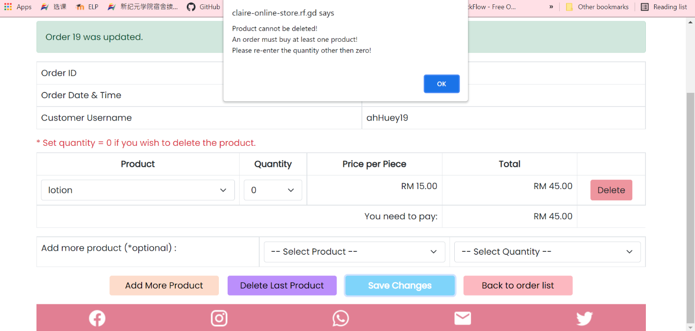

Figure 14.3: Delete the product when the order only has one product in the order by selecting the quantity to 0.

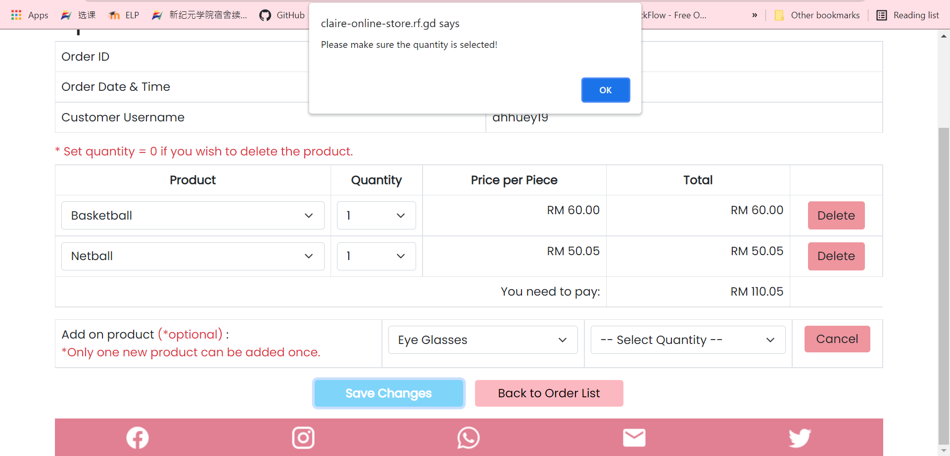

Figure 14.6: Add product by only choose the product

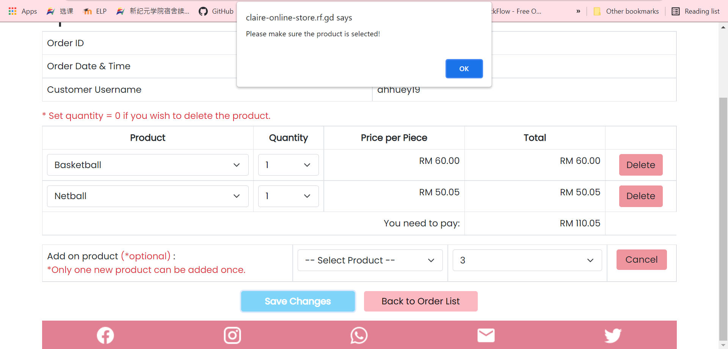

Figure 14.7: Add product by only choose the quantity

Before “Cancel”:



After “Cancel”:



Figure 14.8: Cancel add on new product

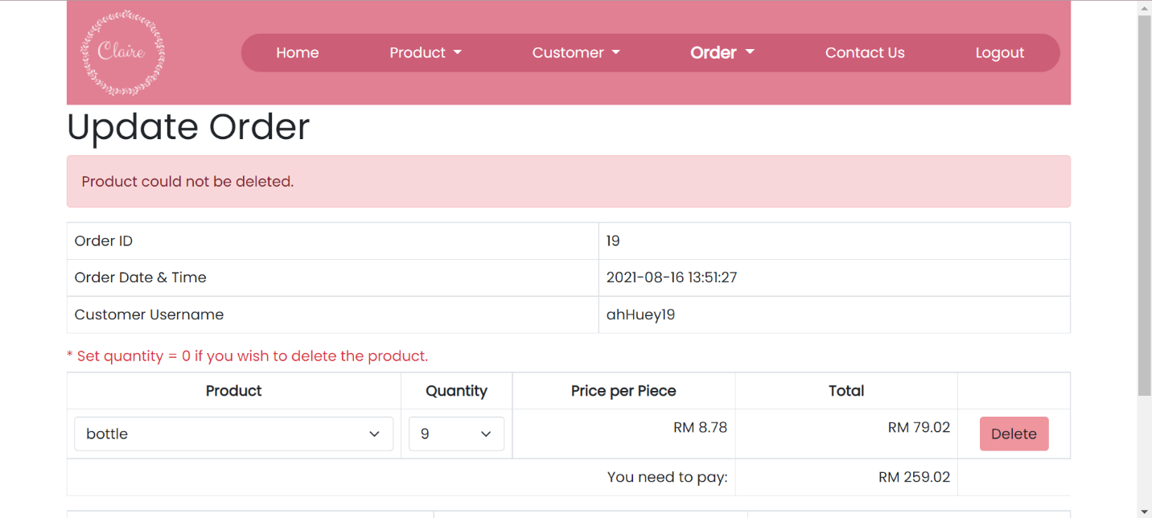

Figure 14.9: Delete the product when order only have one product

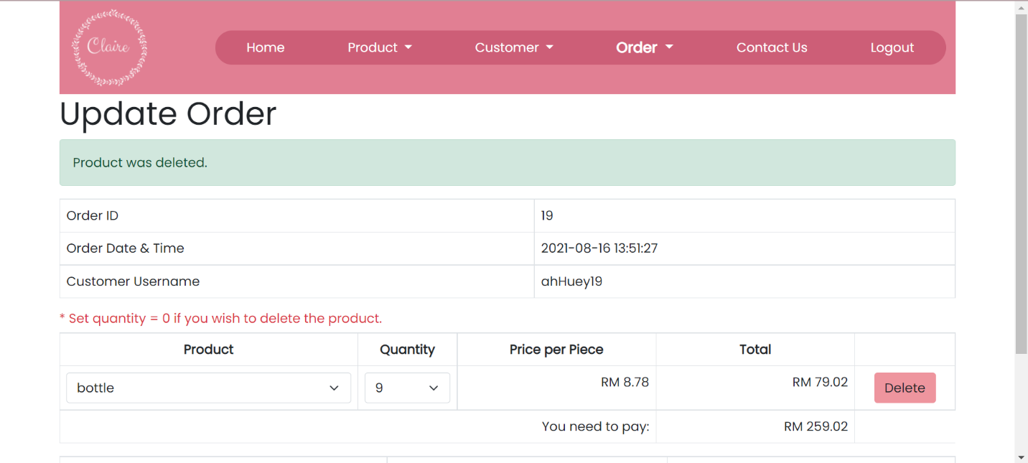

Figure 14.10: Delete the product when order has more than one product